ECE342 Lab #1 Introduction to the Agilent E4402B Spectrum Analyzer and Tracking Generator

Notes
Symbol indicates that a graph, or data, or explanation needs to be recorded in your lab notebook.
(Record)
Each lab team consists of two students.
Each team must bring to the lab: a standard quadrille-ruled lab notebook, a laptop PC, a floppy disk, a breadboard, assorted small capacitors, such as 0.1μF, 0.047μF, 0.01μF, 0.0047μF, 1000 pF, 470 pF, 220 pF.

Objectives
To learn how to use the Agilent spectrum analyzer E4402B.
To observe high frequency behavior of a printed circuit board (PCB).
To find the capacitance of a PCB from its frequency response, as measured with the spectrum analyzer and tracking generator.
To design a low-pass filter that offers 20 dB signal suppression between 1 MHz and 60 MHz relative to that at dc.

Deliverables
Complete the prelab questions, placing the answers in your lab notebook.
Record lab measurements in your lab notebook.
Record your observations and explanations in your lab notebook.
Submit your lab notebook in class next Monday.

Equipment and Components
Agilent Spectrum Analyzer E4402B (100 Hz to 3.0 GHz).
An LCR meter (one to be shared among all the lab groups)
Two bnc-bnc RG58/U coaxial cables (50 ohms)
Two bnc-to-pigtail or “pin lead” adaptors (for connecting the coax cables to your breadboard).
One alligator clip cable, about 1 foot in length.
A two-layer PCB with female socket pins soldered on the copper layers. Assume that the board has thickness of 1.0 mm and a dielectric constant ε_{r} = 4.5 if dielectric is blue or ε_{r} = 8.0 if dielectric is brown. (Also recall that ε₀ = 8.854 pF/m.)
A breadboard. (Please bring your own)
A number of capacitors with values ranging approximately from 0.1 μF to 100 pF.
A ruler calibrated in both inches and centimeters. (Please bring your own)
A floppy disk. (Please bring your own).

Prelab Problems

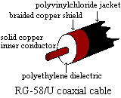
RG58/U coaxial cable (50 ohms)
Standard RG58/U coaxial cable has an inner wire of diameter 0.81 mm, an outer conductive braid of diameter 2.9 mm, and polyethylene insulating material of dielectric constant 2.3. Equation 4.35 in the textbook can be used to calculate capacitance per-unit-length. Here is this equation (which will later be derived in this class), where r_{s} = the outer shield interior radius and r_{w} = the inner wire radius.
$C=\frac{\text{55}\text{.}\text{56}ε_{r}}{\text{ln}(\frac{r_{s}}{r_{w}})}$ (units of pF/m)
Prelab Question 1 Calculate the per-unit length capacitance of RG58/U coaxial cable. Show your calculations in your lab book.
(Record)

Capacitance of a double-sided (two-layer) printed circuit board
Prelab Question 2 Find an equation to estimate the capacitance of a two-layer PCB.
(Record)

Design of a low-pass filter with a 20 dB stop-band above 1 MHz
Let us imagine that we want to build a first-order low-pass RC filter circuit that uses the internal 50 ohm tracking generator impedance and the internal 50 ohm spectrum analyzer input resistance along with an external capacitance, “Cexternal”, that is connected in parallel with the tracking generator output and the spectrum analyzer input, as shown in Fig. 1 below.
Prelab Question 3 Calculate the necessary value of Cexternal to obtain a 20 dB reduction in the output voltage amplitude at 1 MHz (and at frequencies above 1 MHz) relative to the output voltage amplitude at dc, as would be observed on the spectrum analyzer. Show your calculations in your lab book.
Hint: Let us define the voltage gain of this LPF as Gain = |Vout/Vtrack_gen|, where the boldface notation indicates phasor representations of the input and output voltage sinusoids. From Fig. 1, we see that because of the presence of the two 50 ohm resistors, the dc voltage gain of this filter is ½ or
-6 dB. Because the output voltage amplitude at 1 MHz must be 20 dB below the output voltage magnitude at dc, the actual voltage gain of the filter at 1 MHz must be -20 dB + (-6 dB) = -26 dB. The theoretical value of Cexternal may be obtained by solving a phasor voltage divider equation. Start by expressing Vout/Vtrack_gen as a phasor voltage division ratio. Then take the magnitude of this phasor voltage division ratio before setting it equal to 10^(-26/20) and solving for the necessary value of Cexternal. If you are doing this in MAPLE, the magnitude must be taken using the square root of the sum of the squares of the real and imaginary parts, rather than using MAPLE’s built-in “abs” function, since the “abs” function does not work when solving equations.
Answer: You must be able to show that Cexternal = 0.0632 μF in this problem!
Practical Note: In practice, the implementation of Cexternal may not be just a single capacitor, but instead is often a parallel connection of two or maybe even three capacitors, where C1 >> C2 >> C3, and Cexternal = C1 + C2 +C3. The capacitors usually differ by about an order of magnitude. Because the Cexternal = C1 + C2 + C3 is very nearly equal to C1, it is quite natural to wonder about the purpose of C2 and C3. The value of C1 should be selected to meet the low-pass filter’s required -26 dB voltage gain requirement at 1.00 MHz which you have shown must be 0.0632 μF. Because the values of C2 and C3 are much smaller than C1, assuming the same (or smaller) lead inductance, C2 and C3 will exhibit higher self-resonant frequencies, since the self-resonant frequency of capacitor C1, which is modeled as an ideal capacitance C_{x1} in series with lead inductance L_{x1}, is given by $f_{\text{res}}=1/(2π\sqrt{L_{x1}⋅C_{x1}})$. Therefore, at a frequency well above 1.00 MHz, C1 will become self-resonant, where it acts like a very low impedance, but above this frequency, the capacitor becomes inductive (the lead inductance dominates) and so C1 no longer functions as a low-impedance path to ground. Thus above the self-resonant frequency of C1, the next largest capacitor (C2) should “kick in” and exhibit a low capacitive impedance until the self-resonant frequency of C2 is passed, and so on. A general rule of thumb is to make C2 about one order of magnitude below C1, and C3 about one order of magnitude below C2. Therefore, if we select C1 = 0.1 μF (which is reasonably close to the theoretically calculated value of Cexternal = 0.0632 μF) , then as a “first cut” for our LPF design, we might want to select C2 = 0.01 μF and C3 = 1 nF. This first-cut design will have to be experimentally tweaked, based on the actual self-resonant frequencies of C1, C2, and C3.
Figure 1. Low-Pass Filter Circuit and Practical Implementation of Cexternal.
(Record)
(Record)

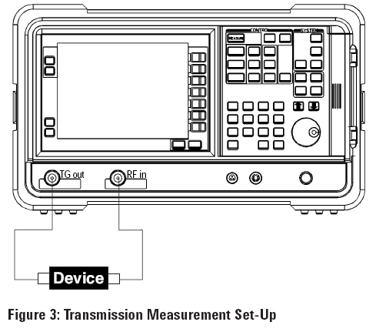
Lab Measurements
6.1) Displaying Frequency Spectra on the Agilent E4402B Spectrum Analyzer
First carefully follow the steps outlined in Chapter 3, “Viewing a Signal” (Steps 1 – 8 only) of the “Getting Started Guide” from Agilent to learn how to use the E4402B spectrum analyzer with the 10 MHz reference signal. This guide is included as a PDF file in the ECE342 Lab 1 class folder (the file name is “getting started e4401-90464.pdf”). Note that you will first have to connect a BNC cable between the rear panel “10 MHz out” calibration oscillator signal output and the RF Input (INPUT 50Ω) connector on the front panel. This is connector #13 in the Rear Panel view shown in Section 2.2 of the getting started document.
Once you have successfully displayed the 10 MHz calibration oscillator spectrum according to the directions in Chapter 3 “Viewing a Signal” (Steps 1 – 8 only), disconnect the 10 MHz calibration oscillator from the RF Input connector on the spectrum analyzer’s front panel, and connect instead a BNC cable with a BNC-to-pigtail adaptor connected to its far end. Use an alligator clip cable to extend the center wire from this cable straight out to act as an “antenna”. Clip the other end of the alligator cable to a book that is placed up on the upper shelf of the laboratory bench away from any metal objects. Now press the green [Preset] button to restore the manufacturer’s presets. Then hit [Amplitude] {Ref Level} 30 {-dbm} to make the spectrum analyzer more sensitive. Hit the [Peak Search] button to find the frequency of the highest peak. Note that this corresponds to an FM radio station (probably this station will be WTHI “Hi 99” located at 99.9 MHz.) Also note the sporadic pulsing that occurs in the vicinity of 850 MHz, 1.9 GHz, and 2.4 GHz (which are popular cell phone and wireless internet frequency bands). By the way, you may want to go to the following website: http://www.howstuffworks.com/cell-phone.htm to learn more about how cell phones work. If you have a cell phone, try turning it on and placing a call. My favorite number to call when testing is 232 0300 (the time and weather). Do you observe any change in the observed spectrum while the cell phone is in operation? Try hitting the {Next Pk Right} softkey to locate the frequencies of other prominent radio transmissions in your area. Record the prominent station frequencies you have observed in your lab book.
(Record)
Now let us display just the FM broadcast band (88 MHz – 108 MHz) by changing the spectrum analyzer’s Center and Span frequencies:
[Frequency] {Center Frequency} 98 {MHz}
[Span] {Span} 20 {MHz}
Hit [Peak Search] to go to the strongest station. This will probably be WTHI once again, but now its frequency (which should be 99.90 MHz) can be read more accurately, since the spectrum analyzer is operating over a much more narrow range of frequencies. Then hit {Next Pk Right} and {Next Peak Left} to jump from one station to another. Can you ascribe these station frequencies to various local radio or TV stations in the area? Record, in tabular form, as many station frequencies and their corresponding station call letters and their transmitter location. For a list of local radio stations and their locations and operating frequencies, go to http://www.radio-locator.com. Enter our zip code to obtain a list of the radio stations near us and the frequencies that they operate on.
(Record)
Once again hit [Peak Search] to go to the strongest station. Then to actually LISTEN to this station, put it at the center frequency by pressing [→ Marker] {Mkr → CF}. Hit [Det/Demod] {Demod AM] {AM}.
Make sure the Speaker is toggled ON. Turn up the volume control on the bottom right of the panel. To hear the station clearly, you must stop the spectrum analyzer from scanning. To do this, hit [Span] {Zero Span}. Finally, you must hit [Frequency] and tune slightly off of the station frequency using the rotary selector knob. (For example, if the strongest station is WTHI at at 99.9 MHz, then you will have to detune the signal to about 100.0 MHz.) This must be done because our spectrum analyzer only has a built-in AM detector, so the FM modulated signal must be converted (in a rather sloppy way) into an AM modulated signal using the principle of “Slope Detection”. The station’s audio should now be quite clear! Now try receiving your favorite FM station. For example, hit [Frequency] {Center Frequency} 88.5 (or whatever your favorite station frequency is) {MHz}. Remember to detune (say about 0.1 MHz higher than the center frequency) in order to hear the station. Experiment with different positions of the antenna. Note that once you selected {Zero Span}, the spectrum analyzer stopped displaying the signal spectrum and began displaying the demodulated signal in the time domain.
6.2) Using the Tracking Generator/Spectrum Analyzer to Measure Frequency Response
The tracking generator that comes as part of the spectrum analyzer may be used to measure the frequency response of any “2-port network” (circuit) that is placed between the tracking generator output (RF OUT 50Ω) and the Spectrum Analyzer input (INPUT 50Ω). The tracking generator has a 50 Ω internal “output resistance”, and it delivers a sine wave whose frequency follows the frequency to which the spectrum analyzer is currently tuned. The output amplitude of the tracking generator is held steady at 96.99 dBμV (or -10 dBm) across a 50 Ω load. Thus the tracking generator/spectrum analyzer combination permits the gain vs. frequency curve of the 2-port network to be automatically displayed as the “spectrum” on the spectrum analyzer!
However, before making actual measurements on a 2-port network, we need to understand how to measure, and then compensate for, the effects of parasitic (unwanted) inductance and capacitances introduced by the connecting cables and connectors, etc. In this section, we shall find that the Agilent E4402B spectrum analyzer can be “calibrated” to remove the influence of the parasitic effects of the transmission path (cable/connector) to and from the 2-port network under test.
Let us start by observing the unwanted spectral response of the transmission path.
6.2.1) Calculate and then measure capacitance of coaxial cable
(a) Measure the length of your coaxial cable, and calculate capacitance of your coaxial cable with the equation from the prelab.
(Record)
(b) Measure the capacitance with the LCR meter. .
(Record)

6.2.2) Direct connection between tracking generator output and spectrum analyzer input.
- As you should always do each and every time you change the settings on the spectrum analyzer, hit the green [Preset] button in order to restore the spectrum analyzer to its factory default settings.
- Set the spectrum analyzer for a 200 MHz Span, 100 MHz Center, and a -10 dBm (= 96.99 dBμV) Amplitude reference level. For now, change the vertical scale sensitivity “Scale/Div” to 1 dB/division to get a more sensitive display. This may be done by entering [Amplitude] {Scale/Div} 1 {dB}. Please note that this vertical scale sensitivity should be readjusted at any time during this lab when the spectrum display does fit on the screen.
- Turn on the tracking source by pressing [Source] {Amplitude On Off}
- Connect the tracking generator output (RF OUT 50Ω) with a single BNC-to-BNC coaxial cable to the spectrum analyzer input (INPUT 50Ω). Find the minimum peak with [Peak Search]->{Min Search}. Your frequency response should be a nearly ideal horizontal line that slopes downward only very slightly at higher frequencies.
- Save a copy of the observed frequency response (or “spectrum” for short) on your floppy disk as “FIGA” in reverse bitmap (.GIF) format. Insert a floppy disk into the floppy drive on the right. Be sure to insert the floppy disk very carefully and gently into the spectrum analyzer, with the label side of the floppy disk facing to the right. Then enter:
[File] {Save} {Type} {Screen}
{Format} {Reverse Bitmap}
{Name} FIGA [←Return]
{Dir Select} [Select [-A-] with the rotary selector knob} {Dir Select} {Save Now}
A yellow “Saving File” message appears while the file is being written to the floppy drive. Once the file is saved, you may press [←Return] button to return to the spectrum display.
(Record)

6.2.3) Connection of tracking generator and spectrum analyzer via pigtail (pin lead)
connectors and breadboard
- Connect the tracking generator output (RF OUT 50Ω) using one coaxial cable, the other end of which is connected to a BNC-to-pigtail adaptor. Connect the spectrum analyzer input (INPUT 50Ω) to a second coaxial cable, the other end of which is connected to a second BNC-to-pigtail adaptor. Connect the two coaxial cables together by connecting their pigtails together using your breadboard: connect shield to shield (white to white) and center wire to center wire (black-to-black).
- Display the spectrum as done in the previous section with the single coaxial cable. Notice the spectrum difference between when the BNC connector grounds are touched directly and when the BNC connectors are separated (note that the grounds are still connected through the pin connectors). The frequency response of the transmission media no longer looks as ideal as before, due to the inductance/capacitance of the pigtail connectors.
- Save a copy of the frequency response with the cables connected to the breadboard (and with the BNC metal shields touching) from 0 Hz to 200 MHz as FIGB. Use reverse bitmap format as before.
(Record)

6.2.4) Calibrate the spectrum analyzer to establish 0 dB reference
- Keep the cables connected together and the BNC connectors touching, as in the previous section. Redisplay the frequency response of the two coaxial cables connected together on the breadboard. The spectrum analyzer can be calibrated to eliminate the influence of this system. Note that any change in the transmission system or in the analyzer settings such as the reference amplitude, center frequency, span frequency, etc. will make the calibration invalid, so that a new calibration will be required.
- Begin by storing this reference trace as Trace 3:
[View/Trace] {More 1 of 2} {Normalize} {Store Ref 1 → 3}
- Next turn on the spectrum analyzer’s “normalization function” by pressing the {Normalize soft button as shown below. After you do this, note that the stored reference trace (Trace 3) is automatically subtracted (on a dB basis) from the currently measured trace before the result is displayed as Trace 1. In this way, the effects of the transmission system are removed from the observed frequency response curve. Note that the top line of the spectrum analyzer display now displays a flat 0 dB line, rather than the dBm absolute scale that you started with before normalization. That is because the display now represents a power ratio of the measured trace to the stored reference trace.
{Normalize On Off}
Push the following button to see the reference trace on the screen
{Ref Trace (Trace 3) View Blank}
You may have to change the vertical sensitivity in order to see the two traces.
Recall that this is done by entering
[Amplitude] {Scale/Div} desired value {dB}.
(Try a desired Scale/Div value of 5.00 dB)
- After you perform these steps, you should see two traces displayed. One should be the frequency response of the transmission system that was measured earlier; the second should be a perfectly flat 0-dB line that represents the calibrated, or normalized, frequency response. Now depress the {Ref Trace} soft key to turn off the reference display. The flat 0 dB line is all that you should see.

6.4 Capacitance of your PCB

Find the capacitance of your PCB in three ways.
- Calculate the capacitance between the two PCB layers with the equation for capacitance of a parallel plate capacitor. You will need to measure the dimensions of your PCB. Assume that your board is 1 mm thick and that the dielectric material between the traces has a relative permittivity (dielectric constant) of ε_{R} = 4.5.
(Record)
- Measure the capacitance of the PCB with the LCR meter by touching the LCR meter probes directly to the upper and lower layers of the PCB.
(Record)

Find the PCB capacitance from the frequency response of the PCB as discussed in class.
  - Connect the tracking source center (black) wire and spectrum input center (black) wire to one end of a copper layer.
  - With the spectrum analyzer set as in Step 4 of the preceding section, disconnect the pigtail wires from the breadboard and connect both ground (white) wires to the same end of the other copper layer, so that the capacitor formed by the top and bottom conducting layers of the PCB is connected in parallel with the tracking generator output and the spectrum analyzer input. As before, touch the BNC connectors of the two coaxial cables together. You should see a frequency response similar to that of a capacitor that exhibits a sharp dip (resonant frequency) somewhere in the middle of the screen. Use [Peak Search] {Min Search} to find this resonant frequency, and then turn the selector knob to measure a convenient attenuation level and the frequency at which it occurs. In order to ensure accuracy, pick a frequency that is at least four times lower than the self-resonant frequency. Calculate the capacitance and the series inductance of the PCB from this information, as discussed in class.
  - Save this spectrum on disk as FIGC in reverse bitmap.
(Record)

6.5) Design of a Low-pass Filter with 20 dB stopband from 1 MHz to 60 MHz
Now is the time to find out if you can design a low-pass filter (that exhibits a 20 dB stopband from 1 MHz to 60 MHz ) using several parallel-connected capacitors a number of capacitors, as discussed in the Prelab Problem 5.3. Recall that several parallel-connected capacitors should be used because any real capacitor has a self-resonant frequency, and above this resonant frequency, the capacitor acts like an inductor. The larger the capacitor’s value, the lower its self-resonant frequency. The strategy for covering a wide stopband is therefore to use the largest capacitor to cover the low-end frequency and, as the frequency rises above the self-resonant frequency of the largest capacitor, to use smaller capacitors to “kick in” and cover the higher frequencies over the desired stopband. The goal is to choose capacitors whose self-resonant frequencies are somewhat evenly spaced over the desired stopband,so that the stopband remains below the 20 dB goal over the entire range of frequencies (from 1 MHz to 60 MHz).

6.5.1) Measure the resonant frequencies of each of the capacitors to be used in making the LPF
- Calibrate the spectrum analyzer with 60 MHz Span, 30 MHz Center, -10 dBm Reference, with the coaxial cables connected together on the breadboard (use the power rail to connect the center wires and the ground rail to connect the ground wires), and this time, with the BNC connectors touching. (To do this, you must start by hitting the green preset button, then repeating the steps outlined in Sections 6.2.2 through 6.2.4, except now the span and center frequency have been changed as indicated in the preceding sentence.)
- Now that the display has been normalized (a flat 0 dB trace is observed with the BNC connectors held together), place a single 0.01 μF capacitor across the power and ground rails on one side of your breadboard. Cut the leads as short as possible to minimize the effects of lead inductance, yet still leave enough lead length so the capacitor plugs fully into the breadboard.
- Connect the tracking source and spectrum analyzer input in parallel with the capacitor, using the BNC pin connectors.
- Record the following measurements for this capacitor (a) Record the marked value of this capacitor (e.g. “103” = 1x10³ pF = 0.001 μF, and “471” = 47x10¹ = 470 pF) (b) the capacitance of this capacitor as indicated by the LCR meter, (c) its self-resonant frequency and (d) its attenuation at a frequency that is at least four times smaller than the resonant frequency. From these measurements calculate the (e) capacitance (Cx) and (f) lead inductance (Lx) of the capacitor.
(Record)
- Do this for each capacitor you plan to use in your filter. Present your data (items a – f listed above) in tabular form.
(Record)

6.5.2 Observe the frequency response of your filter
- With the spectrum analyzer set as in the previous section (with 60 MHz Span, 30 MHz Center, -10 dBm Reference), use the red and power distribution rails to connect the center wires and the ground rail to connect the ground wires with the BNC connectors touching.
- Place your capacitors across the power and ground rails at either the top or the bottom of your breadboard.
- Connect the tracking source and spectrum analyzer input in parallel with the capacitor, using the BNC pin connectors. Keep all connections as close together as possible. (See the photograph below.)
- Find the peaks in the stopband. If necessary, change capacitors to meet the requirement (at least 20 dB suppression compared to the 0 dB dc output level between 1 MHz and 60 MHz). Mark the largest peak on the spectrum.
If necessary, adjust the amplitude reference and/or the vertical sensitivity to use the whole screen to display the spectrum by entering
[Amplitude] {Scale/Div} desired value {dB}.
- Save this frequency response curve as FIGD in reverse bitmap.
(Record)
- Does your final design meet the specifications? Indicate what capacitors were used in your final design.
(Record)
Here is an example spectrum of a 30 dB suppression LPF whose stop band begins at 100 kHz and extends up to at least 200 MHz.

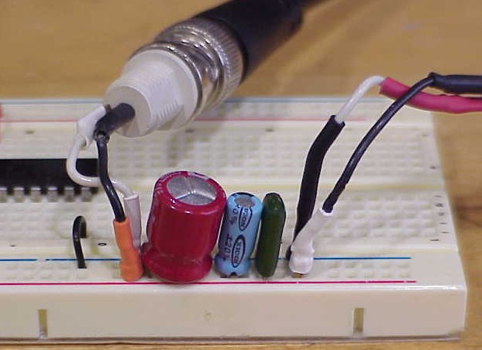
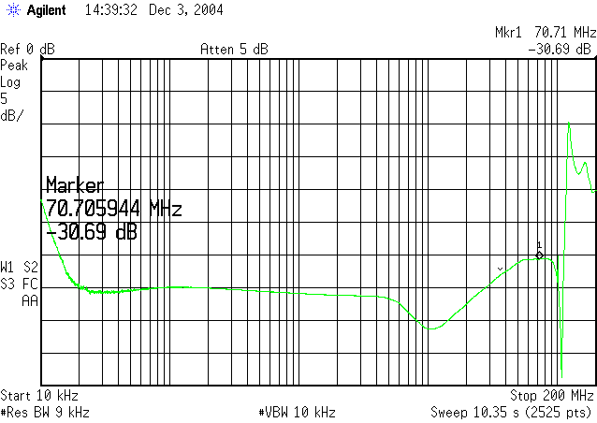
The 0 dB passband is located at the extreme low frequency portion of the display, and is barely visible in this plot. Here we are concentrating on the stop band (from 100 kHz to 200 Mhz.)

Appendix: E4402B with a Tracking Generator [1]

Tracking generator and Transmission Measurement
A tracking generator in E4402B provides single-channel scalar-network-analysis capabilities in addition to its spectrum analysis capabilities. The scalar-network-analysis capability allows you to perform stimulus-response measurements such as gain, frequency response, return loss, insertion loss, and flatness on components and subsystems.
Stimulus-response measurements are made to characterize the transmission or reflection parameters of a device. Devices can range from individual cables and components like filters and amplifiers, all the way to complex systems encompassing multiple components, connectors and cables. Some examples of stimulus-response measurements are: the 3 dB bandwidth of a bandpass filter, the return loss of an antenna, gain versus frequency for an amplifier, and the frequency-response of a length of cable. Stimulus-response measurements require a source to stimulate the device and a receiver to analyze its frequency response characteristics.
The first thing we need to do before making a transmission measurement is to configure the spectrum analyzer/tracking generator system. As shown in Figure 3, the RF output from the tracking generator is connected to the input of the device, and the output of the device is connected to the input of the E4402B. Next, we need to turn the tracking generator on by going into the [Source Amptd] hardkey functions, and turning the Amplitude On; {Amplitude On Off}.
Notice that the output power is -10dBm and the corresponding output matched voltage is 96.99 dB μV.
An overview of the steps required to make an accurate transmission measurement are as follows:
A. Set up the spectrum analyzer’s control settings (frequency, resolution bandwidth, sweep time, input attenuation, etc.) with the device connected. B. Establish a 0 dB reference by removing the device and measuring the incident signal level. Turn on the normalization function to subtract the incident power from the transmitted power.
C. Make the transmission measurement by re-inserting the device into the transmission measurement path.

A tracking generator
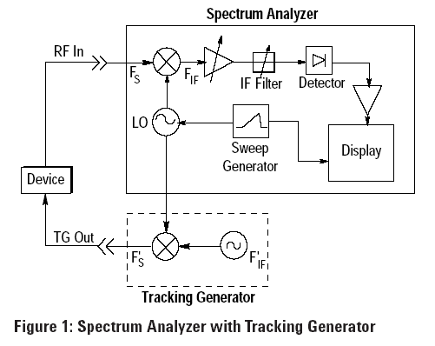
A tracking generator is a signal source whose RF output follows (tracks) the tuning of the spectrum analyzer. The tracking generator output signal is generated by mixing the signals from two or more oscillators. A simplified block diagram is shown in Figure 1. For the spectrum analyzer block diagram, the incoming signal, Fs, mixes with the LO, and when the mixing product equals the center frequency of the IF filter, this signal passes through to the peak detector. The detector output is amplified to cause a vertical deflection on the display. Synchronism between the horizontal frequency axis of the display and the tuning of the LO is provided by the sweep generator, which both drives the horizontal deflection and tunes the LO.

The tracking generator uses the swept LO from the spectrum analyzer and mixes that LO signal with a stable, fixed oscillator. If we tune the oscillator in the tracking generator (F’if) to the center frequency of the IF filter in the spectrum analyzer, Fif, and use the difference mixing product, then the output frequency of the tracking generator (F’s) will equal the input frequency of the spectrum analyzer (Fs).
FS = FLO – FIF and F’S = FLO – F’IF
The spans of the spectrum analyzer and tracking generator are matched and synchronous, and therefore precise tracking between the two instruments is achieved.

The Normalizing Function
Before we can determine the transmission loss or gain of our device, we must measure the incident signal level. We do this by removing the device and measuring a “thru” from the source directly to the receiver. This establishes a 0 dB reference trace which is stored in the spectrum analyzer and used for normalizing the measured data. The procedure on the Agilent ESA-L1500A is as follows:
1. Remove device and connect the tracking generator output directly to the spectrum analyzer input using the same test cables as will be used in the measurement. Use a thru adapter if necessary to connect the test cables.
2. Notice that the frequency response may not be perfectly flat, showing the response of the cables, as well as the flatness of both the tracking generator and the spectrum analyzer.
3. Turn Normalize On: [Trace], {Normalize >}, {Normalize On}. This procedure automatically subtracts the measured “thru” level from an ideal thru (flat reference line) and stores it. This difference is then used to normalize the measured signal (measured signal - error = normalized signal).
4. Notice that with the device disconnected, the displayed trace is now flat, or normalized. The position of the normalized trace can be moved to a different position on the display by changing the normalized reference position {Norm Ref Posn}. This may be useful if the device to be tested has positive gain, such as an amplifier.

References
- Agilent Option 1DN/1DQ, Scalar Measurements with the ESA-L1500A, 1.5 GHz Spectrum Analyzer and Tracking Generator.
- Getting Started Guide, Agilent Technologies ESA Spectrum Analyzers.
- Introduction to EMC, Clayton Paul.

