ECE342 Homework #2

1. A regular tetrahedron has vertices at the following four points (all coordinates are in meters)

Charges of 1 mC are located at each of the four vertices. If the configuration is located
in free space (air)

A. Find the magnitude of the force on each charge. (Ans: 1835 N)

B. Find the angle between any two edges of the tetrahedron. (Hint calculate the length
of each edge of the tetrahedron.) (Ans: 60 degrees)

2. Eight 25-nC point charges in free space are located symmetrically on a circle of radius 0.2 m centered at the origin in the z = 0 plane.

A. At what point on the z axis is |E| maximum? (Ans: plus or minus z = 0.1414 m)

B. What is the value of this maximum value of |E|? (Ans: 17.30 kV/m)

3. Consider two vectors expressed in rectangular coordinates as
A. Working from the definition of the vector dot product
Show that

B. Working from the definition of the vector cross product
Where in is a unit vector that is mutually perpendicular to vectors A and B, and it is oriented in the direction implied by the "right-hand screw" rule. This is the direction in which a right-hand threaded screw will advance if its head is turned from the direction of vector A to the direction of vector B.

Show that

Note that this result may be written more compactly (and mnemonically) as the determinant of a matrix:

4. For positive x, y, and z, the volume charge density within a region is
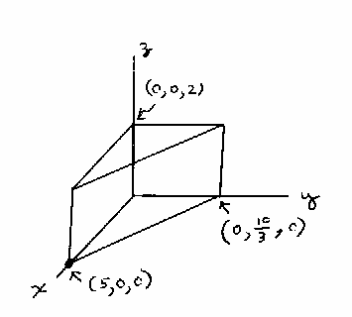

Find the total charge enclosed by the region defined by
x = 0, y = 0, 0 < 2x + 3y < 10, 0 < z < 2. (Ans: 926 C)

5. A uniform line charge density of 20 nC/m lies on the z axis between z = 1 m and z = 3 m.
No other charges are present. Find E at the origin. (Ans: E = -119.8iz V/m).

