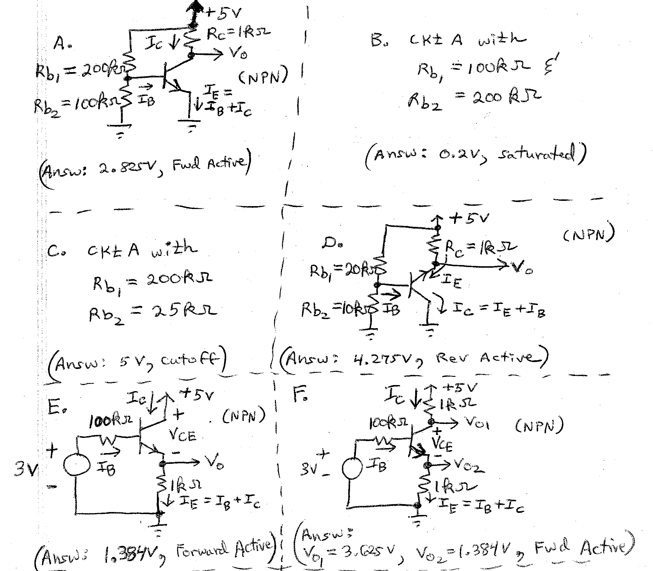
ECE250 Homework Assignment #5
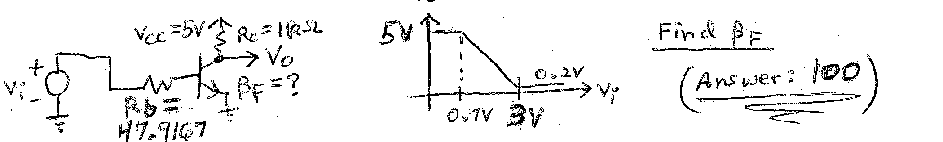
- The NPN BJTs in the circuits below all have the following parameters
Forward Active Mode: β_{F} = 150; Vbe(on) = 0.7 V; Vce(sat) = 0.2 V
Reverse Active Mode: β_{R} = 5; Vbc(on) = 0.7 V; Vec (sat) = 0.2 V
Determine the output voltage(s) and also the operating region of the BJT (Forward Active, Reverse Active, Cut Off, or Saturated)
2. Given the “Vo vs. Vi” voltage transfer curve (VTC) of the BJT inverter circuit drawn below, find β_{F} of the BJT. Hint: from the VTC it can be seen that the BJT has Vbe(on) = 0.7 V and Vce(sat) = 0.2 V.
Vo
kΩ

