Thermocouple parameter identification | ES 205  Analysis and Design of Engineering Systems

1. Summary

Experimentally estimating a convection coefficient
Parameter identification is the experimental determination of a system parameter. In this experiment, we measure the response of a thermocouple to a step input. From the data we obtain an estimate of the thermocouple’s time constant from which we determine an approximate value for the convection coefficient between the thermocouple bead and still water. We compare this value to published values.

2. Demonstration and preliminary data reduction

Model
The two parameters of first-order systems are the time constant τ and the steady-state gain K. The first-order model of a thermocouple, obtained previously, is given by
, (1)
where T is the temperature of the thermocouple bead and T∞ is the temperature of the surrounding fluid. The steady-state gain Κ = 1 and the time constant τ is given by
$τ=\frac{ρ c_{v}V}{h A_{s}}$, (2)
where the bead’s physical properties are density ρ, specific heat c_{v}, volume $V$, and surface area A_{s}. The convection coefficient h is between the bead and the surrounding fluid.

Demonstration
- Start with the thermocouple near 0ºC.
- Start the data acquisition. Display real-time results on the monitor.
- Create a step input to the system by quickly changing T∞ from a low temperature (ice water, near 0ºC) to a high temperature (boiling water near 100ºC).
- Stop the data acquisition.
- What is the magnitude of the input just before the onset of the step? Record your estimate on the Lab Worksheet.
- What is the magnitude of the step input? Record your estimate on the Lab Worksheet.
- Estimate the time constant from the 63% point of the response plot. Record your estimate on the Lab Worksheet.

Data acquisition and preliminary data reduction
The data displayed on the monitor have been previously recorded and are available to each team. The data acquisition system records elapsed time and the thermocouple voltage output. The following data reduction has already been performed for you:
- Voltage measurements are converted to temperature.
- Measurements prior to the step input have been deleted so that the first time measurement is at the beginning of the step input.
- A constant Δt was subtracted from the measured time values so that the time record starts at t = 0.
- The response reaches 98% of its final value over an interval of four time constants, so data after approximately 4τ have been deleted.

3. Your task: determine a time constant

Determining the time constant of the system
Following the instructions below, create an incomplete response plot using the data provided to you. For more information on the incomplete-response plot, see ref. [1,2].
- The first column of the spreadsheet is time t in seconds. The second column is the measured temperature in ºC. No changes required.
- Create a new column in the spreadsheet in which you divide all the temperature data by the magnitude of the step input.
- In the next column, subtract this number from 1 and take the natural logarithm of this difference. This column is the variable Z(t), the log incomplete response.
- Plot Z(t).
- Plot a linear least-squares curve fit (trend line) and record the slope of the line.
- Determine the time constant τ from the slope of the fitted curve. Record τ.

In a new column of your spreadsheet, record this value of τ and label it. Also record and label in the spreadsheet the initial temperature and the magnitude of the step input.

A sample spreadsheet layout is shown below.

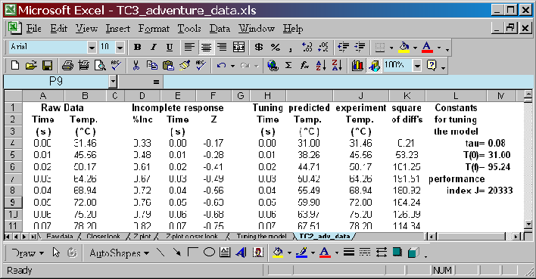

Assess your time constant estimate
The exact solution to the first-order, differential equation of motion (1) is given by
$T_{P}(t)=T(0)+A\left[1−\text{exp}\left(−t/τ\right)\right]$, (3)
where T(0) is the initial condition, A is the magnitude of the step, τ is the time constant, and T_{P}(t) is the theoretical, or predicted, temperature as a function of time.
- Create a new column in your spreadsheet to compute T_{P}(t) using equation (3). In this equation, the values of τ, T(0) and A should refer to the cells containing these values. The values of t to use are in the time column of the experimental data.
- On a new figure, plot both T_{P}(t) (the predicted temperature) and the original data T_{M}(t) (the measured temperature).
- You will probably find that the theoretical prediction deviates from the measured values.

4. Finding a time constant, a second approach

Tuning the model
Model tuning involves varying a parameter (in this case, the time constant) such that the difference between the experimental results and theoretical prediction is made as small as possible.

We create a cost function J, defined as follows,
$J=\sum_{i=1}^{n}{{\left(T_{\text{Mi}}−T_{\text{Pi}}\right)}^{2}}$, (4)
where T_{Mi} is the measured value of temperature at the instant t_{i}, T_{Pi} is the predicted value of temperature at the same instant [this is the value that depends on τ and is computed using equation (3)], and n is the number of measured (experimental) data points.
- In your spreadsheet, create a new column is which you take the difference between the measured temperatures and the predicted temperatures.
- Square the differences.
- In a separate cell, sum the squares of the differences and label this cell the cost function (or performance index) J.
- In Excel, select ToolsSolver. (If Solver is not on your Tools menu, select ToolsAdd-Ins to add the solver to the menu.) The Solver window is shown below.

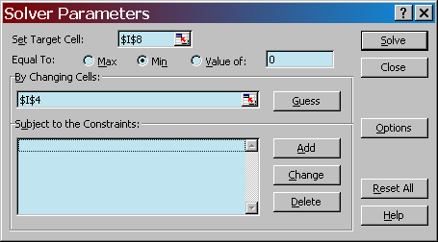

- The cell location of the cost function J goes in the Set Target Cell space.
- The cell location of the time constant τ goes in the By Changing Cell space.
- Set Equal To to Min.
- Click on Solve. The solver then tries to find a value of τ that minimizes J.

If the solver converges on an answer, you’ll see the following window. Select Keep Solver Solution, and OK.

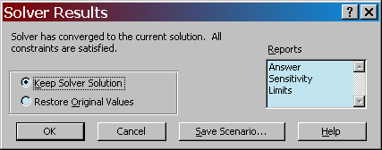

In your spreadsheet, you’ll see that a new value of the time constant has been computed. Record this value on the worksheet.

Return to the figure comparing experimental and theoretical responses. The theoretical plot, while not exactly like the experimental, is as close as we can get using a first-order model. In this figure, do the following:
- Use small discrete symbols to represent the experimental data.
- Use a solid line to represent a theoretical prediction. Change the line thickness so that it is neither too thick nor too faint.
- Add titles and labels. Make sure that the line and the data points are distinguishable. Adjust the font sizes so they are suitable for printing.
- Print the figure. Attach it to your worksheet.

5. Estimating the convection coefficient

Properties
Assume the copper-constantan thermocouple bead is a sphere with the following properties:
density ρ = 4800 kg/m³
specific heat c_{v} = 410 J/kg·K at 100ºC
diameter d = 0.5 mm
volume/area $V/{A_{s}}$ = d/6

Calculations
Using equation (2) and your best estimate of the time constant, compute a value for the convection coefficient h. Show your calculations on the worksheet and record your value of h.

Comparing to published values
For free convection in liquids, the convection coefficient h is generally in the range of
50 to 1000 W/m²·K. See ref. [3].

6. References

[1] E.O. Doebelin, System Dynamics: Modeling, Analysis, Simulation, Design, Dekker, 1990.
[2] E.O. Doebelin, Measurement Systems, 4/e, McGraw-Hill, 1990.
[3] F.P. Incropera and D.P. DeWitt, Introduction to Heat Transfer, 3/e, Wiley 1985.

Lab Worksheet Return to CM:_____________

To: Dr. C.H. Grigg
From:

Date:
Re: ES 205 Thermocouple Parameter Identification

Record the following as you work your way through the adventure.
1. Input amplitude before the step.
2. Amplitude of the step input.
3. Time constant estimate from the 63% point of the measured response.
4. Slope of the linear curve-fit to the incomplete-response plot
5. Time constant estimate from the slope of the incomplete-response plot
6. Time constant estimate from model tuning
7. Convection coefficient estimate
8. Attach your figure comparing measured and theoretical responses.

Show your calculation of the convection coefficient.

Why do the time-constant estimates vary so much?

One person will write a cover memo to transmit this worksheet with the plot. Everyone on the team is to initial next to their names in the header above and initial the plot as well.

