Installations Instructions for the Agilent USB/GPIB interface

Before you install
•Requires Windows98SE or newer
•You will need access to the network
•Do NOT have the device plugged in to your computer to start with

1) Install the software
•From the start button menu, select run. In the text box type \\tibia\public\apps\agilent\setup.exe. The following window will appear.
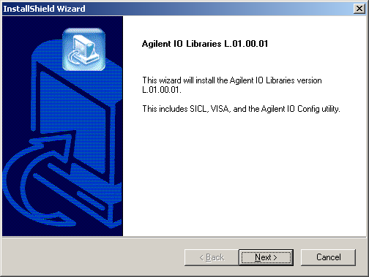
Click next.

•Now the license agreement will appear. Click yes to accept terms.

•The next window shows the readme information. Click next.

•After the readme information, you will see a window asking you to choose between a “full installation” and a “custom installation”. Choose Full installation
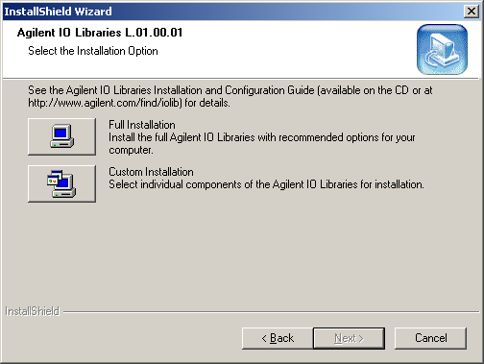

•Next you will see a window showing the components to be installed. Click next. A new window will appear showing setup status.

•After all of the components have been installed you may be asked to restart. If so, hit yes. After you restart, or immediately after the installation window if you didn’t have to restart, you will see a “Successfully Installed” window. Leave the two checkboxes unchecked and click finish. An icon saying “IO” will appear in your system tray.

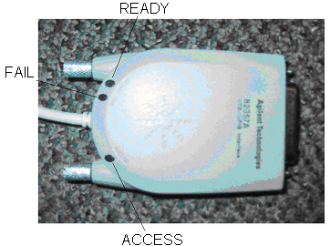

2) Install the hardware
•Plug the USB connector into any available USB port on your laptop. Do NOT connect the 82357A to any GPIB instruments yet. Initially, only the red FAIL light will be on. After a few seconds, the other two lights should come on unless you are running Windows XP. If you are running Windows XP and all three lights are not on follow the instructions below. Otherwise, skip to step 3.

For WindowsXP only
•For Windows XP you may have to go through the “Found New Hardware Wizard.” This window will pop up automatically.

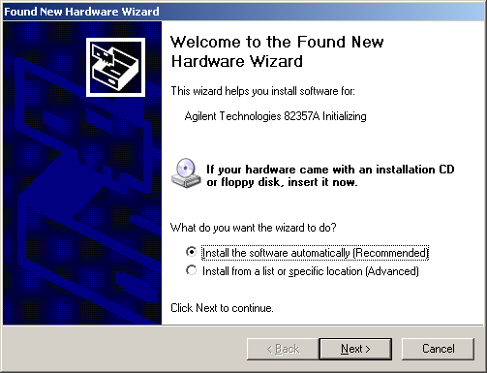
•Ignore the message telling you to put the installation CD in. Select “Install the software automatically” and click next. A new window will appear showing setup status.

•After Windows has finished installing the device, click finish.

•Another “Found New Hardware Wizard” window will appear. Again, select “Install the software automatically” and click next.

•This time a window will pop up telling you that the hardware “…has not passed the Windows Logo testing…” Just click continue anyway. After the install wizard is done installing, click finish.

3) Setting the address
Next, a window will pop up looking like this:
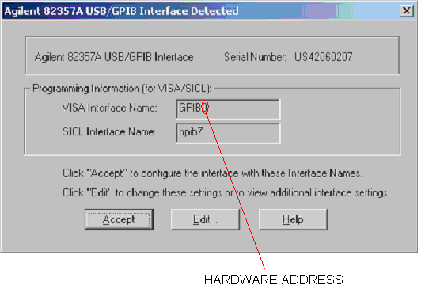
•The program that does the data collection assumes a certain hardware address for your interface device. The number at the end of the “Visa Interface Name” is the address that the program uses to access devices. If this address is wrong your laptop won’t be able to find any of the equipment it’s supposed to be reading data from. If you don’t know what address the program is assuming, check with the writer of the program (probably your instructor). If the address is already correct, just hit accept and you are done.

•If you need to change the address, hit edit. The following window will appear.
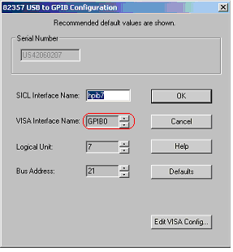
•The box for the VISA Interface Name is grayed out so you won’t be able to edit it directly, but you can change the address number by hitting the up and down arrow next to the box until the correct address number is displayed.

4) Connecting GPIB instruments
- To connect a single GPIB instrument, simply plug the 82357A GPIB connector into the GPIB port on the instrument. An example is shown in the picture below.
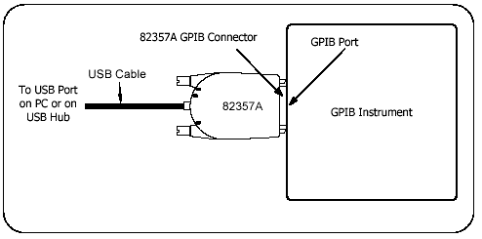
- To connect multiple GPIB instruments, first connect all of the GPIB instruments together using GPIB cable connectors. Then connect the 82357A GPIB connector to any of the GPIB cables. This is demonstrated in the diagram below. Note: Since multiple GPIB Instruments can be connected together, the 82357A does not have to be “piggy backed” to the first instrument, you can attach it to any of the instruments.
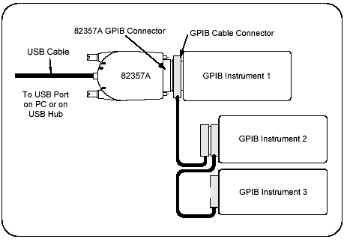

5) Establishing Instrument Communication
- An IO utility called VISA Assistant was also installed on your PC when you installed the Agilent IO Libraries. This IO utility can be used to verify communication between the instruments and your PC. To run VISA Assistant, click on the blue IO icon in the taskbar. Then click Run VISA Assistant. Note: all instruments must be turned on before running VISA Assistant
- A screen will pop-up and on the left hand side should be a column listing the GPIB instruments. Highlight the instrument to be addressed and select the “Formatted I/O” Tab.
- On the bottom right side under Inst. Lang. change the setting to IEEE 488.2. 3 new buttons should appear now on the right hand side.
- Click the *IDN? Button and the GPIB Instrument String will appear on the screen.
- To address additional instruments, just highlight the next instrument in the column on the left hand side of the screen and repeat the following steps.

6) Configuring an Instrument in VEE
- Once Agilent VEE Pro is installed on your PC, start the VEE program. Click Start then click Programs and select Agilent VEE Pro
- From the menu bar select I/O and then click on Instrument Manager. The dialog box shown below will appear.
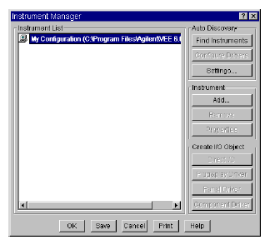
- Click on Find Instruments under Auto Discovery in the column on the right side of the dialog box. Note: The instruments must be turned on.
- At this point, several dialog boxes will appear letting you know that VEE is recognizing the interface and searching for the appropriate instruments. When it is done, the last box will tell you how many instruments are found. If this number does not match with the number of instruments you have, then follow the directions in the next step.
- If all of the instruments were found:
  - Another dialog box will appear titled Identify Instrument. Click Yes for each box (one will appear for each instrument).
  - Now highlight one of the instruments and click on the Properties dialog box under Instrument. Go to the next main step.

If all of the instruments were not found:
  - In the Instrument Manager dialog box, highlight My Configuration. Under Instrument in the right side, click Add. The following Instrument Properties dialog box appears.
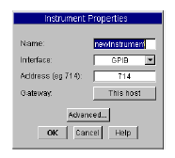
  - Change the name to indicate which instrument you are adding. First change the name to scope and the address for the scope is 707. Note: The first digit represents the logical unit of the interface (GPIB is normally 7) and the last 2 digits are the local bus address of the instrument (range from 0-31). 0 means developing without an instrument present.
- Now click the Advanced button and the Advanced Instrument Properties dialog box will appear as shown. The live mode can be toggled to ON and OFF depending on if you are connected to the instrument at the present time. This is to keep in mind if you wish to write programs without being connected to the instruments.
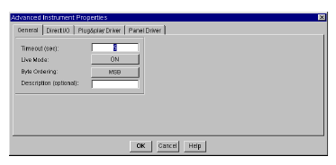
- Now click on the Plug&play Driver folder and this dialog box will appear.
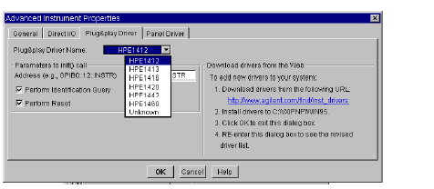

- Drop down the list next to the Plug&play Driver Name to select the correct driver name (the number will correspond with the model number of the instrument). If there is not a driver listed for the instrument, follow the directions on the right side of the dialog box to download new drivers.
- Click OK to return to the Instrument Properties dialog box. Click OK again. Notice that there should now be a new instrument configuration for the instruments you added with the appropriate driver file and bus address.
- Repeat these steps for the additional GPIB instruments, but changing the name, bus address, and driver file to correspond with each instrument. The standardized local bus address for the following equipment are as follows:
DC Power Supply 05
Multimeter 22
Function Generator 10
Oscilloscope 07
- Finally, Click Save and this will close the Instrument Manager box.

