Installations Instructions for the Agilent USB/GPIB Interface

Amanda Martin and Bruce Ferguson, Summer 2002

This document will guide you through the process of setting up your laptop computer to interface with the instruments in the laboratory for control and data acquisition. You will be stepped through the process of installing drivers and components, and then testing the setup to recognize attached equipment.

The software you install will allow you to interface with any General Purpose Interface Bus (GPIB or IEEE 488.2) equipment in the EE labs using Agilent VEE software. While the installation is applicable for any ECE labs at RHIT, these instructions refer specifically to equipment in D115. Some modification may be required for other equipment or labs.

Introduction
The lab bench setup in D115 consists of several instruments useful in making the usual lab measurements. Some of this equipment is connected on a GPIB network bus to allow for communication between equipment and for computer interfacing. The system configuration is as shown below. Note that the Tektronix analog scope and spectrum analyzer are not GPIB connected.

Laboratory setup showing GPIB connected equipment

Installation Instructions
These instructions will set up your computer for instrument interfacing. You should read these instructions carefully and follow the steps precisely. Note especially the notes at the end of this document, which will help you as you use this software for labs other than D115.

You will complete the following steps in this installation:
  - Installation of the GPIB instrument interface software
  - Installation of appropriate instrument drivers
  - Installation of VEE run-time module for running programs
  - Configure the software to find the attached equipment
  - (Optional) Installation of the VEE programming environment

The first four steps get you ready for using ready-made programs for data acquisition. Should you wish to investigate VEE, for example to modify the programs or write your own, you are encouraged to complete the optional step and install VEE. RHIT has several network licenses which you can use to develop your own VEE programs.

Before you begin, check that the following requirements are met by your laptop
- Requires Windows98SE or newer
- Requires a USB or USB2 port
- You will need access to the network
- You will need to have your computer connected to AC power to prevent battery drain
- Do NOT have the device USB cable plugged in to your computer to start with

  - Login: The installation of this software requires administrator privileges. If you laptop was setup by IAIT, you can log in as “localmgr” to have those privileges.

  - Software Installation:
- From the start button menu, select run. In the text box type the network directory \\tibia\public\Apps\Agilent\EC300. Run the installation package “Agilent Win XP.exe”. This will install the IO software that allows your Windows XP computer to communicate via GPIB.
- From the same network directory, run each of the instrument drivers packages to install the plug-n-play drivers used to talk to the instruments (5462xx.exe, 33120a.exe, 33250a.exe, 34401.exe,a nd e3631a.exe). This will install the software drivers which allow your computer to communicate with the bench equipment via GPIB.
- Your computer now has the basic IO software installed for you to run VEE run-time modules.

  - Connect to instruments (Moench D115)
- Turn on each the five instruments at your bench.
- Locate the USB cable attached to the Agilent AG 82357 USB/GPIB interface. The interface box is shown below.
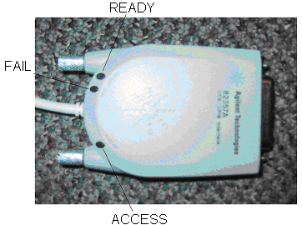

Agilent AG 82357 USB/GPIB interface

- Plug the USB connector into any available USB port on your laptop. Initially, only the red FAIL light will be on. After a few seconds, the other two lights should come on. You are now ready to communicate with the instruments.

  - Setting the address
After plugging in the USB interface cable the “Interface Detected” window will pop up:

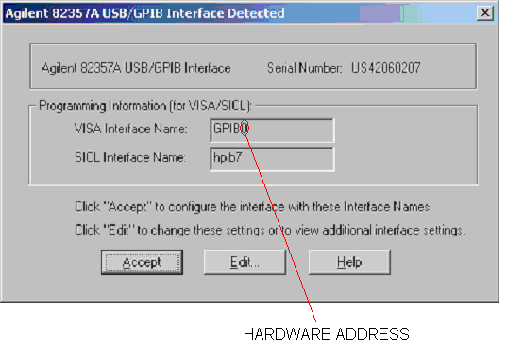
- The program that does the data collection assumes a certain hardware address for your interface device. The number at the end of the “Visa Interface Name” is the address that the program uses to access devices. If this address is wrong your laptop won’t be able to find any of the equipment it’s supposed to be reading data from. The default value assigned to the device is GPIB0, and this number will work fine in this lab. If you don’t know what address the program is assuming, check with the writer of the program (probably your instructor). If the address is already correct, just hit accept and you are done.

- If you need to change the address, hit edit. The following window will appear.

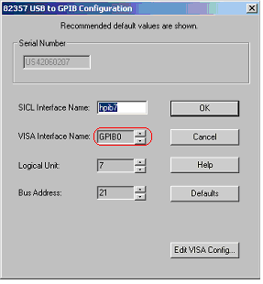

- The box for the VISA Interface Name is grayed out so you won’t be able to edit it directly, but you can change the address number by hitting the up and down arrow next to the box until the correct address number is displayed.

  - Establishing Instrument Communication
- An IO utility called VISA Assistant was also installed on your PC when you installed the Agilent IO Libraries. This IO utility can be used to verify communication between the instruments and your PC. To run VISA Assistant, click on the blue IO icon in the taskbar. Then click Run VISA Assistant. Note: all instruments must be turned on before running VISA Assistant
- A screen will pop-up and on the left hand side should be a column listing the GPIB instruments. Highlight the instrument to be addressed and select the “Formatted I/O” Tab.
- On the bottom right side under Inst. Lang. change the setting to IEEE 488.2 (the name of the standard describing GPIB). 3 new buttons should appear now on the right hand side.
- Click the *IDN? (Identify Instrument) Button and the GPIB Instrument ID String will appear on the screen.
- To address additional instruments, just highlight the next instrument in the column on the left hand side of the screen and repeat the preceding steps.

Congratulations – you are now ready to communicate with your lab equipment!

Notes
1. As long as you use the same GPIB/USB interface box, this installation will be sufficient. If you switch interface boxes, such as sitting at a different lab station or working in another lab, you will be using a different interface. When you plug in the USB cable to your laptop, windows will begin the found new hardware wizard for the interface box. Don’t panic, it seems to be normal. Just accept the defaults in the windows and you will be ready to go.

2. If you wish to use a different piece of equipment, you will need to install drivers for that piece. The drivers are available from the Agilent web site at http://ftp.agilent.com/pub/mpusup/vxipnp/index.html. These drivers install as a regular windows software item, so download the executable file and install the software. VEE will then have access to these drivers.

