Lab Project 3
Modulation and Receiver Front End

Purpose
To modulate a 40 kHz carrier with the pseudorandom “data.”
To design, construct, and test a bandpass filter “RF” stage for the receiver.

Equipment

Agilent 33120A Function Generator
Agilent E3631A Power Supply
Agilent 34401A Multimeter
Agilent 54625 Oscilloscope

TL072 Op Amp
2 2N3904 Transistors
Resistors & Capacitors
Transmitter & Receiver Breadboards

Background
Fig. 1 below shows a Dual-Amplifier bandpass filter circuit. This circuit is an active filter, so called because it contains an active element (op-amp). There are certain advantages to active realizations of filters:
- No inductors are needed.
- The filter can also amplify.
There are also disadvantages:
- A power supply is needed.
- A high-order circuit may require many active devices.
- Filter performance may be sensitive to variations in the component values.
+
+
-
+
-
1
2
3
4
8
U1a
U1b
U1: TL072
6
5
7
+12 V
-12 V

v_{in}

Figure 1. Dual-Amplifier Bandpass Filter
The Dual-Amplifier bandpass filter circuit has the transfer function

where ω₀ and Q are the “center” frequency and the “Q,” respectively, of the bandpass filter, and K is related to the midband gain. More specifically, if we substitute s = jω₀, then the midband gain is given by , and the 3 dB bandwidth is given in radians/s by . The Dual-Amplifier circuit is a second-order bandpass filter, which is adequate for our purpose. For more exacting applications, higher order filters can be produced by cascading Dual-Amplifier circuits. Then, by careful choice of the center frequency and Q of each stage, we can create Butterworth and Chebyshev filters.

Now a circuit analysis of the Dual-Amplifier BPF, which is not beyond your capability, shows that

,

so that and .

Prelab
- Define the terms ω₀, Q, and BW in the discussion above.
- Design a Dual-Amplifier bandpass filter having a center frequency between 35 kHz and 40 kHz and a Q of about 10. (Also, the bandwidth must be at least 1 kHz, but it will be difficult to implement the filter if you try to make the bandwidth this small.) Use standard resistance and capacitance values in your design. Show the steps in your design process, and include a clean schematic diagram, complete with pin numbers, U-numbers, power supply connections, and component values.
- Calculate the expected center frequency, 3 dB bandwidth, and midband gain of your filter. Plot the frequency response (H in dB) vs f on a log scale, and indicate these calculated quantities on your plot. Tape the plot in your notebook.
- Simulate your design in PSPICE to verify that your design works with actual component values. Tape the frequency response curve into your lab notebook. Indicate the values from Problem 3 on your plot, and estimate the filter Q from your plot.
- Compare your results from theory and simulation.

Procedure
1. Draw a block diagram of the full system as it will exist at the end of today’s lab. Sketch the waveforms at the output of each block in the system. Explain the purpose of each block.

2. Band Pass Filter. Wire up the bandpass filter on your receiver breadboard. Locate it just to the right of the current-to-voltage converter. Use the function generator and the DMM to obtain the frequency response of your filter. (See the lab webpage for a suggested technique.) From the frequency response plot determine the center frequency, 3 dB bandwidth, and midband gain. Compare your lab results to your prelab results.

3. Transmitter Carrier. Use the Function Generator as a carrier oscillator. Drive the infrared LED using the function generator, as shown in Fig. 2.

Funct. Gen.
R_{d}
+

Figure 2. Carrier Transmitter

Set the function generator to produce a square wave at a fundamental frequency of about 40 kHz. Set the voltage levels so that the square wave switches between zero and five volts when the diode and resistor are connected as a load, as shown above.

Place the transmitter LED and the receiver phototransistor about two feet apart. Be sure that you can observe the carrier at the output of the current-to-voltage converter. Now connect the Dual-Amplifier bandpass filter to the output of the current-to-voltage converter. Carefully tune the function generator frequency to maximize the bandpass filter output. You may have to reduce the gain of the current-to-voltage converter to avoid overdriving the bandpass filter. Record and verify the output of your BPF. Record your observations and any circuit modifications you make. Be sure that your notebook contains a complete up-to-date schematic of your system and circuits.

4. Maximum Range. Observe the output of the current-to-voltage converter. How far apart can the LED and phototransistor be separated before you can no longer clearly observe the carrier? (Use your judgment regarding what “clearly observe” means.) Observe the output of the bandpass filter. Now how far apart can the LED and phototransistor be separated and still produce a clearly observable signal?

5. Modulation. Remember the pseudorandom sequence generator? Use this as the message signal to modulate a square wave carrier in the modulation circuit shown below in Figure 3. Here, the LED current-limiting resistor has been changed, and two NPN BJTs have been used to allow for modulation of the carrier on the LED current. This implementation was proposed by RHIT students Ryan Kingsbury and Chris Geiger in the Fall of 03-04 as a way to avoid using the function generators, which involves a bothersome setup. If noisy spike arise on your signals, add a 1000 pF cap to ground for each of the input signals.

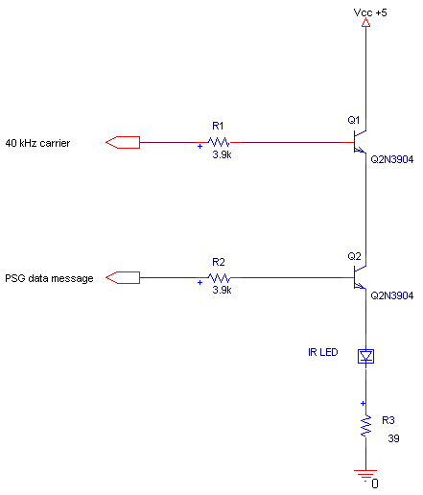
Figure 3. Modulation Circuit.

6. Observe the current driving the LED, and verify that it represents a carrier modulated by your message. You should see the carrier keyed on and off by the pseudorandom “data.” Now, with the transmitter and the receiver one-to-two feet apart, observe the output of the receiver bandpass filter. You should clearly see the modulated carrier. Record your observations. Paste in your notebook a screen capture showing your PSG sequence, the modulated-carrier LED current signal, the output of the bandpass filter for your system, and the data clock.

Report
Your lab notebook is to be handed in at the end of the laboratory session.

Modulation Review

We first learned of modulation in ECE 300, as a property of the Fourier Transform. In Communication Systems, this property becomes the foundation for radio communication, and so we must become adept at its use both in analysis and in the laboratory. We begin with a review of the basics of modulation. We will address modulation more thoroughly later in lecture.

Consider the signal block diagram shown below. A message m(t) is multiplied with a carrier x_{c}(t) to produced a modulated signal x(t). The modulated signal may be considered the transmitted signal.

From basic Fourier Transform theory, we can analyze this problem and review one advantage of using modulation in our lab design. First, consider that both the message and the carrier signal have Fourier Transforms.

Using the modulation property of the Fourier Transform, we find that multiplication in the time domain has an equivalent operation in the frequency domain. Specifically, if the carrier is a sinusoid, then

Note that the notation for describing this process is that the message signal m(t) modulates (modifies) the carrier signal x_{c}(t). In the frequency domain, then, we see that the process of modulation transfers the spectrum of m(t), which was baseband, up to a center frequency of f_{c} Hz.

Why is this important? Well, ambient light will produce a DC photocurrent in our phototransistor, which is as baseband as you can get. Also, there will be various DC bias signals in our circuitry. If our signal energy is at a higher frequency, we can separate the desired signal from DC using a bandpass filter!

