Practical 8 Worksheet
Rose-Hulman Institute of Technology - CSSE 232 Computer Architecture

Names: _______________________________________________________________________ Section: ____

NOTE: follow instructions on the practical web page, it will have more details than this document.

Memory Instructions
1.1 (1 points) – Trace an memory instructions on this datapath. Include indications of the relevant control signals moving through the pipe.
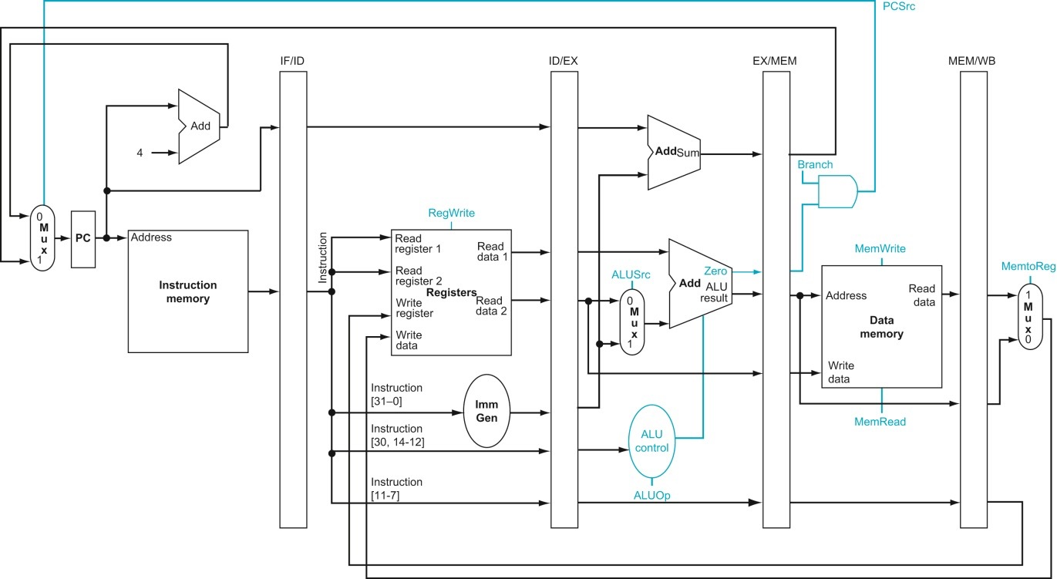

3.5 (4 points) Testing plan. Use the template below to describe one of the provided tests which will show that your datapath executes memory instructions correctly. One entry is filled in as an example, you should delete it and add your own content. The second entry in this table should be a new test you create.
Test name/number: R-type 1 – basic add
(line number XXX from test_pipe_rtype_nohaz.asm)

Inputs/code to test:
add x1, x1, x1 //hex: 0x0010 80b3
[Note: this can be more than one line of code for some tests,
You may also want to specify addresses of instructions for some tests.]

starting values:
x1 = 0x0000 0001

Expected output:
After 1 cycle the instruction output of the IF/ID stage register will be = 0x0010 80b3
After 1 more cycle the ID/EX register will output 0x0000 0001 for both “A” and “B”
After 1 more cycle the EX/MEM register will output 0x0000 0002 for “ALUout”
After 1 more cycle the MEM/WB register will output 0x0000 0002 for “ALUout”
After 1 more cycle Reg[1] will be 0x0000 0002

Description/Justification for test:
This tests a simple addition operation.
This is a baseline for normal operation in each stage of the pipe.

Test name/number: [Put your new test here]

Inputs/code to test:

Expected output:

Description/Justification for test:

3.5 (1 points) Justify why the provided tests are sufficient to detect errors for basic memory functionality.

lui
2.1 (1 points) – Trace a lui instruction on this datapath. You may need to add hardware. Indicate relevant control signals being passed through the pipe.

2.4 (4 points) Testing plan. Use the template below to describe one of the provided lui tests, and a new test of your own design.
Test name/number:

Inputs/code to test:

Expected output:

Description/Justification for test:

Test name/number:

Inputs/code to test:

Expected output:

Description/Justification for test:

2.4 (1 points) Explain why the provided tests are sufficient to test I-types, or explain how you improved the test bench and why

branches
3.1 (1 points) – Trace a beq instruction on this datapath. You may need to add hardware. Indicate relevant control signals being passed through the pipe. Indicate all control signals that will be relevant for any branch instruction, (you don’t need to trace the others, just make sure all the signals you need are listed).

3.4 (6 points) Testing plan. Use the template below to describe one of the provided beq tests, one provided bge test, and a new test of your own design for any branch instruction.
Test name/number:

Inputs/code to test:

Expected output:

Description/Justification for test:

Test name/number:

Inputs/code to test:

Expected output:

Description/Justification for test:

Test name/number:

Inputs/code to test:

Expected output:

Description/Justification for test:

3.4 (1 points) Explain why the provided tests are sufficient to test I-types, or explain how you improved the test bench and why

jumps
4.1/5.1 (1 points) – Trace both a jal instruction and a jalr instruction on this datapath. You may need to add hardware. Indicate relevant control signals being passed through the pipe.

4.3/5.3 (6 points) Testing plan. Use the template below to describe one each of the provided jal and jalr tests, and a single new test of your own design.
Test name/number:

Inputs/code to test:

Expected output:

Description/Justification for test:

Test name/number:

Inputs/code to test:

Expected output:

Description/Justification for test:

Test name/number:

Inputs/code to test:

Expected output:

Description/Justification for test:

4.3/5.3 (1 points) Explain why the provided tests are sufficient to test I-types, or explain how you improved the test bench and why

Custom tests
6.1 (5 points) You need to write a test plan to test all the RISC-V instructions in the same program. Start by describing your test using the test plan format below. Your test will include more than one instruction in the “code to test” section. Your test should cause no hazards.

Test name/number:

Inputs/code to test:

Expected output:

Description/Justification for test:

6.2 (2 points) Why have all the provided tests (and the new test you just wrote) avoided any dependencies? (e.g. What would happen if we wrote tests that contain hazards?)

General Practical Questions:
- (Need) (2 points) Do you think that you “need” to write a testing plan and tests as part of a project like this? Explain why or why not.

- (Performance) (1 points) The practical description suggests that you use one memory module and split the “A” and “B” ports between the Fetch and Memory stages of the pipe. If you don’t do this, explain what modifications you’d need to make to the processor. Discuss the performance implications of these modifications. (Hint: What is the “bottom” address of the data memory segment?)

- (Correctness) (6 points)
Is it always necessary to test every possible combination of inputs for a software project? Why or why not? Include a link to one source you use to justify your testing philosophy. You should discuss the implications of this source. (Your answer to this question can be longer than the usual 100 word limit, but don’t write more than a page!)

- (Iteration) (1 points)
Why do you think the practicals have had you add one instruction at a time? Did you ever break this plan (e.g. by adding extra outputs from control early)? Discuss why you did that and if you think it was okay.
- What is the git commit ID for your final commit of your code. This is required to pass the assignment. Check Practical 1 for instructions on how to get the correct commit ID.

