Practical 7 Worksheet
Rose-Hulman Institute of Technology - CSSE 232 Computer Architecture

Names: _______________________________________________________________________ Section: ____

NOTE: follow instructions on the practical web page, it will have more details than this document.

R-Types
1.1 (2 points) – Trace an R-Type instruction on this datapath.
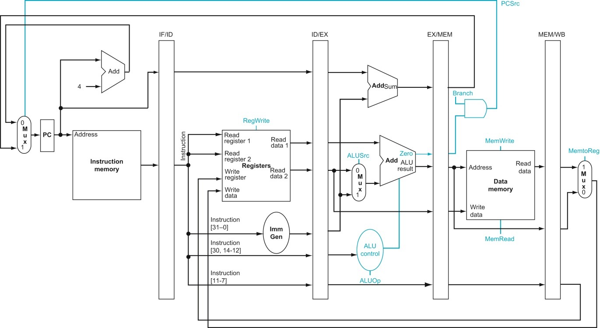

3.4-5 (5 points) Testing plan. Use the template below to describe one of the provided tests which will show that your datapath executes R-types correctly. One entry is filled in as an example, you should delete it and add your own content. The second entry in this table should be a new test you create.
Test name/number: R-type 1 – basic add
(line number XXX from test_pipe_rtype_nohaz.asm)

Inputs/code to test:
add x1, x1, x1 //hex: 0x0010 80b3
[Note: this can be more than one line of code for some tests,
You may also want to specify addresses of instructions for some tests.]

starting values:
x1 = 0x0000 0001

Expected output:
After 1 cycle the instruction output of the IF/ID stage register will be = 0x0010 80b3
After 1 more cycle the ID/EX register will output 0x0000 0001 for both “A” and “B”
After 1 more cycle the EX/MEM register will output 0x0000 0002 for “ALUout”
After 1 more cycle the MEM/WB register will output 0x0000 0002 for “ALUout”
After 1 more cycle Reg[1] will be 0x0000 0002

Description/Justification for test:
This tests a simple addition operation.
This is a baseline for normal operation in each stage of the pipe.

Test name/number: [Put your new test here]

Inputs/code to test:

Expected output:

Description/Justification for test:

3.6 (2 points) Justify why the provided tests are sufficient to detect errors for basic R-type functionality.

I-Types
5.1 (2 points) – Trace an I-Type instruction on this datapath.

5.4 (5 points) Testing plan. Use the template below to describe one of the provided I-type tests, and a new test of your own design.
Test name/number:

Inputs/code to test:

Expected output:

Description/Justification for test:

Test name/number:

Inputs/code to test:

Expected output:

Description/Justification for test:

5.6 (2 points) Explain why the provided tests are sufficient to test I-types, or explain how you improved the test bench and why

General Practical Questions:
- (Need) (3 points)
What is the “need” for a pipelined processor? Should all implementations of RISC-V be pipelined?

- (Performance) (5 points)
Assume the cycle time of your single cycle processor is 8ns, assume the cycle time of your pipelined processor is 2ns. Assume there are no hazards in the code described below.
  - How long would each processor take to execute a program that is only 1 instruction long? Report your answer both in number of cycles and number of seconds.

  - How long would each processor take to execute a program that is 100 instructions long? Report your answer both in number of cycles and number of seconds.

  - Explain in your own words why pipelined processors have a faster execution time for most programs.

- (Correctness) (2 points)
What is the point of having a Testing Plan for your processor before you start testing?

- (Iteration) (2 points)
Describe one error you uncovered because of the tests provided or tests you added.
- What is the git commit ID for your final commit of your code. This is required to pass the assignment. Check Practical 1 for instructions on how to get the correct commit ID.

