Practical 6 Worksheet
Rose-Hulman Institute of Technology - CSSE 232 Computer Architecture

Names: _______________________________________________________________________ Section: ____

NOTE: follow instructions on the practical web page, it will have more details than this document.

RTL (Parts 1-3): (5 points)

RTL for lui

RTL for jal

RTL for jalr

New Instruction (Part 4)
- (2 points) Describe your new instruction and show an example of how a programmer would use it.

- (1 point) Draw the instruction format, indicating purpose of each field and number of bits (like on the green sheet):

- (2 points) RTL for your new instruction

- (2 points) Add your new instruction to the datapath below.

Datapath for tracing and labeling during parts 1-4.
(5 points – for the edits to the core RISC-V instructions) We recommend printing this worksheet and marking it with a pen/pencil or marking this document up with a tablet. (Edits should include support for: lui, jal, jalr, and your new instruction)

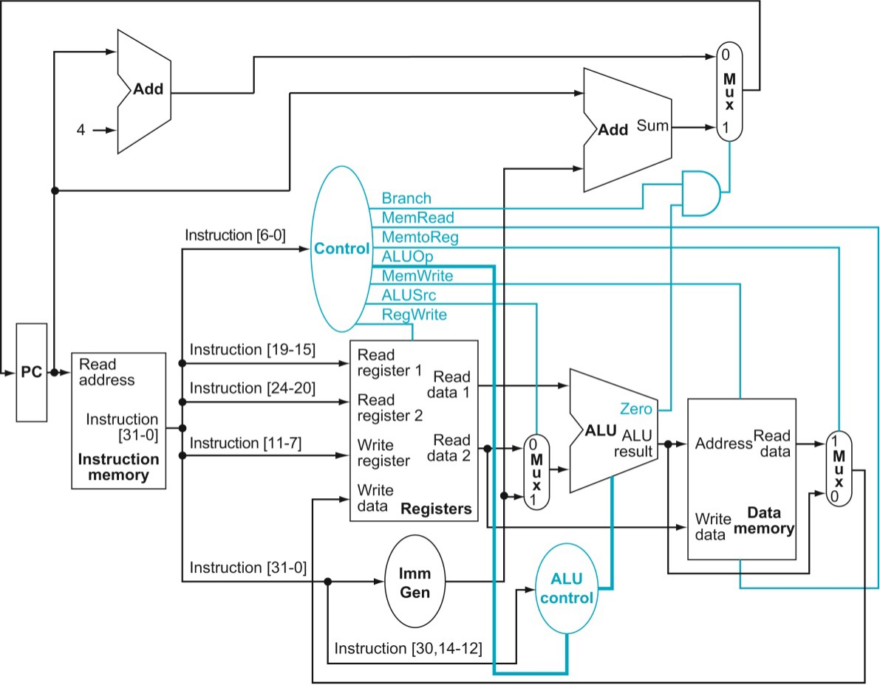

General Practical Questions:
- (Need) (2 points)
Explain how you addressed the timing problem with the link address for jal and jalr. How did you overcome the “PC gets changed to branch target before we save PC+4” dilemma?

- (Performance) (2 points)
Does the addition of your new instruction (part 4) make your processor slower? Explain how you know it doesn’t or why you think it does.

- (Correctness) (2 points)
When you added your new instruction in the last part, how did you make sure you didn’t break the other instructions?

- (Iteration) (2 points)
Describe one error you uncovered because of the tests you wrote.
- What is the git commit ID for your final commit of your code. This is required to pass the assignment. Check Practical 1 for instructions on how to get the correct commit ID.

