Name: ______________________________________

Use this quiz to help make sure you understand the videos/reading. Answer all questions. Make additional notes as desired. Not sure of an answer? Ask your instructor to explain in class and revise as needed then.

Throughout, where you are asked to “circle your choice”, you can circle or underline it (whichever you prefer).

Handout: Counted Loops and Range Expressions
- Write the sequence of numbers that each of the following range expressions generates:
  - range(5) – generates the sequence:
  - range(2) – generates the sequence:
- When the code snippet below runs, what gets printed?
(Show your answer to the right of the box.)
for k in range(3):
print(k, k + 20)
print((k + 1) * 'hello')

- Write the sequence of numbers that each of the following range expressions generates:
  - range(1, 5) – generates the sequence:
  - range(2, 12, 2) – generates the sequence:
  - range(12, 2, -2) – generates the sequence:
  - range(2, 5) – generates the sequence:
  - range(5, 2) – generates the sequence:
  - range(5, 2, -1) – generates the sequence:
Hint: The above yield six different sequences – none of the answers is the same as any of the other answers.

- Write a loop that prints 'funny' 40,000 times.

- Write a loop that prints the cubes of the numbers from 35 to m, inclusive (where m is some integer bigger than 35). For example, if m were 37, then this loop should print:
42875 (which is 35 cubed)
46656
50653

Textbook Reading: Section 1.7 Problem Solving – Algorithm Design (pages 16 – 22) and Section 2.3 Problem Solving – First Do It By Hand (pages 45 – 46).
- Consider the following problem (it is an extension of the problem in Section 2.3):
A row of black, grey and white tiles needs to be placed along a wall, in a pattern like this:

For aesthetic reasons, the architect has specified that the first and last tile shall be black.
Your task is to computer the number of tiles needed, and the gap at each end, given the space available and the width of each tile:
Total width
Gap
Do a by-hand calculation (using reasonable numbers that you choose) that solves this problem (for the particular numbers you choose). Then, write a formula for the general solution based on your by-hand calculation.

Video: Object Oriented Programming (OOP)
- Four computer languages developed in the 1950s dominated early computing. One of them is Lisp. What is the name of one of the other 3 languages then?
Eat cereal
Go to ATM to get $10
Buy milk
Out of milk?
Yes
No
- The diagram shown to the right is part of a: (circle your choice)
  - Poem called Beowulf
  - Rocket ship
  - Garbage can
  - Flowchart

- Procedural decomposition is: (circle your choice)
  - The process by which leftovers become fertilizer for gardens
  - What happens to mummies when they are left out in the open air
  - How great ideas become hollow ones
  - The process of breaking a problem into a sequence of subproblems, with each subproblem given a procedure to solve it, and then breaking those subproblems into sub-subproblems, with each sub-subproblem given a procedure to solve it, and so forth until the problem is reduced to procedures of manageable size.

- The first object-oriented (OO) language was (in some historians’ view) SIMULA, but the most influential of the early OO languages was: (circle your choice)
  - Smalltalk
  - Bigmouth
  - Farsight
  - Giggles

- True or False: Most of the widely-used languages developed
since 1990 have been object oriented languages. True False (circle your choice)

- The procedural programming paradigm focuses on: (circle your choice)
  - Nouns
  - Verbs
  - Adjectives

- The object-oriented programming paradigm focuses on: (circle your choice)
  - Nouns
  - Verbs
  - Adjectives

- True or False: Today’s software engineer typically uses both the
procedural and object-oriented paradigms – there is a place for each. True False
(circle your choice)

- True or False: Python supports both a procedural
and an object-oriented notation. True False (circle your choice)

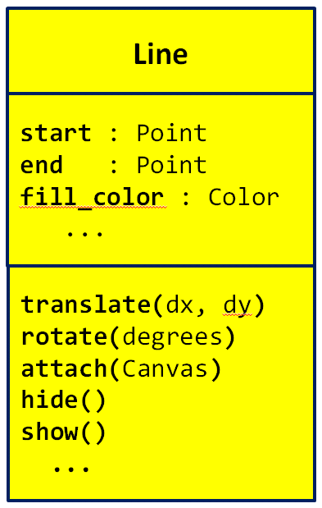
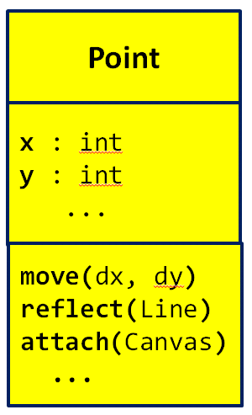
Video: UML Class Diagrams
- The diagrams to the right are called
_________ Class Diagrams, where
________ stands for Unified Modeling Language. (Fill in both blanks with the (same) 3-letter acronym for Unified Modeling Language.)
- Consider the 2 UML class diagrams shown above and to the right. What are the names of the two classes shown?

- Consider the UML class diagram for the Point class shown above. For that class:
  - What are the names of the two instance variables (fields) that are shown?

  - What do you think that those fields represent? (You can’t tell this authoritatively from the UML class diagram; just make your best guess based on the names of the fields.)

  - How many methods are shown?
  - How many parameters does the move method require?
  - How many parameters does the reflect method require?
  - How many parameters does the attach method require?
  - What kind of thing is the reflect method’s parameter?
  - What kind of thing is the attach method’s parameter?
- Consider the UML class diagram for the rg.Line class shown above. For that class:
  - What are the three instance variables (fields) that are shown?

  - How many methods are shown?
  - How many parameters does the translate method require?
  - How many parameters does the hide method require?
  - What do you think that the rotate method does? What is its parameter for? (You can’t tell this authoritatively from the UML class diagram; just make your best guess based on the names of the method and its parameter.)

Video: Objects and Classes – Using Objects
- What trick do we use in Eclipse to figure out what instance variables and methods an object has?

- What trick do we use in Eclipse to figure out what arguments a constructor or method takes?

- The following examples show two different attempts by two students to construct a new rg.Point at (4, 3). Based on what you learned about constructing objects in Python, which student is correct and why?
# Anna
point_anna=rg.Point
point_anna.x=4
point_anna.y=3
# Dalton
point_dalton=rg.Point(0,0)
point_dalton.x=4
point_dalton.y=3

- rg.Point’s constructor takes an initial x and a y. Thus, both of the above examples are needlessly long. How would you instead construct the point using just one line of code?

- Based on the video, how would you construct an rg.Circle at the point (100,200) with radius 35 and a blue fill color?

- Suppose you are told that an rg.Line’s constructor takes a start and end point as its constructor arguments. What line of code would you write to create a Line between a point called point_mine and a new Point at (0, 5)?

Textbook Reading: Section 2.4 Strings (pages 48 – 51) and Sections 2.5.1 – User Input and 2.5.2 – Numerical input (pages 55-56).
- True or False: One can write string literals like 'Hello' or like "Hello".
That is, one can use single or double quotes
to delimit string literals. True False (circle your choice)
- Suppose that s and t are variables whose values are strings. Write a statement that prints the length of the string s + t + s

- Show the output that appears when the following code snippet runs.
s = 'Bilbo'
n = len(s)
mystery = s[0] + s[n-1]
print(mystery * 4)

- Consider the following statement:
s = input('Enter your name: ')
Write a statement that sets the variable t to the string that is the same as s, except all upper-case. For example, if the human enters Rhonda , so that the value of s is 'Rhonda', then your statement should make t have the value 'RHONDA'. Likewise, if the human enters gaia , so that the value of s is 'gaia', then your statement should make t have the value 'GAIA'.

- Consider the following statement:
s = input('Enter your name: ')
Write a statement that sets the variable t to the string that is the same as s, followed by an upper-case version of s, followed by a lower-case version of s. For example, if the human enters Rhonda , so that the value of s is 'Rhonda', then your statement should make t have the value 'RhondaRHONDArhonda'.

- Consider the following statement:
s = input('Enter your name: ')
Suppose that the human user enters 43 in response to the prompt for input. What will the value of s + s be in that case? (Hint: the answer is NOT 86.)

- Continuing the previous problem, what if the software developer intended that the value of s + s be 86 if the user enters 43 as the input (and similarly for other inputs). What should the programmer change or add to the statement above?

