Name: ______________________________________

Use this quiz to help make sure you understand the videos/reading. Answer all questions. Make additional notes as desired. Not sure of an answer? Ask your instructor to explain in class.

Video: The Debugger [13:04 minutes]

Note: Don’t try to learn all the details of the Debugger – just breeze through this video to get the ideas, and return to it later as needed. These questions highlight the main points:
- When the coder finds and fixes errors in her code, we call that: _____________________.
- Technically, testing is the process one does after producing the code (or at least after producing its first version), while debugging is what the coder does to find and fix errors while producing the code.
However, we will use the terms debugging
and testing interchangeably in CSSE 120. Yes No (circle your choice)
- True or false: A debugger lets you set a breakpoint and run the program to that point, pausing the execution at the breakpoint. True False (circle your choice)
- True or false: A debugger lets you step
through a program, line by line. True False (circle your choice)
- True or false: A debugger lets you see the values of the variables in your program and how they change as you step through program. True False (circle your choice)
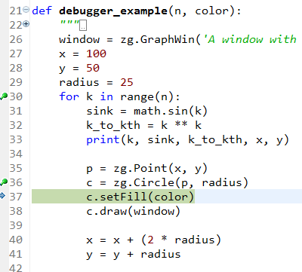
- Examine the code snippet to the right.
  - At what lines have breakpoints been set?
  - At what line is the program currently paused?
  - At this point:
    - Has the program just executed line 37, or
    - Is the program just about to execute line 37?
(Circle your choice.)
- State, very briefly (just a few words for each is enough), what each of the following circled-in-red symbols do in the debugger:
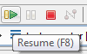
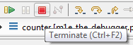
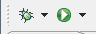

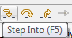
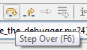
- The Step Into button runs the next statement in the program.
Explain, very briefly:

  - How is the Step Over button different (in what it does) from Step Into?

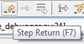
  - How is the Step Return button different (in what it does) from Step Into?

Handout: Functions with Parameters, and Namespaces
- What gets printed when main is called in the program shown below? (Pay close attention to the order in which the statements are executed. Write the output in a column to the right of the program.)
Output

def main():
hello()
goodbye()
hello_and_goodbye()
goodbye()

def hello():
print('Hello!')

def goodbye():
print('Ciao!')

def hello_and_goodbye():
print('Here is stuff!')
goodbye()
hello()
hello()
print('Here is more!')
hello()
goodbye()

- What gets printed when main is called in the program shown below? (Pay close attention to the order in which the statements are executed. Write the output in a column to the right of the program.)
Output

def main():
big()
bigger()
biggest()
big()

def big():
print('basketball')

def bigger():
print('truck')
big()

def biggest():
print('house')
bigger()
big()

- For each of the following boxes:
    - If the code is correct, state what gets printed when main runs.
    - If the code is wrong, explain why.
def main():
x = foo()
print(x)

def foo(m):
return m ** 3
Correct? If so, prints ______________________________
Wrong?
If so, explain why:

def main():
x = foo(m)
print(x)

def foo(m):
return m ** 3
Correct? If so, prints ______________________________
Wrong?
If so, explain why:

def main():
x = foo('help')
print(x)

def foo(m):
return m ** 3
Correct? If so, prints ______________________________
Wrong?
If so, explain why:

- The code in the box to the right has syntax errors: it causes big red X error message(s). Circle the line(s) that will have red X error message(s) beside them and explain why those line(s) will have those Xs.
def main():
foo()
print(n)
print(m)

def foo():
n = 3
m = 1
return m

- Suppose you want to write a function called foo that has two zg.Point objects sent to it and does something with them. Write the “header” line of foo, that is the line that begins with def.

def ___________________________________________________:

- Suppose you want to write a function called blah that takes a zg.Point object and a zg.GraphWin object (in that order) and does something with them. Write the “header” line of blah, that is the line that begins with def.

def ___________________________________________________:

- What gets printed when main is called in the program shown below? (Pay close attention to the order in which the statements are executed. Write the output in a column to the right of the program.)
def main():
a = 2
b = 3

m = do_it(a, b)
print(m)

m = do_it(b, a)
print(m)

m = do_it(a, a)
print(m)

m = do_it(b, b)
print(m)

c = do_it(b, a)
m = do_it(c, a)
print(m)

b = do_it(b, a)
m = do_it(b, a)
print(m)

def do_it(x, y):
return x ** y

Output

- What gets printed when main is called in the program shown below? (Pay close attention to the order in which the statements are executed. Write the output in a column to the right of the program.)

def main():
a = 2
b = 3

foo1()
print(a, b)

foo2(a, b)
print(a, b)

foo3(a, b)
print(a, b)

def foo1():
a = 88
b = 99

def foo2(a, b):
a = 400
b = 500

def foo3(x, y):
x = 44
y = 55

Output

Video: The Accumulator Pattern – Summing [13:04 minutes]
- Trace the following snippet of code by hand (no fair typing it into a program),
and show what gets printed:
What gets printed?

The sum 10 + 11 + 12 + 13 + 14 is

total = 0
for k in range(5):
total = total + (k + 10)
print(k, total)

print('The sum 10 + 11 + 12 + 13 + 14 is')
print(total)

- Write a snippet of code that calculates:
sine(3) + sine(4) + sine(5) + ... + sine(500)

