CSSE 120 – Introduction to Software Development
Concept: Functions with Parameters, and Namespaces

Defining functions
def convert_and_return(celsius):
fahrenheit = ((9 / 5) * celsius) + 32
return fahrenheit
A function is a chunk of code that has a name. Here (to the right) is a portion of an example of the notation for defining a function.
The name of the function follows the keyword def. The variables in the parentheses after the name of the function are called parameters. This function returns a value. (Functions that have no return statement return the special value None.)

Why have functions?
Functions are powerful for 2 reasons:
- They help organize a program into logical chunks. That makes it easier to:
  - Test the program (by testing the chunks, called unit testing).
  - Modify the program (by focusing your interest on the chunks of interest).
  - Write correct code (by understanding the organization of the program).
  - Encapsulate (enclose and hide) the behavior of a function inside its definition, thus separating:
    - the specification (what the function accomplishes) of the function
    - from its implementation (how it accomplishes its specification).
- You can re-use functions. That is, you can call them over and over again, with different values for the parameters to achieve different results.

(continues on the next page)

Calling functions
You call (aka invoke) a function by writing its name followed by parentheses, with the actual arguments placed inside the parentheses.
When you call a function:
- The actual arguments of the function call (the values in the parentheses) are sent into the formal parameters of the function definition.
- Execution continues at the beginning of the definition of the called function.
- When the function’s return statement is executed, the returned value is sent back to the calling function. Or, if the end of the function is reached without a return statement, the special value None is sent back to the calling function.
- Execution continues from the place where the function call appeared, with the returned value replacing the function call.
A function call

def blah():
...
x = number_of_primes(100, 200)
...

def number_of_primes(m, n):
...
...
...
return <the number of primes between m and n>

Step 1
Step 4

Step 3
Step 2

(continues on the next page)

Namespaces and variable’s scope
Today’s programs might have thousands of functions. If we had to think up new variables for each function, we would be in trouble! For that reason, variables are local to the functions in which they are defined. That is, each function call has its own namespace, which means:
- When a function is called, a namespace for its variables is created. The function’s parameters and any variables defined inside the function are placed into the function call’s namespace.
- Variables in one namespace have NOTHING to do with variables of the same name in another namespace. The namespaces are completely independent.
- When a function returns to its caller, its namespace (and all the variables defined in it) is destroyed and no longer available.
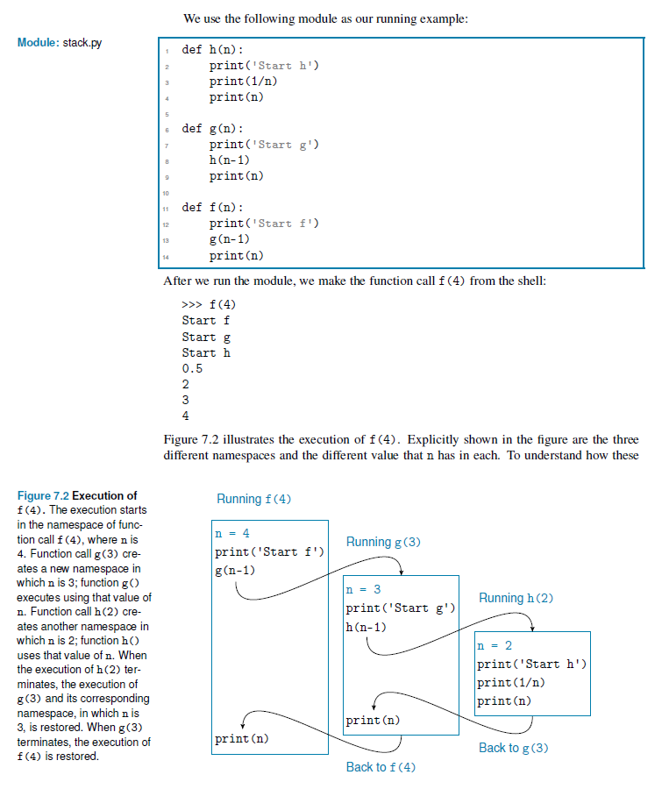
Here is a picture showing the creation of namespaces, from a textbook by Ljubomir Perkovic:

You MUST have the parentheses even when there are no arguments. It is the parentheses that tell the interpreter to call the function instead of just referring to it. Avoid this common mistake: y = blah where you meant y = blah()

