CSSE 120 – Introduction to Software Development (Robotics section)
Concept: Functions with Parameters, and Namespaces

Defining functions
def convert_and_return(celsius):
fahrenheit = ((9 / 5) * celsius) + 32
return fahrenheit
A function is a chunk of code that has a name. Here (to the right) is a portion of an example of the notation for defining a function.
The name of the function follows the keyword def. The variables in the parentheses after the name of the function are called parameters. This function returns a value. (Functions that have no return statement return the special value None.)
Why have functions?
Functions are powerful for 2 reasons:
- They help organize a program into logical chunks. That makes it easier to:
  - Modify the program (by focusing your interest on the chunks of interest).
  - Write correct code (by understanding the organization of the program).
  - Encapsulate (enclose and hide) the behavior of a function inside its definition, thus separating the specification (what the function accomplishes) of the function from its implementation (how it accomplishes its specification).
  - Test the program by testing the chunks. (This is called unit testing.)
- You can re-use functions. That is, you can call them over and over again, with different values for the parameters to achieve different results.
A function call

Calling functions
def blah():
...
x = number_of_primes(100, 200)
...

def number_of_primes(m, n):
...
...
...
return <the number of primes between m and n>
You call (aka invoke) a function by writing its name followed by parentheses, with the actual arguments placed inside the parentheses.
Step 1
Step 4
When you call a function:
Step 3
- The actual arguments of the function call (the values in the parentheses) are sent into the formal parameters of the function definition.
Step 2
- Execution continues at the beginning of the definition of the called function.
- When the function’s return statement is executed, the returned value is sent back to the calling function. Or, if the end of the function is reached without a return statement, the special value None is sent back to the calling function.
- Execution continues from the place where the function call appeared, with the returned value replacing the function call.
Namespaces
Today’s programs might have thousands of functions. If we had to think up new variables for each function, we would be in trouble! For that reason, variables are local to the functions in which they are defined. That is, each function call has its own namespace.
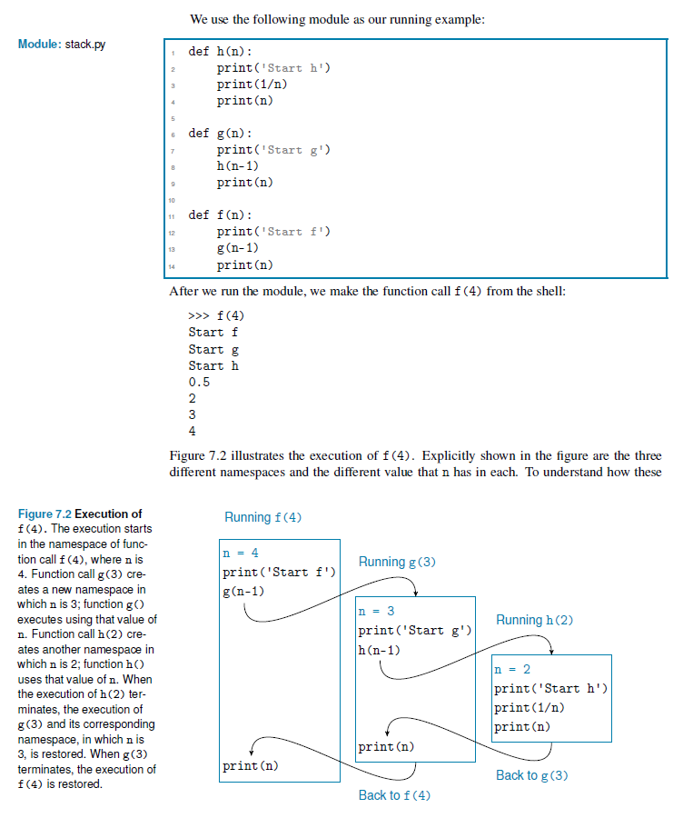
From a textbook by Ljubomir Perkovic:

