CSSE 120 – Introduction to Software Development (Robotics section)
Concept: Using Objects
Objects, Types and Values – and Classes
In Python, every “thing” (that is, every item of data) is called an object.
An object has a type and a value. For example:
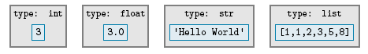
The type of an object determines:
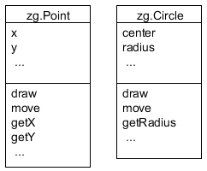
- The kind of thing the object is
- What operations the object can do
You can create your own type, by writing a class. We’ll see the insides of a class later, but for now all you need to know is that a class has:
- A name
- Instance variables (aka fields) – the data that instances of the class hold
- Methods – the operations (functions) that instances of the class can do
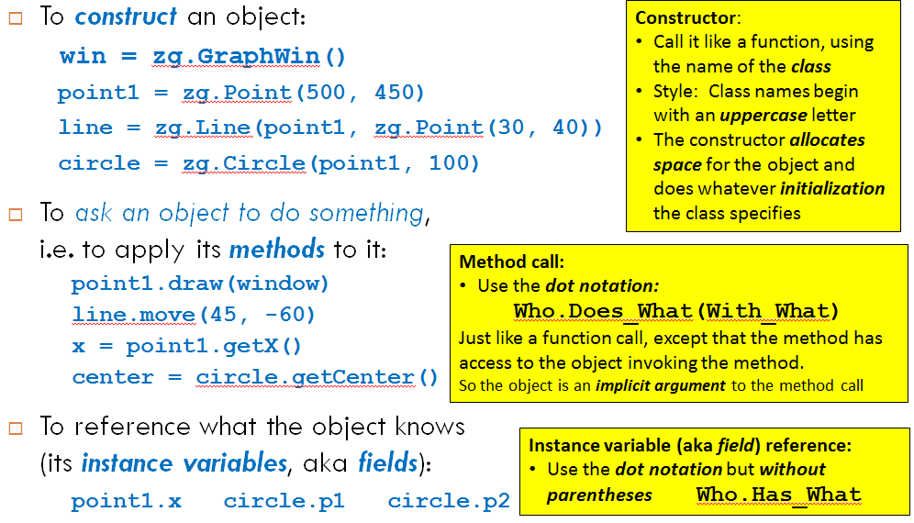
We describe these in a UML Class Diagram, where UML stands for Unified Modeling Language. See the examples to the right.
The 3 Key Ideas for Using Objects

