How to Install the Create robot Simulator
Install the iRobot Create Simulator and its Eclipse plugin, as follows:
  - Install the iRobot Create Simulator by running:
http://www.rose-hulman.edu/class/csse/binaries/iRobotCreateSimulator/iRobotCreateSimulatorSetup.msi
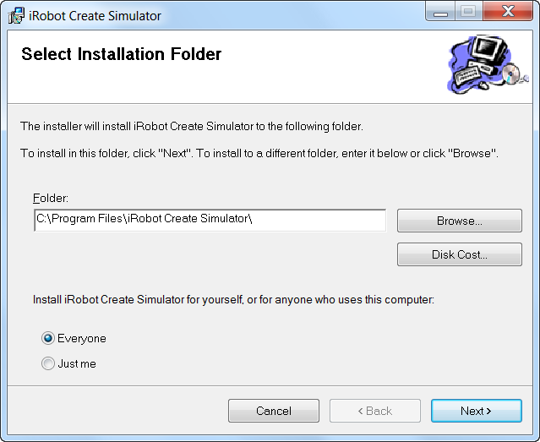
Your browser may warn that “This file is not commonly downloaded and may harm your computer.” Run anyway. (In IE, choose Actions, then More Options, then Run Anyway.)
Important:
- At the Select Installation Folder dialog, check Everyone, as shown to the right.
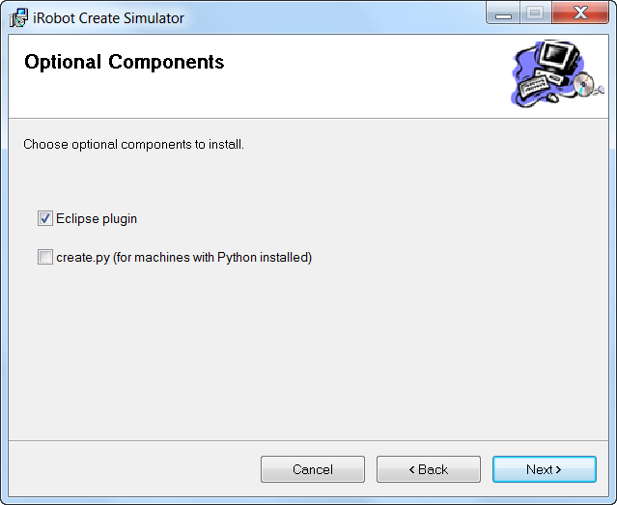
- At the Optional Components dialog:
  - Check Eclipse plugin, but
  - leave create.py UN-checked,
as shown to the right.
The installation will install DirectX if you don’t already have it (it will probably say you already have a more current version, that’s fine.)
  - The above installation created a folder:
C:\Program Files\iRobot Create Simulator
In that folder, create a new subfolder called:
CurrentEnvironment
spelled exactly like that (including capitalization, no spaces).
  - Find the ZIP file:
C:\Program Files\iRobot Create Simulator\Resources\Environments\Default.zip
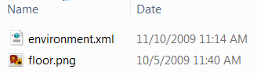
It has two files zipped inside it: environment.xml and floor.png. Extract those two files and put them into the CurrentEnvironment folder that you created in the previous step.
  - Open Eclipse. Choose:
Window ~ Preferences ~ iRobot Create Simulator
Select the Browse button and browse to the simulator itself, which is:
C:\Program Files\iRobot Create Simulator\Roomba Simulator.exe
Press Open to select that file, then OK to exit the Preferences dialog.

You may need to extract them to (say) your Desktop and then drag them into the folder, giving administrative permissions as you do so.

