To obtain the PyDev120 Perspective:
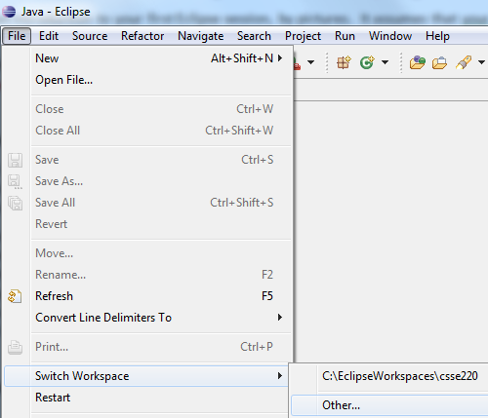
Do this ONLY if you do not already have the PyDev120 Perspective. The Fall 2011 freshman laptops came with it.

Inside Eclipse:
- If you are not already in the
C:\EclipseWorkspaces\csse120
workspace, choose
File ~ Switch Workspace, then Other,
then browse (per the picture below and to the right)
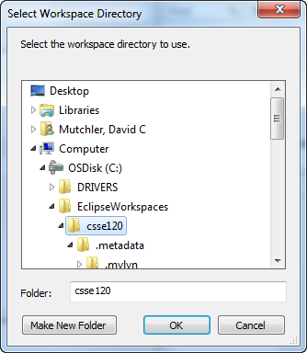
for the C:\EclipseWorkspaces\csse120 folder. Eclipse will then shut down and re-open
in the right workspace.

(If you are not sure what workspace you are in, it does not hurt to switch per the above instructions.)

- Unzip this zipped Eclipse preferences file for csse120:
http://www.rose-hulman.edu/class/csse/binaries/Eclipse/EclipsePreferences-csse120-2011-06-28.zip
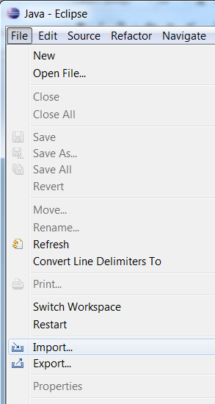
placing its sole unzipped file
(EclipsePreferences-csse120-2011-06-28.epf)
in any convenient place.

- In the Workbench in Eclipse, select:
File ~ Import

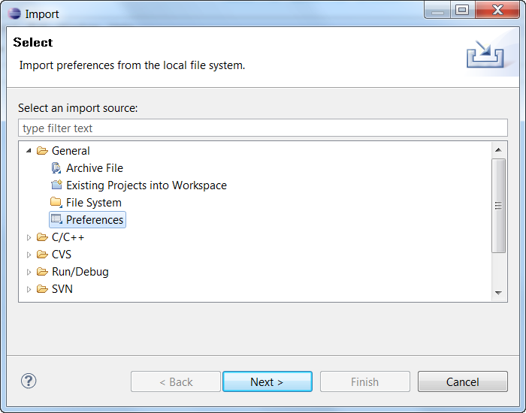
- In the Import dialog that opens, expand General, select Preferences below that, and press Next.

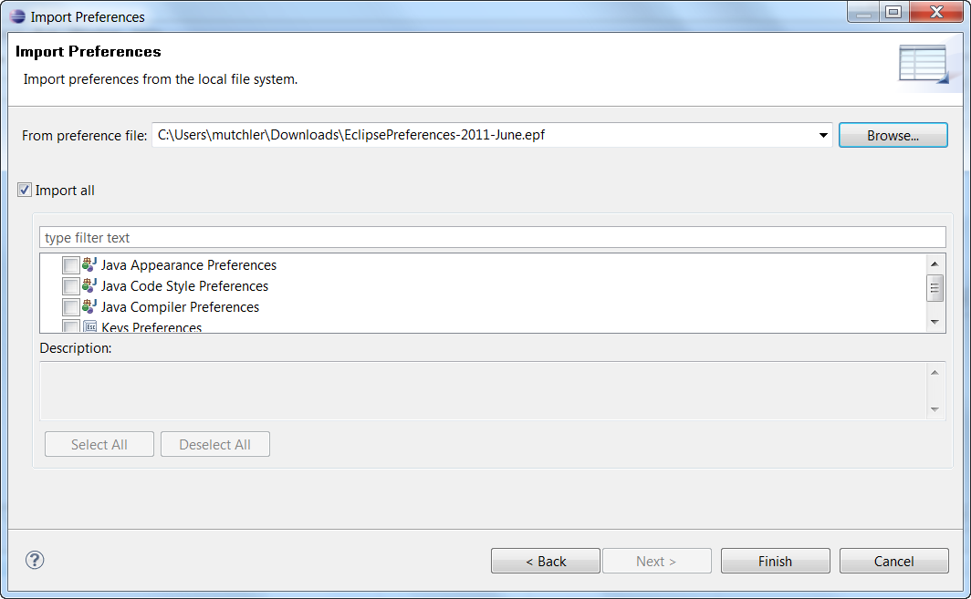
- In the Import Preferences dialog that opens, select Browse and select the EclipsePreferences-csse120-2011-06-28.epf file that you unzipped and saved above.
Back in the Import Preferences dialog, check Import all, then select Finish.

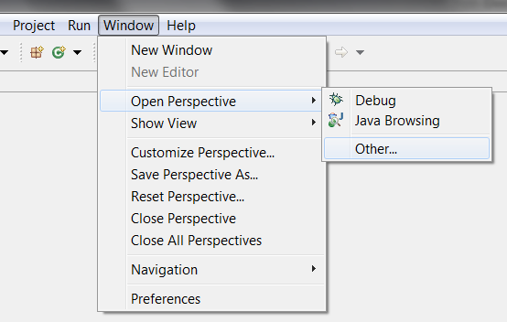
- You can nowchoose:
Window
~ Open Perspective
~ Other
to open the PyDev120 perspective as shown in this and the next picture.
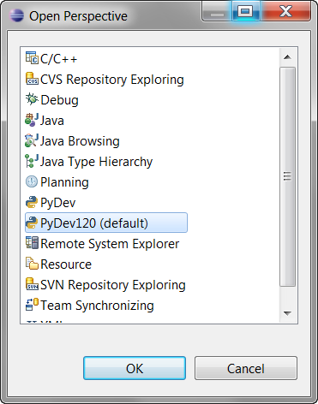

- Continuing the previous step, select
PyDev120 (default)
and then OK to complete opening the PyDev120 perspective.

- If you wish, you can delete the EclipsePreferences-csse120-2011-06-28.epf file that you unzipped and saved above.

