Instructions to IAIT for installing software used in CSSE courses
for 2011-2012 laptops
By Claude Anderson, Madelyn Moulden and David Mutchler
June 29, 2011
Please install the following software in the order listed (other orders will work too, but the order listed is best in some regards).
Once you have installed the software on your test laptop, please let us review it briefly to be sure that we did not miss anything.

Throughout:
- Accept the license agreement but otherwise accept all defaults, unless the instructions below explicitly say otherwise.
- Continue the installation even if the installation indicates potential security problems, for example:
  - If User Account Control asks whether you want to allow the installation program to make changes to this computer, respond Yes.
  - If the installation indicates that you need Administrator privileges, respond Yes.
  - Select Run even if you get a Security Warning that the publisher could not be verified.
- Users (as localmgr or their local account or logged onto Rose-Hulman or whatever) need to read and write to many of the folders that are created. Set permissions appropriately.
You must have internet access for some of the following. These instructions assume a 32-bit installation of Windows 7; many of the programs installed here also have 64-bit versions.

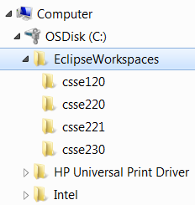
- Folders for CSSE 120, 220, 221 and 230 software projects:
  - Create a folder: C:\EclipseWorkspaces
  - Users need to be able to read and write to this folder and its subfolders. Set permissions appropriately.
  - Create subfolders (that inherit appropriate rights):
C:\EclipseWorkspaces\csse120
C:\EclipseWorkspaces\csse220
C:\EclipseWorkspaces\csse221
C:\EclipseWorkspaces\csse230
Note: We want these folders directly under C: instead of in My Documents because some of the software needs to use workspaces that are in a path that has no spaces.

- Java:
  - Install Java SE 6 Update 26 by running:
http://www.rose-hulman.edu/class/csse/binaries/JavaDevKit/jdk-6u26-windows-i586.exe

  - Install the documentation for the above by unzipping this:
http://www.rose-hulman.edu/class/csse/binaries/JavaDevKit/jdk-6u25-fcs-bin-b04-apidocs-04_Apr_2011.zip
and placing its unzipped docs folder directly below the jdk1.6.0_26 folder
(not the jre6 folder) created by the previous step:
C:\Program Files\Java\jdk1.6.0_26
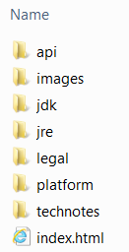
As a double-check,
confirm that you end with a folder:
C:\Program Files\Java\jdk1.6.0_26\docs
that has seven folders and one file beneath it, as shown.

- Python:
  - Install Python 3.2 by running:
http://www.rose-hulman.edu/class/csse/binaries/Python/python-3.2.msi
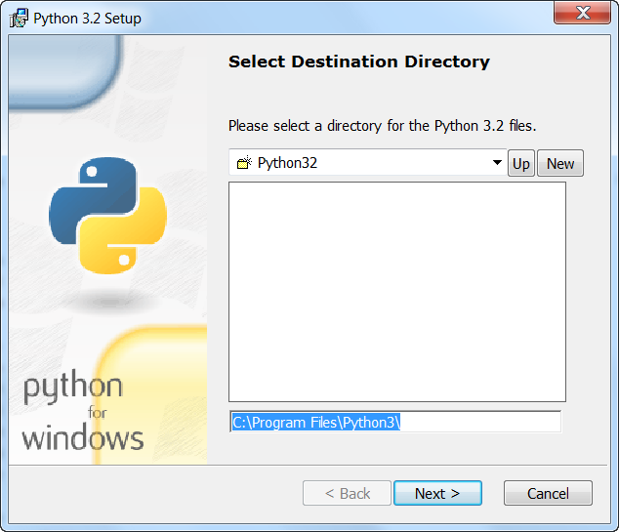
Important: Change the installation folder from the default C:\Python32 to
C:\Program Files\Python3
(Note: just Python3, NOT Python32.)
Other than that (and accepting the license agreement), accept all defaults (including installing for all users).

  - Install pyserial by downloading and saving the following file:
http://www.rose-hulman.edu/class/csse/binaries/Python/serialAndWin32/pyserial-py3k-2.5.win32.exe
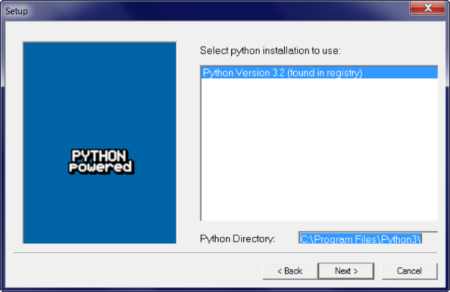
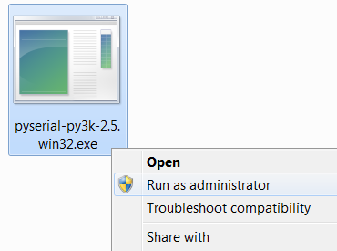
Then right-click on it and select “Run as Administrator” to install. The installation should notice the Python3 folder created by a previous step.
As with all these installation programs, delete them after running them, if you chose to save them on your computer.

  - Install pywin32 by downloading and saving the following file:
http://www.rose-hulman.edu/class/csse/binaries/Python/serialAndWin32/pywin32-216.1.win32-py3.2.exe
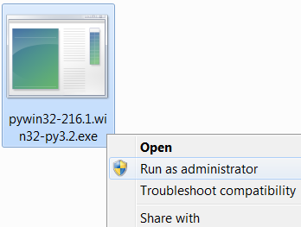
Then right-click on it and select “Run as Administrator” to install. The installation should notice the Python3 folder created by a previous step.

  - Install zellegraphics and pycreate by unzipping this:
http://www.rose-hulman.edu/class/csse/binaries/Python/putInSitePackages.zip
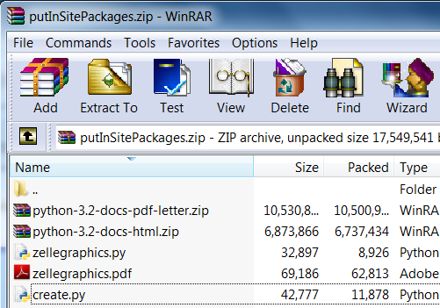

and placing its 5 files into the folder:

C:\Program Files\Python3\Lib\site-packages
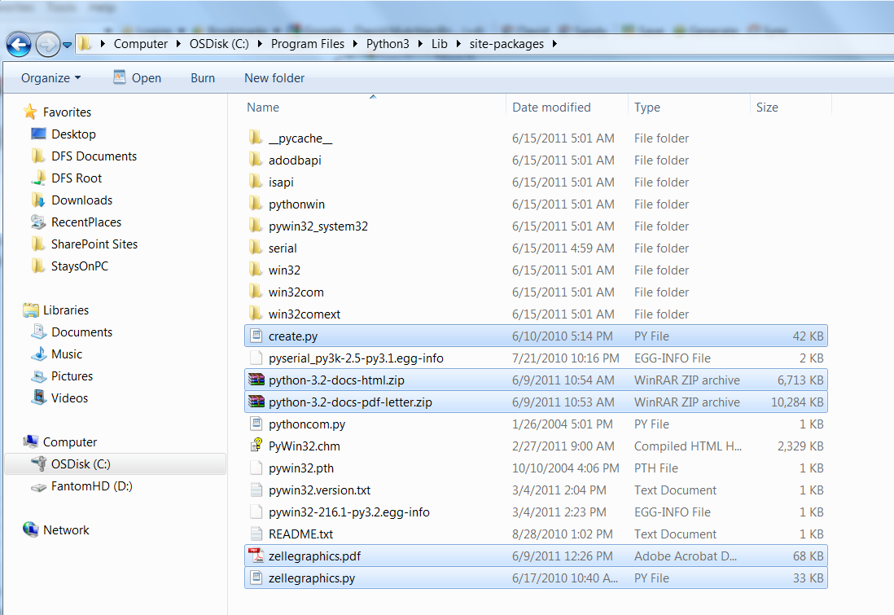

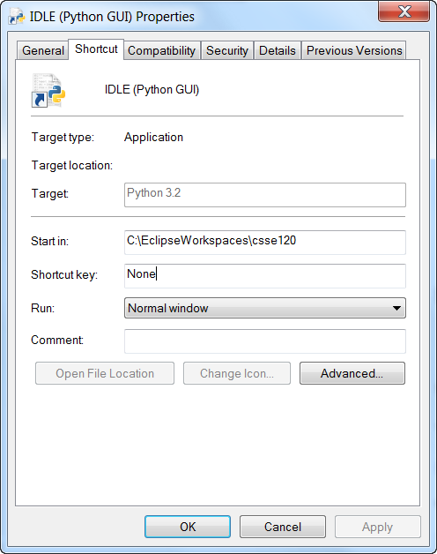
  - Set Python’s IDLE to the correct start-up folder by:
    - From the Start Menu, expand
All Programs ~ Python 3.2.
    - Right-click on IDLE (Python GUI) and select Properties.
    - Set the Start in: field to
C:\EclipseWorkspaces\csse120
- MinGW (for C programming):
  - Install MinGW by running:
http://www.rose-hulman.edu/class/csse/binaries/MinGW/mingw-get-inst-20110530.exe
Your browser may warn that “This file is not commonly downloaded and may harm your computer.” Run anyway. The installation will download various files from the web.
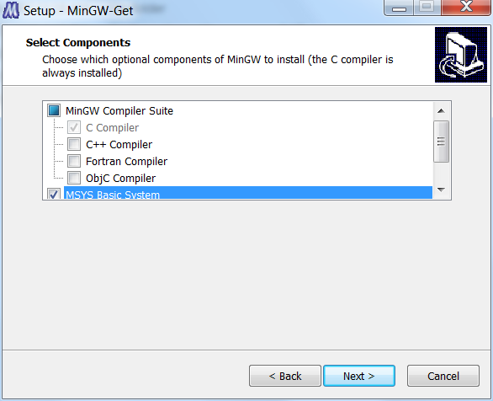
Important:
- Accept the default installation folder of C:\MinGW. The installation instructions strongly recommend using that folder (and not installing inside C:\Program Files).
- At the Select Components dialog, check the
MSYS Basic System, as shown to the right.
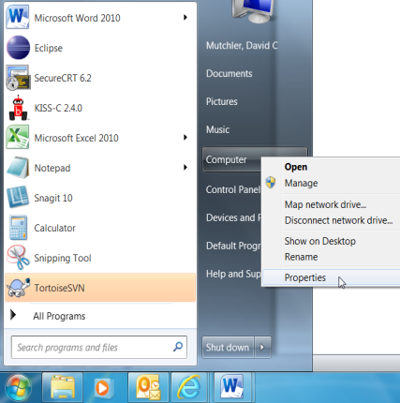
  - Add the C:\MinGW\bin folder to the Windows path variable. One way to do this is:
    - Right-click on Computer in the Start Menu and select Properties.

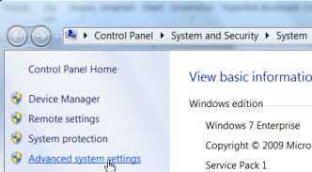
    - Select Advanced Systems Settings.

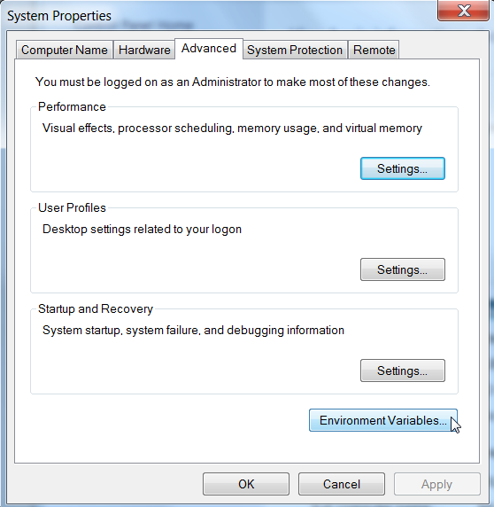
    - In the System Properties dialog that opens, select the Advanced tab, then press Environment Variables on that tab.

    - In the Environment Variables dialog that opens, in the System variables pull-down menu, scroll down and select the Path variable, then select Edit.
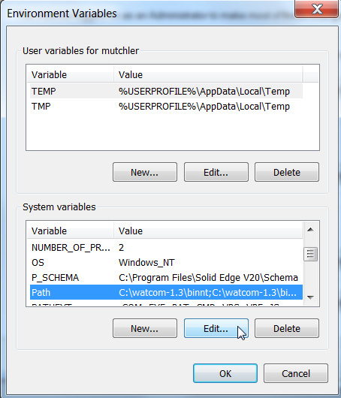
    - Carefully add the following (including the semicolon)
to the end of the Variable value field
;C:\MinGW\bin
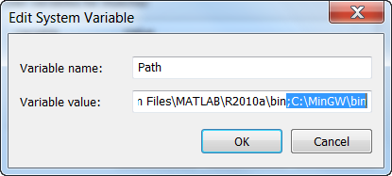
(We suggest using the right arrow key to reach the end of the field.) Press OK as many times as needed to complete the installation.
- Install TortoiseSVN by running:
http://www.rose-hulman.edu/class/csse/binaries/TortoiseSVN/TortoiseSVN-1.6.16.21511-win32-svn-1.6.17.msi
At the end of its installation, it will ask you to restart the computer; do so.

- Eclipse:
  - Install Eclipse by unzipping this:
http://www.rose-hulman.edu/class/csse/binaries/Eclipse/eclipse-java-indigo-win32.zip
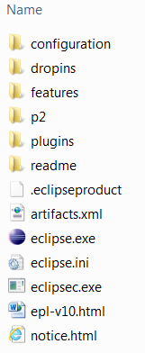
and placing the unzipped eclipse folder directly below:
C:\Program Files

  - Place a shortcut to
C:\Program Files\eclipse\eclipse.exe
in the folder:
C:\ProgramData\Microsoft\Windows\Start Menu\Programs
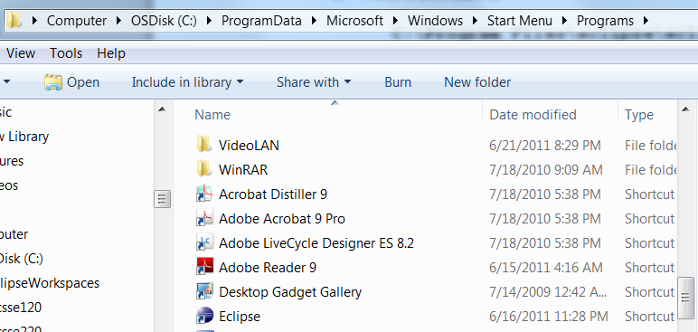
Name the shortcut Eclipse.
This will place it within All Programs of the Start Menu.
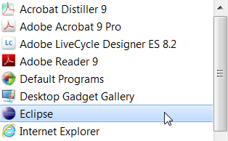

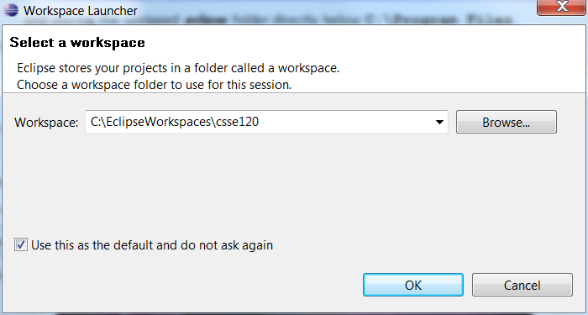
- When you open Eclipse for the first time,
set the workspace by:
  - Open Eclipse.

  - You should see the Select a workspace dialog shown to the right. Do NOT press OK yet. Instead, select Browse.

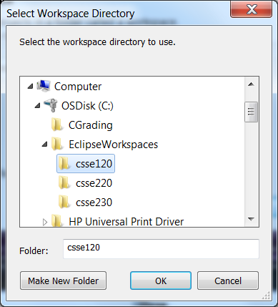
  - In the Select Workspace Directory that opens, select the
C:\EclipseWorkspaces\csse120
folder, as shown to the right.
Press OK to bring you back to the Select a workspace dialog.

  - Check the box labeled “Use this as the default and do not ask again.” Then press OK to continue into Eclipse.

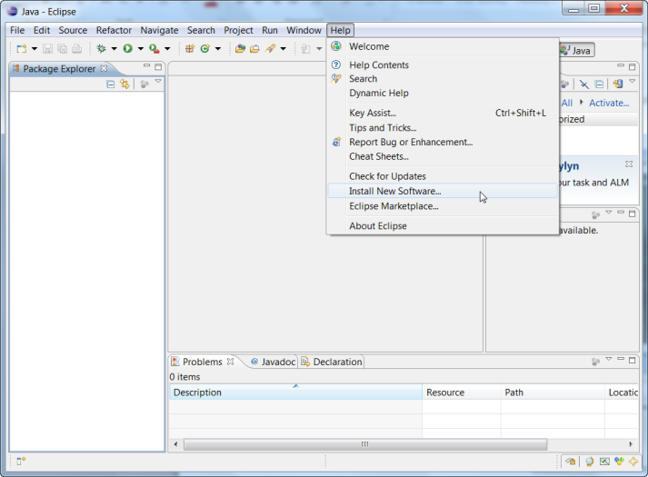
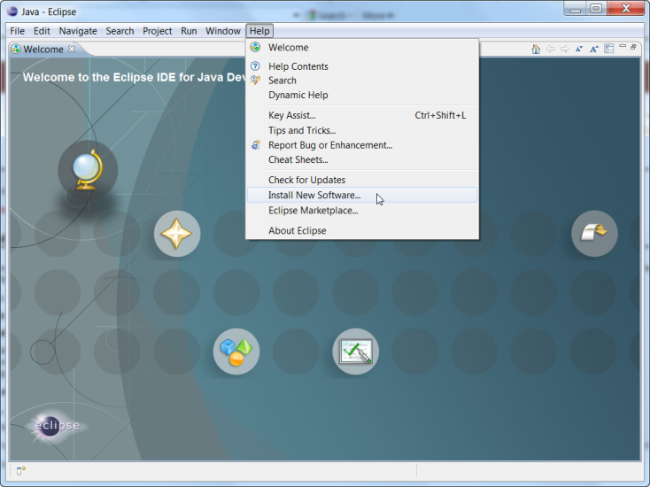
- Install Subclipse from within Eclipse by:
  - After opening Eclipse the first time, you will see the Welcome screen (left screenshot above). Subsequent sessions normally open to the Workbench (right screenshot above). In either case, select: Help ~ Install New Software
  - In the Available Software dialog that opens, type
http://subclipse.tigris.org/update_1.6.x
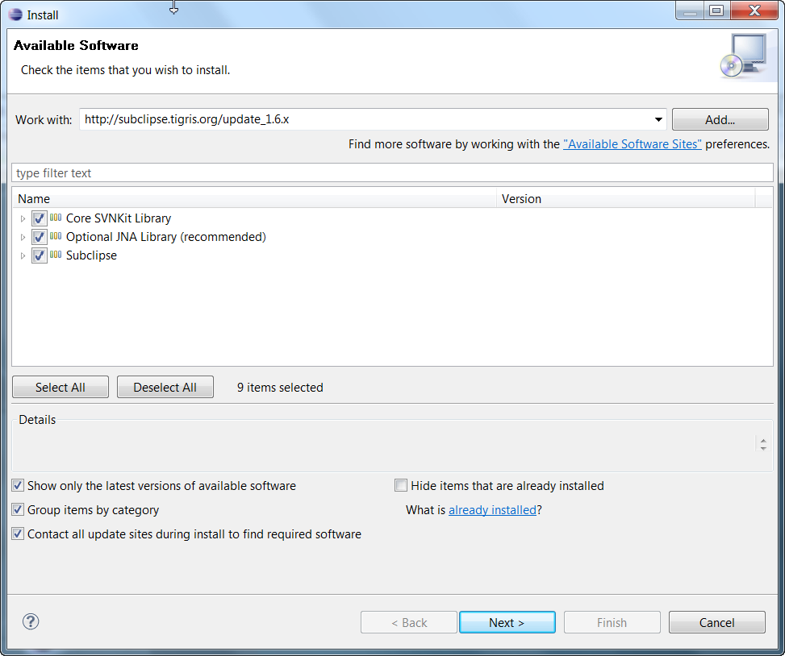
in the Work with: field
and press Enter.
After several seconds, three checkboxes will appear. Check all three checkboxes.
(Including sub-items, this will select 9 items.)

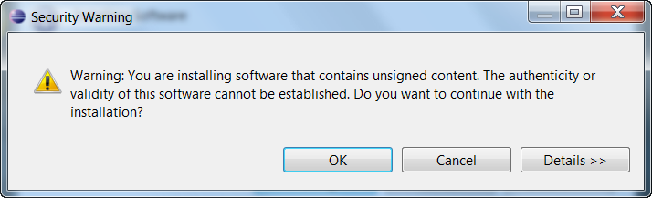
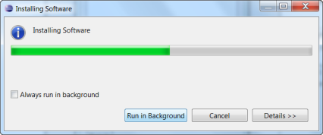
  - Press Next and Next to continue installing Subclipse. Accept licenses and trust certificates as needed and continue despite any Security Warning that you might see. The Installing Software dialog may take several minutes and be slow to start.
When asked to restart Eclipse, do so.
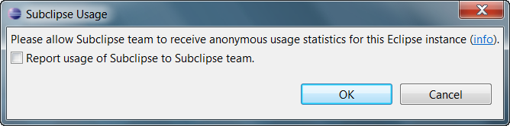
When Eclipse restarts, you may see a Subclipse Usage dialog. If you see this at any point, uncheck the box and continue.
- Install Pydev from within Eclipse by proceeding similarly to the installation of Subclipse (see the screenshots for that installation, above, as needed):
  - From the Welcome screen or the Workbench in Eclipse, select:
Help ~ Install New Software
  - In the Available Software dialog that opens, type
http://pydev.org/updates
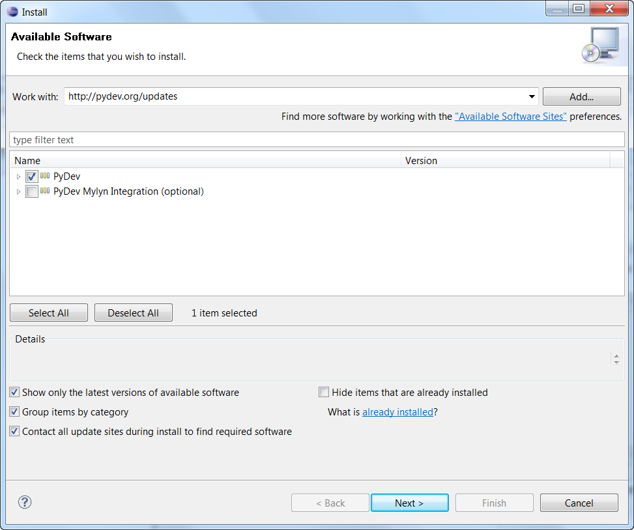
in the Work with: field
and press Enter.
After several seconds, two items will appear. Check the PyDev box.
(Leave the other box,
for PyDev Mylyn integration, unchecked.)

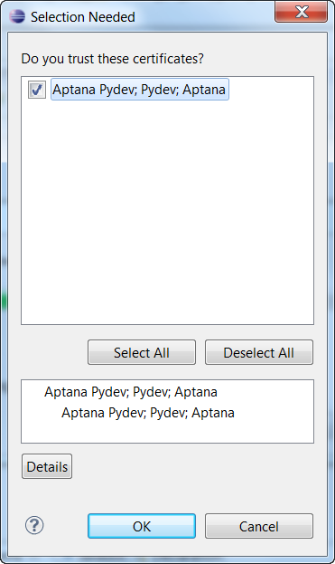
  - Press Next and Next to continue installing Pydev. Accept licenses and trust certificates as needed and continue despite any Security Warning that you might see. The Installing Software dialog may take several minutes and be slow to start.
Caution: When you see the Selection Needed dialog to the right, you must manually check the box before pressing OK.
When asked to restart Eclipse, do so.
When Eclipse restarts, you may see a Subclipse Usage dialog. If you see this at any point, uncheck the box and continue.

- Install CDT (the C/C++ tools) from within Eclipse by proceeding similarly to the installation of Subclipse (see the screenshots for that installation, above, as needed):
  - From the Welcome screen or the Workbench in Eclipse, select:
Help ~ Install New Software
  - In the Available Software dialog that opens, type
http://download.eclipse.org/tools/cdt/releases/indigo
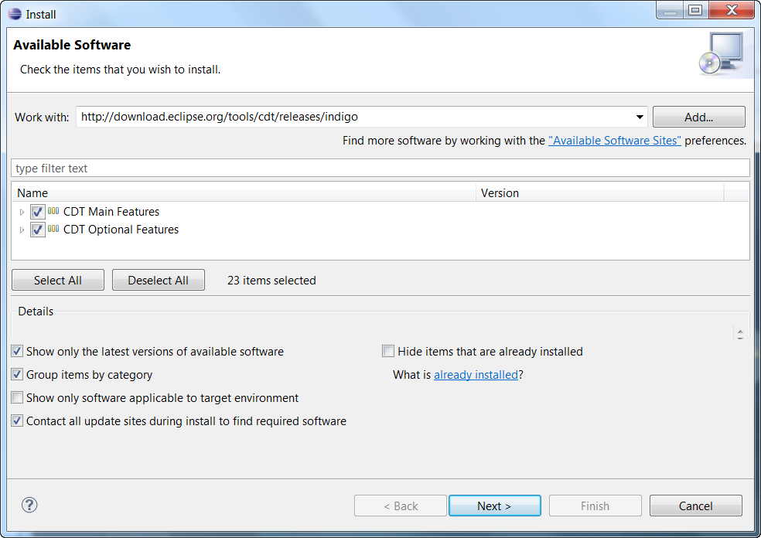
in the Work with: field
and press Enter.
After several seconds, two checkboxes will appear. Check both checkboxes.
(Including sub-items, this will select 23 items.)

  - Press Next and Next to continue installing CDT. Accept licenses and trust certificates as needed and continue despite any Security Warning that you might see. The Installing Software dialog may take several minutes and be slow to start.
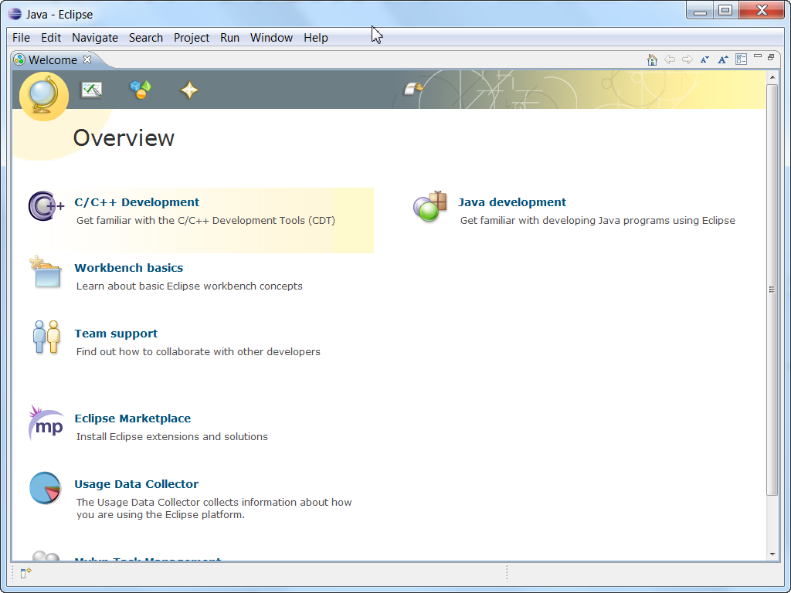
When asked to restart Eclipse, do so.
  - When Eclipse restarts, you may be at a new Welcome screen, as shown to the right. No matter which Welcome screen you see, select the circled “ribbon” to continue to the Workbench.
Then exit Eclipse, to be ready for the next steps of these installation instructions.

- Install UMLet and its Eclipse plugin, as follows:
  - Install UMLet by unzipping this:
http://www.rose-hulman.edu/class/csse/binaries/UMLet/umlet_11_2.zip
and placing the unzipped umlet folder directly below
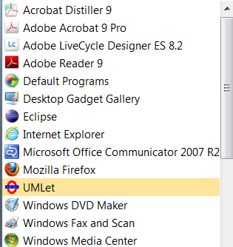
C:\Program Files

  - Place a shortcut to
C:\Program Files\Umlet\Umlet.exe
onto All Programs of the Start Menu. Name the shortcut UMLet.

  - Install the Eclipse plugin for UMLet by copying this file:
http://www.rose-hulman.edu/class/csse/binaries/UMLet/com.umlet.plugin_11.2.0.jar
into the folder:
C:\Program Files\eclipse\plugins
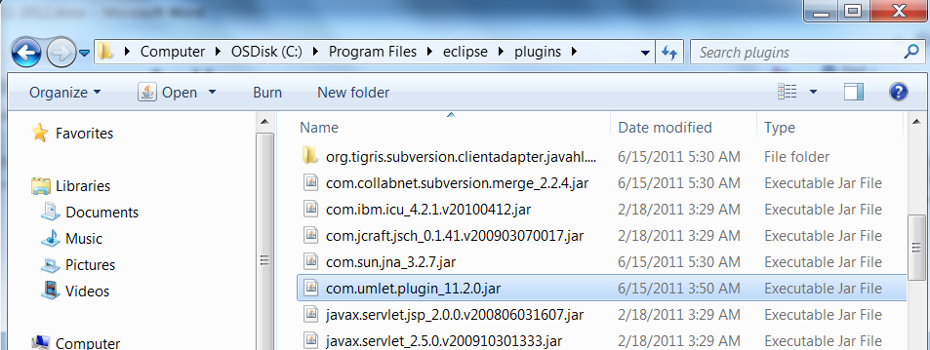
Caution: Some browsers change the extension of a .jar file (like this one) to .zip.
If so, manually change the extension back to .jar when you save the file.
Do NOT unzip (extract) the file.

- Install the iRobot Create Simulator and its Eclipse plugin, as follows:
  - Install the iRobot Create Simulator by running:
http://www.rose-hulman.edu/class/csse/binaries/iRobotCreateSimulator/iRobotCreateSimulatorSetup.msi
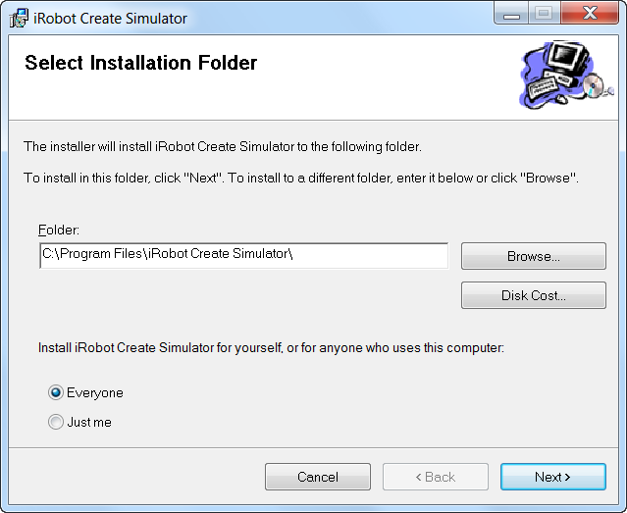
Your browser may warn that “This file is not commonly downloaded and may harm your computer.” Run anyway.
Important:
- At the Select Installation Folder dialog, check Everyone, as shown to the right.

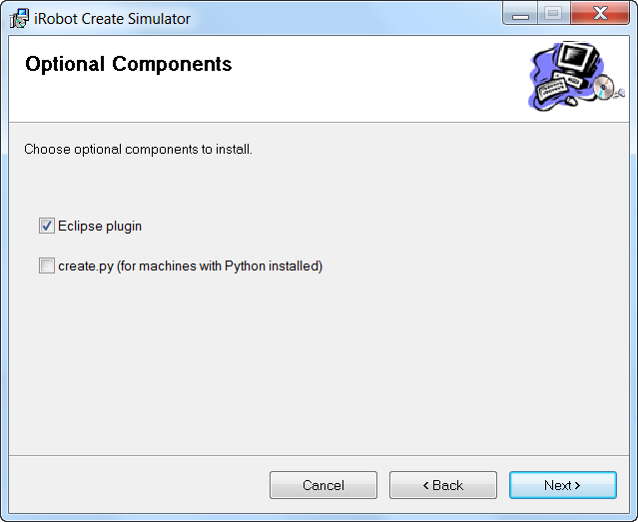
- At the Optional Components dialog:
  - Check Eclipse plugin, but
  - leave create.py UN-checked,
as shown to the right.

  - The above installation created a folder:
C:\Program Files\iRobot Create Simulator
In that folder, create a new subfolder called:
CurrentEnvironment
spelled exactly like that (including capitalization, no spaces).
  - Find the ZIP file:
C:\Program Files\iRobot Create Simulator\Resources\Environments\Default.zip
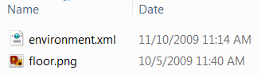
It has two files zipped inside it: environment.xml and floor.png. Extract those two files and put them into the CurrentEnvironment folder that you created in the previous step.
  - Open Eclipse. Choose:
Window ~ Preferences ~ iRobot Create Simulator
Select the Browse button and browse to the simulator itself, which is:
C:\Program Files\iRobot Create Simulator\Roomba Simulator.exe
Press Open to select that file, then OK to exit the Preferences dialog.
- You will do this step 4 times, for each of the 4 Eclipse workspaces:
- C:\EclipseWorkspaces\csse120 C:\EclipseWorkspaces\csse220
C:\EclipseWorkspaces\csse221 C:\EclipseWorkspaces\csse230
Each time, use the preferences file for that workspace. The instructions below are for the csse120 workspace.
  - Do File ~ Switch Workspace to switch to C:\EclipseWorkspaces\csse120.
  - Unzip this zipped Eclipse preferences file for csse120:
http://www.rose-hulman.edu/class/csse/binaries/Eclipse/EclipsePreferences-csse120-2011-06-28.zip
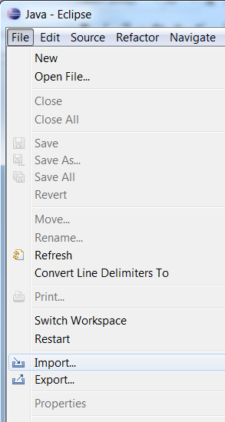
placing its sole unzipped file (EclipsePreferences-csse120-2011-06.epf) in any convenient place.
  - In the Workbench in Eclipse, select:
File ~ Import

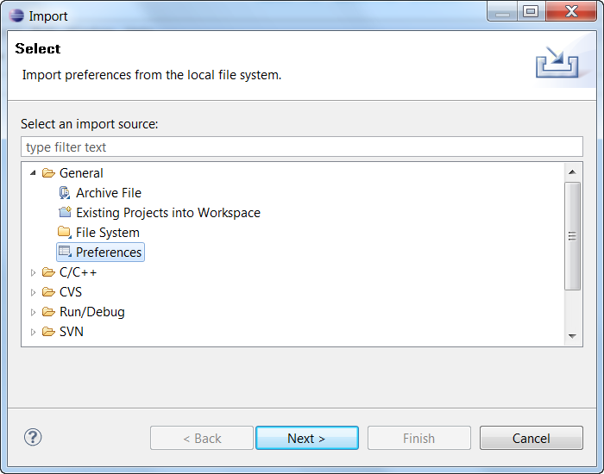
  - In the Import dialog that opens, expand General, select Preferences below that, and press Next.

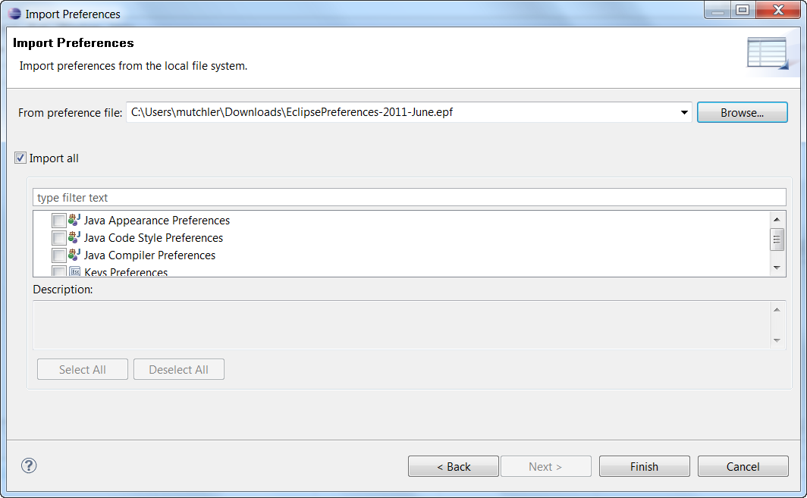
  - In the Import Preferences dialog that opens, select Browse and select the EclipsePreferences-csse120-2011-06.epf file that you unzipped and saved above.
Back in the Import Preferences dialog, check Import all, then select Finish.

  - Delete the EclipsePreferences-csse120-2011-06-28.epf file that you unzipped and saved above.
- Make sure that there are no spurious Eclipse folders/files left behind. Look especially to be sure that there is no .eclipse folder in C:\Users\test (or elsewhere).

For large files like this, it may be faster to save the zipped file somewhere convenient on your computer, then unzip it, placing the unzipped files as directed, then delete the zip file.
If you do not see the Select a workspace dialog the first time that you open Eclipse, or if you accidentally press OK before browsing to the correct workspace folder, you may have accidentally created a workspace folder in an unintended place, or even a new user folder beneath C:\Users. Get help as needed to correct that error.
If you press OK without checking the box indicating that you trust the Pydev certificates, the installation may continue as if all is well. But it isn’t, and you’ll have to uninstall and then re-install Pydev.

