CSSE 120—Introduction to Software Development

Exam 1, Spring 2009-2010 – Answer key
This exam contains two parts.
- The first part is to be done on paper without using your computer.
  - This part is closed-everything except you may use a “cheat sheet” that is one 8.5 by 11 sheet of paper (both sides, or two sheets each using only one side).
  - Complete this first part and turn it in before beginning the second part.
- The second part of the exam is to be done on your computer.
  - This part is open-everything except that you may not communicate with anyone except an exam proctor.
  - So, you can use Angel, the course web site, any projects on your computer, the entire World Wide Web, and search engines like Google, among other sources.
  - If you have questions on the on-the-computer part, you may ask an exam proctor. In particular, we don’t expect you to be experts on understanding error messages yet, so if you get an error message, first try to understand it, but then ask for help as needed.
  - Obtain the on-the-computer part of this exam by checking out the Exam1-201030
project from your SVN repository. It has 5 modules. Do the TODO’s in each. Turn in your work by committing your project.
Time limit: You have a total of 2 hours to complete the entire exam, plus an hour of “bonus” time, so a total of up to 3 hours. Don’t spend more than 30 minutes on the paper-and-pencil part.

Paper-and-pencil score:
Problem | Points | Score
P1 | 3
P2 | 5
P3 | 5
P4 | 6
P5 | 2
P6 | 3
Total | 24

Totals | Points | Score
paper | 24
computer | 96
Total | 120

On-the-computer score:
Problem | Points | Score | Explanation of points deducted
P1 | 10
P2 | 10
P3 | 10
P4 | 10
P5a | 10
P5b | 10
P5c | 10
P5d | 10
P5e | 8
P5f | 8
Total | 96

Your total as a percent (of 100): __________________________

Problems

- (3 points) What is the value of each of the following expressions?
11 % 3
Value: 2

Value: 3

11 / 3

Value: 3.0

float(11 / 3)

- (5 points: 1, 1 and 3, respectively) What is the output of each of the following code fragments?
x = 3
x *= 2
print x + x
Output: 12

def fun(x):
a = 2
return a + x
a = 8
b = fun(a)
print a, b
Output: 8, 10

1 point
def g(a, b):
1 point
print a, "of" , b

def f(n):
for i in range(1, n + 1):
Output: 1 of 3
2 of 3
3 of 3
36
g(i, n)
return n ** 2, n ** 3

x, y = f(3)
print x + y
1 point

- (5 points) What gets printed by the following expressions:

range(2, 11, 3) [2, 5, 8]
On these problems, OK if they have the right idea. E.g., OK if omitted []s or outermost quotes, and any form of quotes is OK.

""" ′hello′ """ “ ‘hello’ “

"one" + "two" “onetwo”

x = [10, 20, 30, 40, 50]
print x[2] 30

y = "forget me not"
print y[2] ‘r’

- (6 points) For each of the following lists, write a Python range expression that produces the list:

[1, 2, 3, 4, 5] range(1, 6)
On these problems, half credit for any single error, no credit if two or more errors.

[4, 6, 8, 10, 12] range(4, 13, 2)

[5, 2, -1, -4, -7] range(5, -8, -3)

- (2 points) What gets printed by the following expressions:

quotesList = ["Immature poets imitate; mature poets steal.",
"by T.S. Eliot"]

print quotesList[1] “by T.S. Eliot”
On these problems, OK if quotes are omitted.

print quotesList[1][1] “y”

1 point

- (3 points) What gets printed by the following code:

circleA = Circle(Point(25, 25), 10)
Output: 40
40
circleB = circleA
circleA.move(15, 0)
print circleA.getCenter().getX()
print circleB.getCenter().getX()
2 points

When you have completed this part of the exam, turn it in to the exam proctor so you can use your computer for the next (on-the-computer) part of the exam.

Begin the on-the-computer part by checking out the project called
Exam1-201030
in your SVN repository. Do the five problems therein, each of which has TODO’s that specify what to do. Commit your work when you are done.
Recall the instructions on the computer part: Open everything EXCEPT that you may NOT communicate with anyone except the exam proctors.

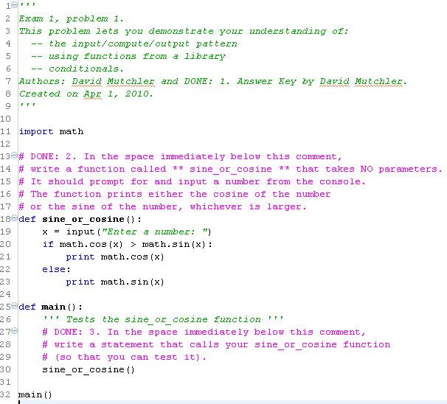
2 points
2 points
4 points
1 point
1 point
2 points

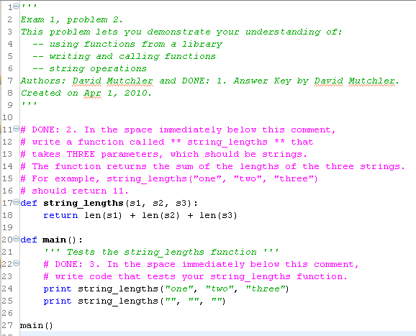
3 points
3 points
3 points
3 points

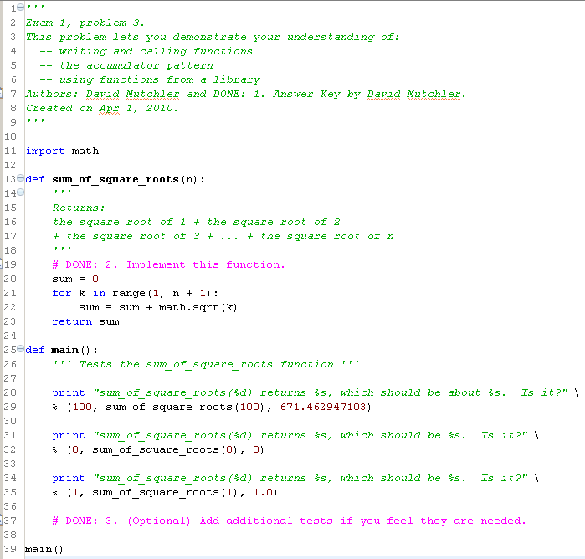
1 point
3 points
3 points
3 points
2 points

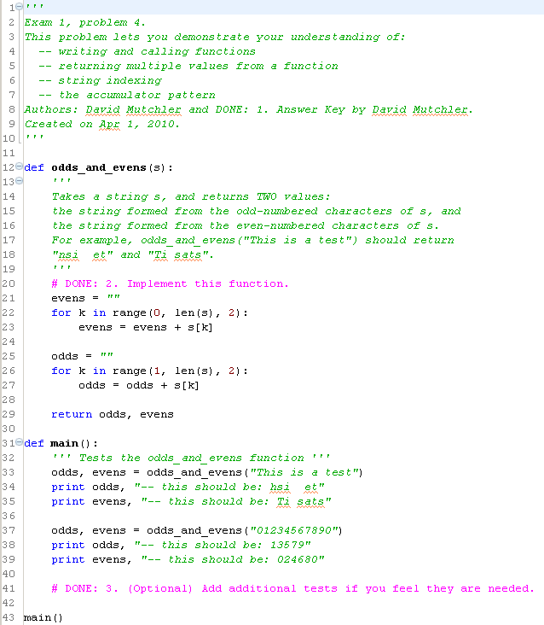
2 points
1 point
2 point
2 points
1 point
2 points
2 point

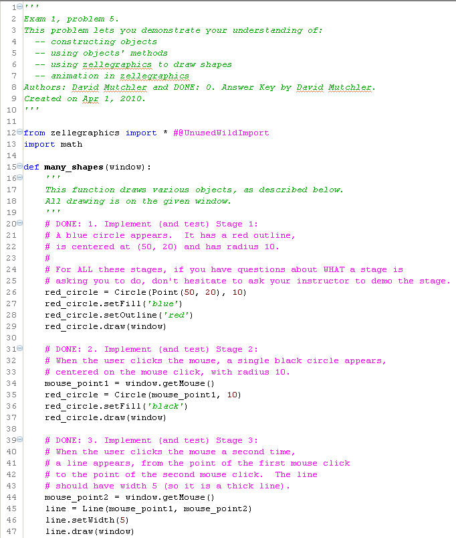
Each TODO (other than the student’s name) is 8 points:
- 4 points if there is a single error
- 0 points if there is more than one error, or if the answer is just way off
Judge correctness by running the program. It is OK if style is poor or they solve the problem in an unusual way (but consider making a comment to them on the cover page). For any points deducted, mark the reason on the cover page.

