PH 404 Acoustics. Some Problems on Chapter 1. December 15, 2005 MJM

Q = ω/(2α) ω_{d} = √(ω_{o}² - α²)

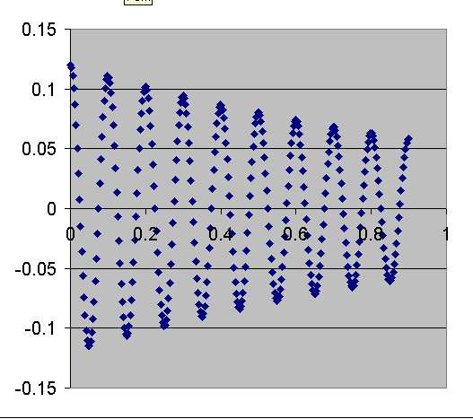

For the graph of displacement vs. time, find

a) The 'damped' frequency, ω_{d}
b) The damping constant α
c) the undamped resonant frequency, ω_{o}
d) the quality factor Q.

A 256-Hz tuning fork takes 25 seconds to have its amplitude cut in half.
What is the damping constant α of this fork? What is its Q value?

A machine is lowered into place on four springs at its four corners, and the springs are compressed 2.30 cm each in the process. What is the resonant frequency of the machine when mounted on its four springs?

For a simple harmonic oscillator, its motion can be described as x(t) = A exp(iωt) where A is complex:

A = A exp(iθ) { A and θ are real }

Make a sketch of both the displacement and velocity of this oscillator in the complex plane, and explain whether the velocity leads the displacement or the other way around.

The mechanical impedance Z is the ratio of force to velocity. For the impedance of a particular oscillator at a given frequency we have

Z = 300 - i 400π kg/s .

a) Z can be written Z exp(iθ), where Z and θ are real. Find Z and θ.
b) Explain whether the force leads the velocity or the other way around.

In steady state, is the rate at which the driving force supplies energy to the driven, damped harmonic oscillator equal at every instant to the rate at which energy is being dissipated? Explain. (Prob 1-26)

The equation of the driven damped oscillator is

md²x/dt² - R dx/dt - Kx = F_{o} exp(iωt) True False

Estimate the quality factor Q from the resonance curve data given below.
