ECE 371
SUSTAINABLE ENERGY SYSTEMS

EXPERIMENT 3
INTRODUCTION TO SYNCHRONOUS GENERATORS

Objective
The objectives of this laboratory experiment are summarized below:
- Learn to connect the dc machine (dynamometer) as a motor and the synchronous
machine as a generator.
2. Gain an understanding of the relationship between the speed of prime-mover and
the frequency of generated ac voltage.
3. Gain an understanding of the phase angle relationship between the phase voltage
and phase current as a function of the impedance angle (power factor angle).
4. Determine the impact of the synchronous generator dc field voltage on the terminal
voltage.

Pre - Lab
Perform the necessary calculations for Column 3 of Table 2.

Procedure
As you approach your bench, you will see the motor-generator set-up for the experiment. You will notice that a synchronous generator is coupled to a dc dynamometer that is operating as a dc motor.

The dynamometer stator in mounted on bearings, so it can rotate (note that the rotation is limited). This is different from the conventional electric machines with the stator being bolted to the foundation. The reaction torque is provided by the bedplate mounted torque transducer. Therefore, the torque produced by the motor can be displayed by the electronic LCD torque indicator. The dynamometer speed is measured by counting the visible light pulses reflected from the tape on the machine shaft coupling. The speed is displayed electronically by the red LED display.

Set all power supplies to zero volts and calibrate the torque indicator to read a zero value.
Then proceed with the following parts of the experiment.

Part 1 – Motor and Generator Electrical Connection
- The dynamometer is operating as a motor and converts the electrical input power to a mechanical output power and torque. This dc motor has three windings:
  - Armature winding
  - Shunt field winding
  - Series field winding (not used for this experiment)

Connect the shunt field winding to the 6A dc power supply, as shown in Figure 1. Apply 125 V dc to this winding. Also, connect the armature winding to the other 6A dc power supply, per Figure 1. Turn on the RPM meter and gradually increase the armature dc voltage until the motor shaft speed reaches 1800 RPM.
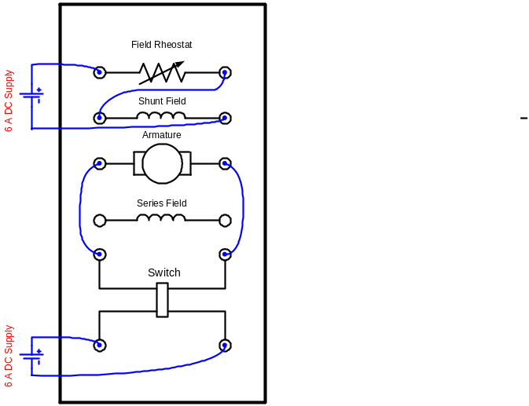

Figure 1. Dynamometer (Separately-Excited DC Motor) Connection

- The synchronous machine operates as a three-phase ac generator and converts the input mechanical power to electrical output power. This generator has two sets of windings:
  - DC field winding
  - AC stator windings establishing the generator terminals

Place the synchronous machine dc field switch on SYNC RUN, and turn off the machine main switch (switch open). Connect the dc field winding to the 1A dc supply. Increase the supply voltage until the field current reaches 0.5A, as shown in Figure 2.
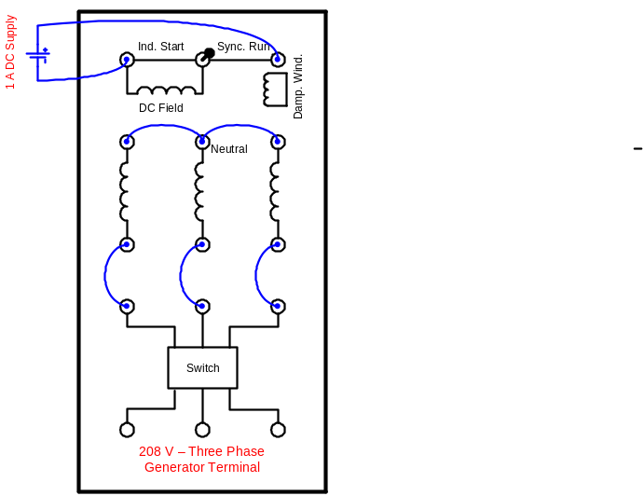

Figure 2. Three-Phase Synchronous Generator Connection
- Connect each of the resistive, inductive, and capacitive load banks in a wye configuration and connect the neutrals as shown in Figure 3. Make sure that the individual load bank switches are in the off position (down position).
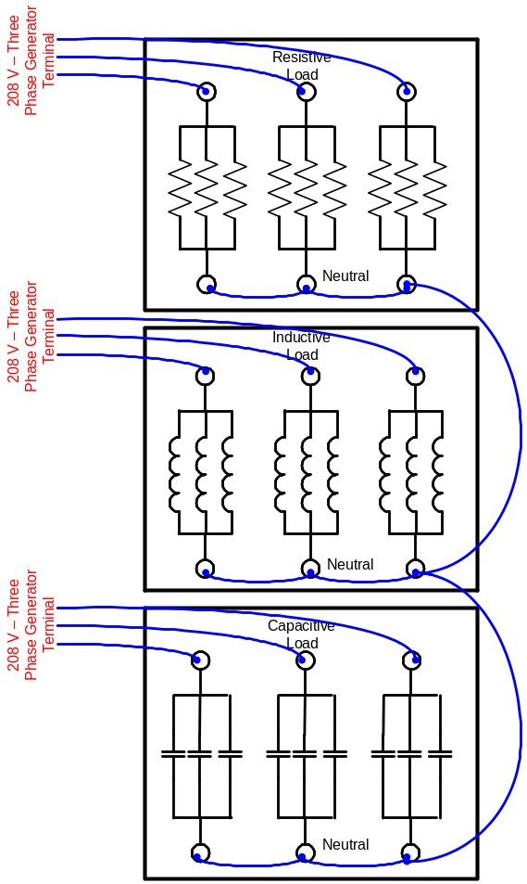

Figure 3. Three-Phase Wye-Connected Load Bank

4. Now connect the three-phase synchronous generator terminals to the terminals of the wye-connected load banks to form a parallel RLC load bank. Don’t forget to connect the neutral (not the ground) of the generator to the neutral (not the ground) of load banks. Then turn on the generator main switch (switch on) and adjust the dc field voltage of the synchronous generator until the voltmeter indicates an ac voltage of 120 V at the terminal (stator) of the synchronous generator. Monitor the phase “a” voltage (L1 to neutral) and the associated current on the oscilloscope. Be sure the arrow of the current probe faces the proper direction. Now you are ready to perform the experiment. Note that at this point the load is not connected to the generator, since all load switches are at the off position.

Part 2 – Prime Mover Speed and Synchronous Generator Frequency Relationship
By adjusting the armature voltage of the dc motor you can change the motor shaft speed. Set the Fluke multimeter that measures the terminal voltage of the synchronous generator to display the generator frequency. Now complete the following table for a 4 pole (p = 4) synchronous generator:

Table 1. Synchronous Generator Frequency and Speed Relationship

Prime-Mover Speed (Measured RPM) | Generator Frequency (f in Hz) | N_{s} = 120f /p  (Calculated RPM)
1500
1600
1700
1800
1900
2000
2100

Now plot frequency f (y-axis) as a function of the prime-mover speed (x-axis), using Excel.

Part 3 – Phase Angle Relationship Between the Synchronous Machine Phase Voltage and Phase Current as a Function of the Impedance Angle
By switching different resistances, inductances, and capacitances you can change the synchronous generator load. As you switch in different loads, make sure that the prime-mover speed is maintained fixed at 1800 RPM by adjusting the armature voltage of the dc motor. Use the oscilloscope voltage and current probes to measure the phase voltage magnitude and phase angle between the phase voltage and phase current.

Now complete the following table:

Table 2. Synchronous Generator Voltage and Current Phase Angles

Case | Load Quantities | Calculated Equiv.  Impedance  in Polar Form  (Ω) | Generator Terminal Voltage  (V) | Measured Phase Angle Between  V and I  (Degree)
1 | 600 Ω // 1.6 H |  | 120
2 | 300 Ω // 0.8 H
3 | 150 Ω // 0.4 H
4 | 300 Ω // 0.8 H // 8 µF

Part 4 – Impact of the Synchronous Generator DC Field Voltage on the AC Terminal Voltage
By adjusting the synchronous generator dc field voltage you can correct for the ac terminal voltage drop resulting from a load increase that was observed in Cases 1-3 of Part 3.

The generator terminal ac voltage should be maintained at 120 V throughout Part 4. This action will impact the speed of the prime-mover. Make sure that for all cases the prime-mover speed is maintained fixed at 1800 RPM by adjusting the armature voltage of the dc motor.

Now complete the following table:

Table 3. Synchronous Generator Terminal Voltage and Field Current

Case | Load Quantities | Generator Terminal Voltage  (V) | Generator  Field  Current  (A)
1 | 600 Ω // 1.6 H | 120
2 | 300 Ω // 0.8 H | 120
3 | 150 Ω // 0.4 H | 120
4 | 300 Ω // 0.8 H // 8 µF | 120

Documentation
At the end of the lab period, submit the pre-lab work, experiment instruction, your completed table of measurements, and the Excel plot to the instructor.

