Physics II

Homework VI CJ

Chapter 21; 84, 90

Chapter 22; 4, 8, 12, 23, 30, 44

21.84. **Identify:** The electric field exerts equal and opposite forces on the two balls, causing them to swing away from each other. When the balls hang stationary, they are in equilibrium so the forces on them (electrical, gravitational, and tension in the strings) must balance.

**Set Up:**

(a) The force on the left ball is in the direction of the electric field, so it must be positive, while the force on the right ball is opposite to the electric field, so it must be negative.

**(b)** Balancing horizontal and vertical forces gives *qE = T* sin *θ*/2 and *mg = T* cos *θ*/2.

**Execute:** Solving for the angle *θ* gives: *θ* = 2 arctan(*qE/mg*).

**(c)** As *E* → ∞, *θ* → 2 arctan(∞) = 2 (π/2) = π = 180°

**Evaluate:** If the field were large enough, the gravitational force would not be important, so the strings would be horizontal.

21.90. **Identify:** Use Eq. (21.7) to calculate the electric field due to a small slice of the line of charge and integrate as in Example 21.11. Use Eq. (21.3) to calculate 

**Set Up:** The electric field due to an infinitesimal segment of the line of charge is sketched in Figure 21.90.

|  |  |
| --- | --- |
| FIG21-090.tif |  |
| Figure 21.90 |  |

Slice the charge distribution up into small pieces of length *dy*. The charge *dQ* in each slice is  The electric field this produces at a distance *x* along the *x*-axis is *dE.* Calculate the components of  and then integrate over the charge distribution to find the components of the total field.

**Execute:** 









**(b) **



**(c)** For *x >> a*, 



**Evaluate:** For  and  and  is in the –*x*-direction. For *x* >> *a* the charge distribution *Q* acts like a point charge.

22.4. **Identify:**Use Eq.(22.3) to calculate the flux for each surface. Use Eq.(22.8) to calculate the total enclosed charge.

**Set Up: **. The area of each face is , where .

**Execute: **.

. .

.









**(b)**Total flux:   Therefore, 

**Evaluate:**Flux is positive when is directed out of the volume and negative when it is directed into the volume.

22.8. **Identify:** Apply Gauss’s law to each surface.

**Set Up:** is the algebraic sum of the charges enclosed by each surface. Flux out of the volume is positive and flux into the enclosed volume is negative.

**Execute:**

**(a)** 

**(b)** 

**(c)** 

**(d)** 

**(e)** 

**Evaluate:**

**(f)** All that matters for Gauss’s law is the total amount of charge enclosed by the surface, not its distribution within the surface.

22.12. **Identify:** Apply Gauss’s law.

**Set Up:** Use a small Gaussian surface located in the region of question.

**Execute:**

**(a)** If  and uniform, then inside any closed surface is greater than zero. This implies , so  and so the electric field cannot be uniform. That is, since an arbitrary surface of our choice encloses a non-zero amount of charge,  must depend on position.

**(b)** However, inside a small bubble of zero charge density within the material with density , the field can be uniform. All that is important is that there be zero flux through the surface of the bubble (since it encloses no charge). (See Problem 22.61.)

**Evaluate:** In a region of uniform field, the flux through any closed surface is zero.

22.23. **Identify:** The electric field inside the conductor is zero, and all of its initial charge lies on its outer surface. The introduction of charge into the cavity induces charge onto the surface of the cavity, which induces an equal but opposite charge on the outer surface of the conductor. The net charge on the outer surface of the conductor is the sum of the positive charge initially there and the additional negative charge due to the introduction of the negative charge into the cavity.

**(a)** **Set Up:** First find the initial positive charge on the outer surface of the conductor using where *A* is the area of its outer surface. Then find the net charge on the surface after the negative charge has been introduced into the cavity. Finally use the definition of surface charge density.

**Execute:** The original positive charge on the outer surface is



After the introduction of  into the cavity, the outer charge is now



The surface charge density is now

**(b)** **Set Up:** Using Gauss’s law, the electric field is 

**Execute:** Substituting numbers gives



**(c)** **Set Up:** We use Gauss’s law again to find the flux. .

**Execute:** Substituting numbers gives

.

**Evaluate:** The excess charge on the conductor is still  as it originally was. The introduction of the  inside the cavity merely induced equal but opposite charges (for a net of zero) on the surfaces of the conductor.

22.30. **Identify:** The net electric field is the vector sum of the fields due to each of the four sheets of charge.

**Set Up:** The electric field of a large sheet of charge is . The field is directed away from a positive sheet and toward a negative sheet.

**Execute:**

**(a)** At .



**(b)** .



**(c) . **

**Evaluate:** The field at *C* is not zero. The pieces of plastic are not conductors.

22.44. **Identify:** Apply Gauss’s law and conservation of charge.

**Set Up:** Use a Gaussian surface that is a sphere of radius *r* and that has the point charge at its center.

**Execute:**

**(a)** For ,  radially outward, since the charge enclosed is *Q,* the charge of the point charge. For ,  since these points are within the conducting material. For , , radially inward, since the total enclosed charge is –2*Q*.

**(b)** Since a Gaussian surface with radius *r*, for , must enclose zero net charge, the total charge on the inner surface is  and the surface charge density on inner surface is .

**(c)** Since the net charge on the shell is  and there is  on the inner surface, there must be on the outer surface. The surface charge density on the outer surface is 

**(d)** The field lines and the locations of the charges are sketched in Figure 22.44a.

**(e)** The graph of *E* versus *r* is sketched in Figure 22.44b.

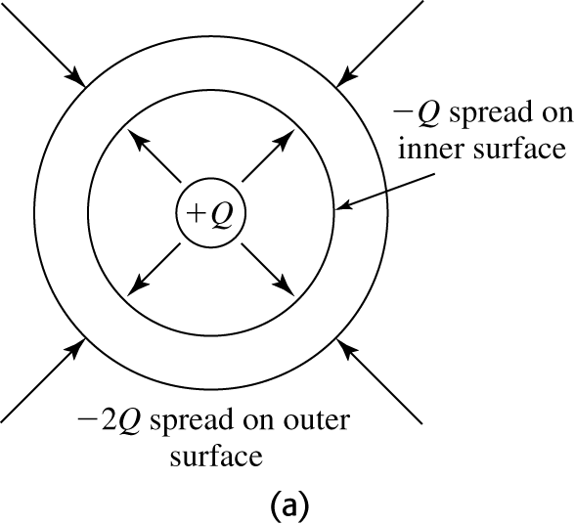 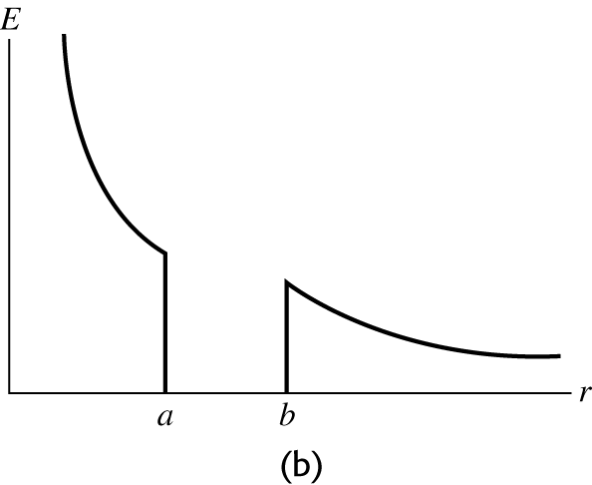

Figure 22.44

**Evaluate:**  For  the electric field is due solely to the point charge *Q*. For  the electric field is due to the charge  that is on the outer surface of the shell.