Physics II

Homework IV CJ
Chapter 13; 68, 96
Chapter 15; 4, 11, 26, 30, 41, 50, 74
13.68. Identify: In SHM, 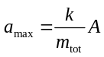. Apply 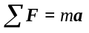 to the top block.
Set Up: The maximum acceleration of the lower block can’t exceed the maximum acceleration that can be given to the other block by the friction force.
Execute: For block m, the maximum friction force is 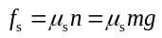. 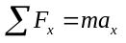 gives 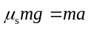 and 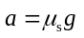. Then treat both blocks together and consider their simple harmonic motion. 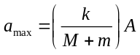. Set 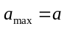 and solve for A: 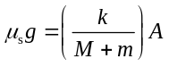 and 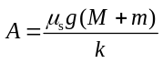.
Evaluate: If A is larger than this the spring gives the block with mass M a larger acceleration than friction can give the other block, and the first block accelerates out from underneath the other block.
13.96. Identify: Calculate 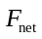and define 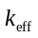by 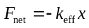. 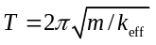.
Set Up: If the elongations of the springs are and , they must satisfy 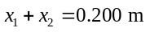
Execute: (a) The net force on the block at equilibrium is zero, and so 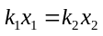and one spring (the one with 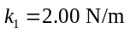) must be stretched three times as much as the one with 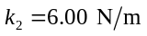. The sum of the elongations is 0.200 m, and so one spring stretches 0.150 m and the other stretches 0.050 m, and so the equilibrium lengths are 0.350 m and 0.250 m.
(b) When the block is displaced a distance x to the right, the net force on the block is From the result of part (a), the term in square brackets is zero, and so the net force is 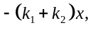 the effective spring constant is 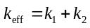 and the period of vibration is 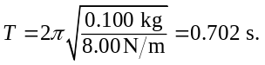
Evaluate: The motion is the same as if the block were attached to a single spring that has force constant .

15.4. Identify: 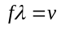
Set Up: 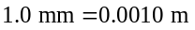
Execute: 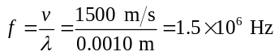
Evaluate: The frequency is much higher than the upper range of human hearing.

15.11. Identify and Set Up: Read A and T from the graph. Apply Eq.(15.4) to determine and then use Eq.(15.1) to calculate v.
Execute:
(a) The maximum y is 4 mm (read from graph).
(b) For either x the time for one full cycle is 0.040 s; this is the period.
(c) Since 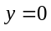 for 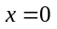 and 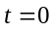 and since the wave is traveling in the 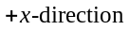 then 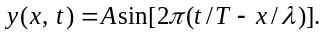 (The phase is different from the wave described by Eq.(15.4); for that wave 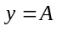 for 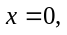 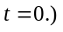 From the graph, if the wave is traveling in the and if and 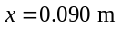 are within one wavelength the peak at 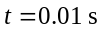 for moves so that it occurs at 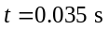 (read from graph so is approximate) for 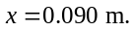 The peak for is the first peak past so corresponds to the first maximum in 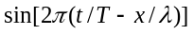 and hence occurs at 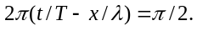 If this same peak moves to 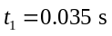 at 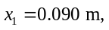 then
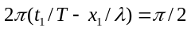
Solve for 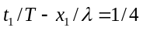
Then
(d) If the wave is traveling in the 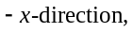 then 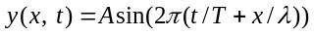 and the peak at 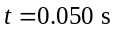 for corresponds to the peak at for 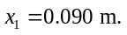 This peak at is the second peak past the origin so corresponds to 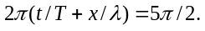 If this same peak moves to for then 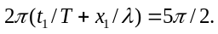
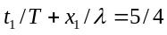
Then
Evaluate: No. Wouldn’t know which point in the wave at moved to which point at
15.26. Identify: The distance the wave shape travels in time t is vt. The wave pulse reflects at the end of the string, at point O.
Set Up: The reflected pulse is inverted when O is a fixed end and is not inverted when O is a free end.
Execute: (a) The wave form for the given times, respectively, is shown in Figure 15.26a.
(b) The wave form for the given times, respectively, is shown in Figure 15.26b.
Evaluate: For the fixed end the result of the reflection is an inverted pulse traveling to the left and for the free end the result is an upright pulse traveling to the left.
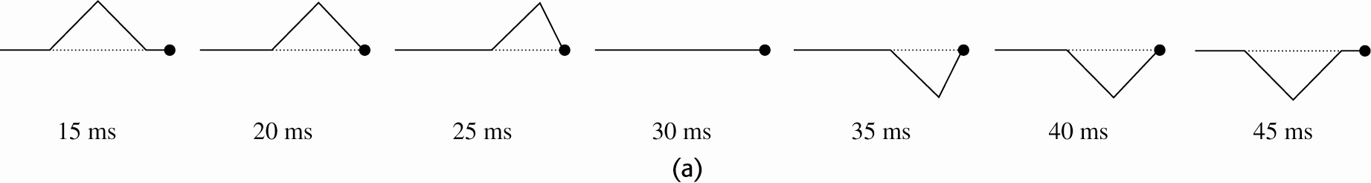
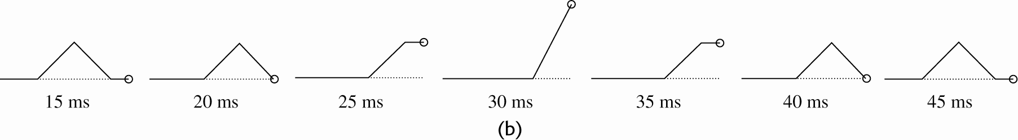
Figure 15.26
15.30. Identify: Apply the principle of superposition.
Set Up: The net displacement is the algebraic sum of the displacements due to each pulse.
Execute: The shape of the string at each specified time is shown in Figure 15.30.
Evaluate: The pulses interfere when they overlap but resume their original shape after they have completely passed through each other.
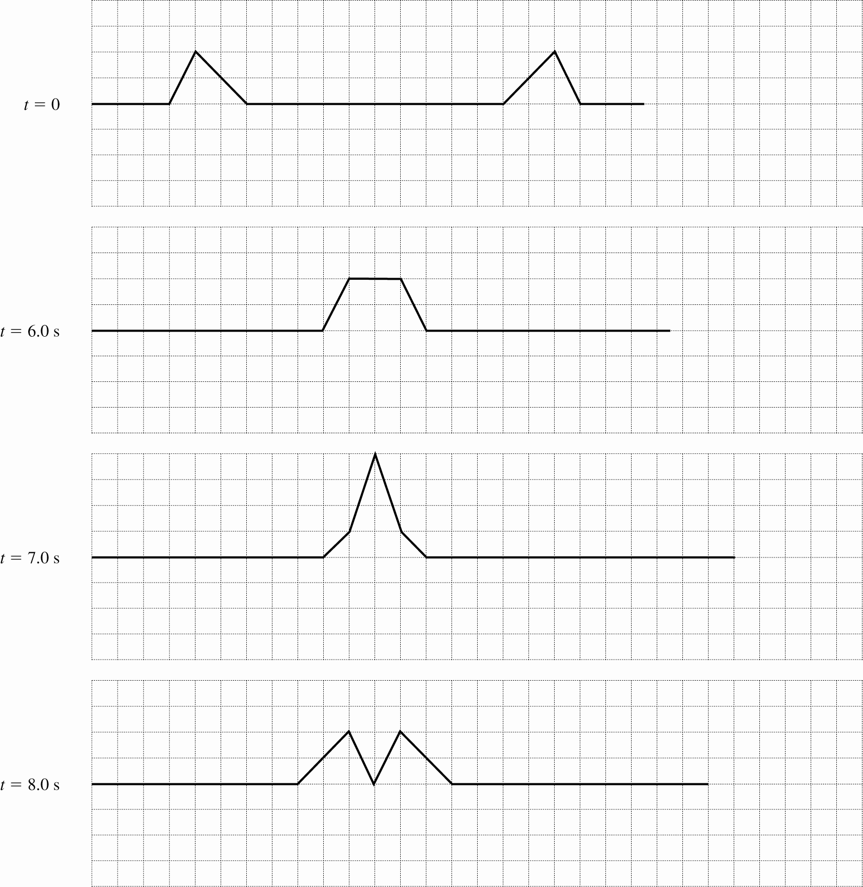
Figure 15.30
15.41. Identify: Compare 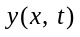 given in the problem to Eq.(15.28). From the frequency and wavelength for the third harmonic find these values for the eighth harmonic.
(a) Set Up: The third harmonic standing wave pattern is sketched in Figure 15.41.
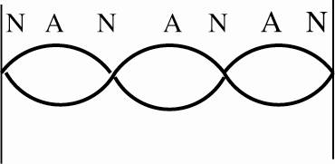
Figure 15.41
Execute: (b) Eq. (15.28) gives the general equation for a standing wave on a string:
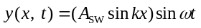
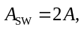 so 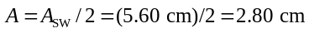

(c) The sketch in part (a) shows that 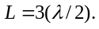 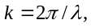 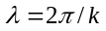
Comparison of given in the problem to Eq. (15.28) gives 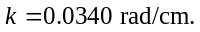 So,
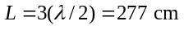

(d) 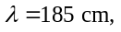 from part (c)
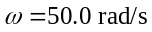 so 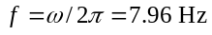
period 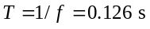
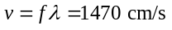

(e) 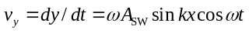

(f) 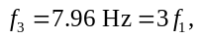 so 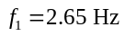 is the fundamental
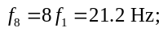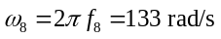
and 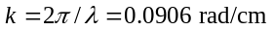

Evaluate: The wavelength and frequency of the standing wave equals the wavelength and frequency of the two traveling waves that combine to form the standing wave. In the 8th harmonic the frequency and wave number are larger than in the 3rd harmonic.

15.50. Identify: Compare 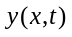given in the problem to the general form given in Eq.(15.8).
Set Up: The comparison gives 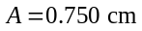, 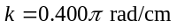and 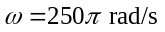.
Execute: (a) 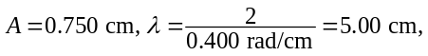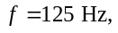 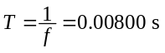 and 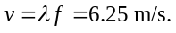
(b) The sketches of the shape of the rope at each time are given in Figure 15.50.
(c) To stay with a wavefront as increases, decreases and so the wave is moving in the -direction.
(d) From Eq. (15.13), the tension is .
(e) 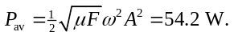
Evaluate: The argument of the cosine is 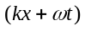for a wave traveling in the 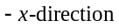, and that is the case here.
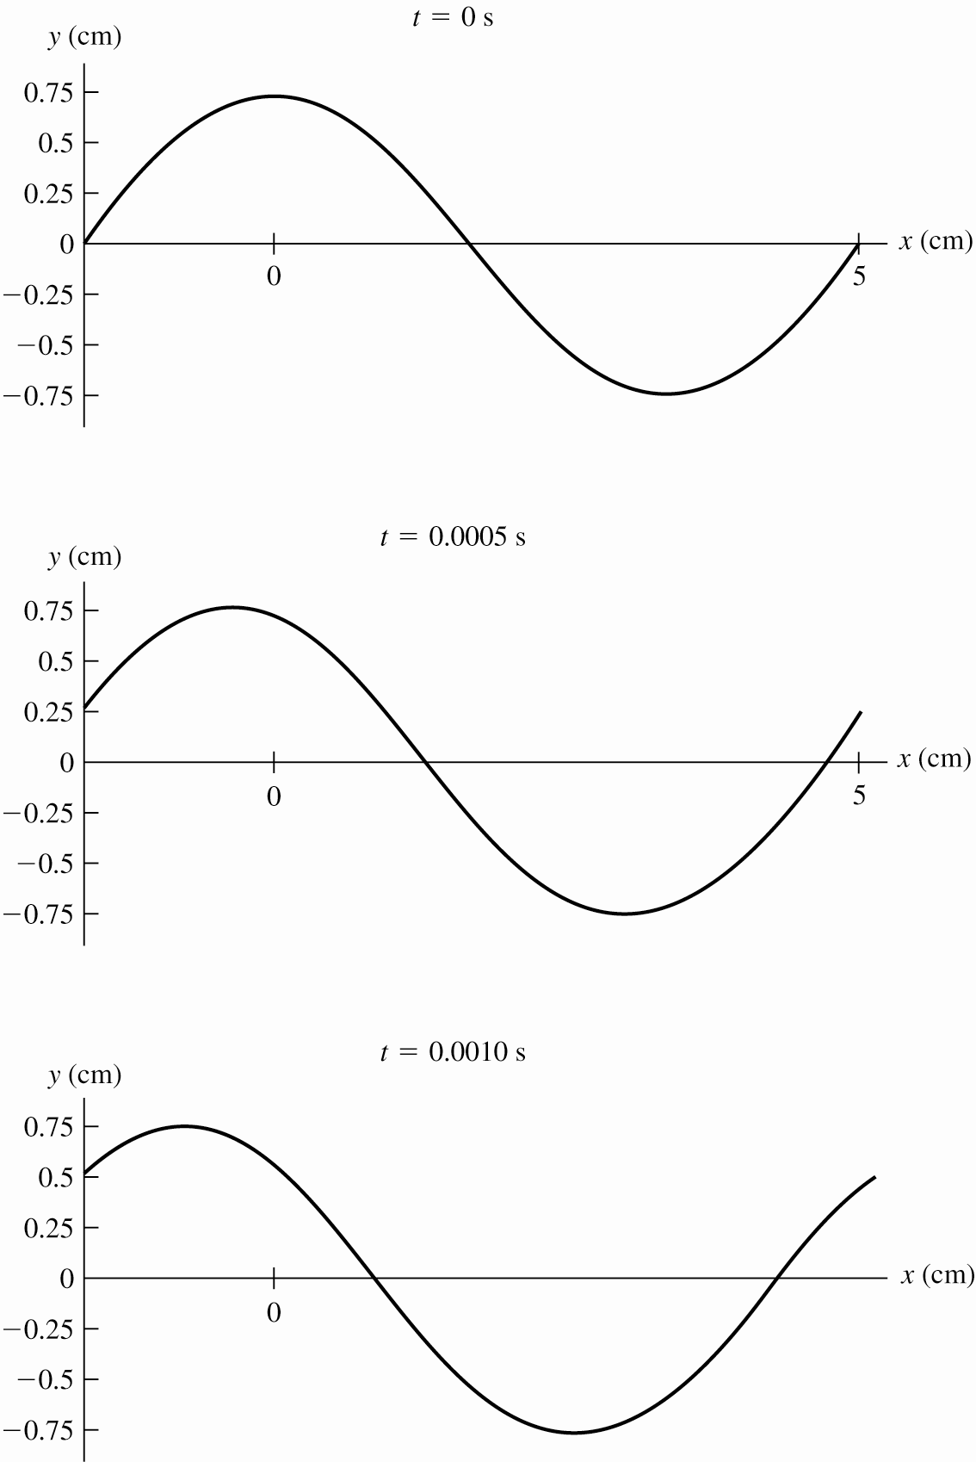
Figure 15.50
15.74. Identify: The standing wave is given by Eq.(15.28).
Set Up: At an antinode, 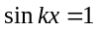. 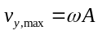. 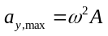.
Execute: (a) , and the wave amplitude is 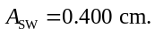 The amplitude of the motion at the given points is
(i) 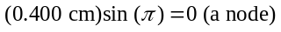 (ii)
(iii) 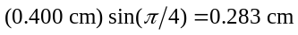
(b) The time is half of the period, or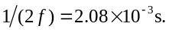
(c) In each case, the maximum velocity is the amplitude multiplied by 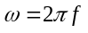and the maximum acceleration is the amplitude multiplied by 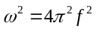:
.
Evaluate: The amplitude, maximum transverse velocity, and maximum transverse acceleration vary along the length of the string. But the period of the simple harmonic motion of particles of the string is the same at all points on the string.

