Homework Set 34A
PH 113 – 10
Q1. Would the headlights of a distant care form a two-source interference pattern? Explain.

P1. Two speakers, emitting identical sound waves of wavelength 2.0 m in phase with each other, and an observer are located as shown in the figure. (A) At the observer's location, what is the path difference for waves from the two speakers? (B) Will the sound waves interfere constructively or destructively at the observer's location-or something in between constructive and destructive? (C) Suppose the observer now increases her distance from the speakers to 17.0 m, staying directly in front of the same speaker as initially. At the observer's new location, what is the path difference for waves from the two speakers? (D) Will the sound waves interfere constructively or destructively at the observer's location-or something in between constructive and destructive?
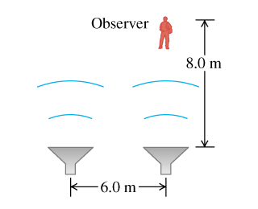

P2. Young's experiment is performed with light from excited helium atoms (λ=502nm). Fringes are measured carefully on a screen 1.20 m away from the double slit, and the center of the twentieth fringe (not counting the central bright fringe) is found to be 10.6 mm from the center of the central bright fringe. What is the separation of the two slits?

P3. Two slits spaced 0.450 mm apart are placed a distance of 75.0 cm from a screen. What is the distance between the second and third dark lines of the interference pattern on the screen when the slits are illuminated with coherent light with a wavelength of 500 nm?

P4. Coherent light with wavelength of 600 nm passes through two very narrow slits and the interference pattern is observed on a screen a distance of 3.00 m from the slits. The first-order bright fringe is a distance of 4.84 mm from the center of the central bright fringe. For what wavelength of light will the first-order dark fringe be observed at this same point on the screen?

