Homework Set 33A
PH 113 – 10
Q1. Light requires about 8 minutes to travel from the sun to the earth. Is it delayed appreciably by the earth’s atmosphere? Explain.

P1. Two plane mirrors intersect at right angles. A laser beam strikes the first of them at a point 11.5 cm from their point of intersection, as shown in the figure below. For what angle of incidence at the first mirror will this ray strike the midpoint of the second mirror (which is 28.0 cm long) after reflecting from the first mirror?
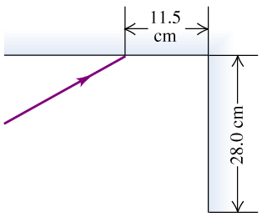

P2. After a long day of driving you take a late-night swim in a motel swimming pool. When you go to your room, you realize that you have lost your room key in the pool. You borrow a powerful flashlight and walk around the pool, shining the light into it. The light shines on the key, which is lying on the bottom of the pool, when the flashlight is held 1.2 m above the water surface and is directed at the surface a horizontal distance of 1.5 m from the edge, as shown in the figure below. If the water here is 4.0 m deep, how far is the key from the edge of the pool?
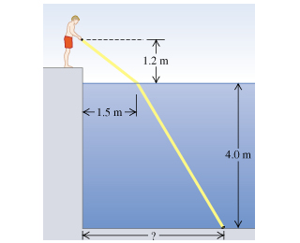

P3. You sight along the rim of a glass with vertical sides so that the top rim is lined up with the opposite edge of the bottom (see the figure (a) below). The glass is a thin-walled hollow cylinder 16.0 cm high with a top and bottom of the glass diameter of 8.0 cm. While you keep your eye in the same position, a friend fills the glass with a transparent liquid, and you then see a dime that is lying at the center of the bottom of the glass (see the figure (b) below). What is the index of refraction of the liquid?
