Homework Set 29C

PH 113 – 10

Q1. A sheet of copper is placed between the poles of an electro-magnet with the magnetic field perpendicular to the sheet. When the sheet is pulled out, a considerable force is required, and the force required increases with speed. Explain.

P1. A cardboard tube is wrapped with two windings of insulated wire wound in opposite directions, as shown in the figure below. Terminals a and b of winding A may be connected to a battery through a reversing switch. State whether the induced current in the resistor R is from left to right or from right to left in the following circumstances: (A) the current in winding A is from a to b and is increasing; (B) the current in winding A is from b to a and is decreasing; (C) the current in winding A is from b to a and is increasing.



P2. A small, circular ring is inside a larger loop that is connected to a battery and a switch, as shown in the figure below. Determine the direction of the current induced in the small ring (A) just after switch S is closed; (B) after S has been closed a long time; (C) just after S has been reopened after being closed a long time.

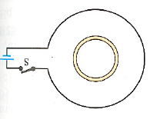

P3. A 0.360-m-long metal bar is pulled to the left by an applied force F. The bar rides on parallel metal rails connected through a 45.0-Ω resistor, as shown in the figure below, so the apparatus makes a complete circuit. You can ignore the resistance of the bar and rails. The circuit is in a uniform 0.650-T magnetic field in the direction indicated in the figure. At the instant when the bar is moving to the left at 5.90 m/s, (A) is the induced current in the circuit clockwise or counterclockwise and (B) what is the rate at which the applied force is doing work on the bar?

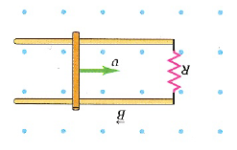

P4. A long, this solenoid has 900 turns per meter and radius 2.50 cm. The current in the solenoid is increasing at a uniform rate of 60.0 A/s. What is the magnitude of the induced electric field at a point near the center of the solenoid and (A) 0.500 cm from the axis of the solenoid; (B) 1.00 cm from the axis of the solenoid?