**PH 111** Fall Term 2016

Physics I

|  |
| --- |
|  |
| Practice Problems – Set B |

1. In our discussions in class about friction, this force is usually referred to as a loss and we typically would like to reduce this force as much as possible. Can friction ever be useful? Explain why or why not and give an example.
2. What must all objects that move along a circular path have? Explain.
3. A child pulls a wagon with some force, causing it to accelerate. Newton’s third law says that the wagon exerts an equal and opposite reaction force on the child. How can the wagon accelerate?

(*Continued on the back*)

1. A 0.15-kg ball is thrown vertically upward with an initial speed of 20 m/s. If air resistance is neglected, (A) what is the net force on the ball when it reaches half its maximum height? (B) What is the net force on the ball when it reaches its maximum height? Explain both answers.
2. In the model for friction, why is the static friction force larger than the kinetic friction force? Does making the surfaces perfectly smooth reduce friction to nearly zero? Explain.
3. List and describe the methods that can be used to electrify an object. Describe a process that would produce a net, positive charge on an initially neutral, metal sphere.

(*Continued on the next page*)

1. A student decides to move a box of books into her dormitory room by pulling on a rope attached to the box. She pulls with a force of 80.0 N at an angle of 25.0° with the horizontal. The box has a mass of 25.0 kg and the coefficient of kinetic friction between box and floor is 0.250. (A) Find the acceleration of the box. (B) Along the way, she must move the box up a ramp inclined at 10.0° with the horizontal (the coefficient of friction is 0.120). If the box starts from rest at the bottom of the ramp and is pulled at an angle of 25.0° with respect to the incline and with the same 80.0-N force, can it be moved up the ramp (assume that the two friction coefficients are the same)? If so, what is the acceleration up the ramp?

(*Continued on the back*)

1. Three charged particles are arranged as shown below. If each particle has a mass of 3 kg, (A) find the magnitude and direction of the electrostatic force on the 6.00-nC charge. (B) Find the magnitude and direction of the gravitational force on the 6.00-nC charged particle?



(*Continued on the next page*)

1. A 2.00-kg aluminum block and a 6.00-kg copper block are connected by a light string over a frictionless pulley. They are allowed to move on a fixed steel block-wedge (of angle θ = 30.0°) as shown below. Assuming that the coefficient of kinetic friction for the aluminum block is 0.470 and the coefficient of kinetic friction for the copper block is 0.360, determine (A) the acceleration of each block and (B) the tension in the string. If the system started from rest, (C) how far does the aluminum block move in 1.30 s? (D) What is the speed of the copper block after 1.30 s?



(*Continued on the back*)

1. A dockworker loading crates on a ship finds that a 20.0-kg crate initially at rest on a horizontal surface requires a 75.0-N force to set it in motion. However, after the crate is in motion, a horizontal force of 60.0 N is required to keep it moving with constant speed. (A) Find the coefficients of static and kinetic friction between the crate and floor. (B) If the worker applies 59.0 N horizontally to the moving box, what happens to the box? Explain. (C) If the crate is at rest and the dockworker applies 59.0 N horizontally to the box, what is the magnitude and direction of the friction force?

(*Continued on the next page*)

1. In a popular amusement park ride, a rotating cylinder of radius 3.00 m is set in rotation with a speed of 15.00 m/s as shown below, measured at the surface where the riders stand. The floor then drops away, leaving the riders suspended against the wall in a vertical position. What minimum coefficient of friction between a rider’s clothing and the wall is needed to keep the rider from slipping?

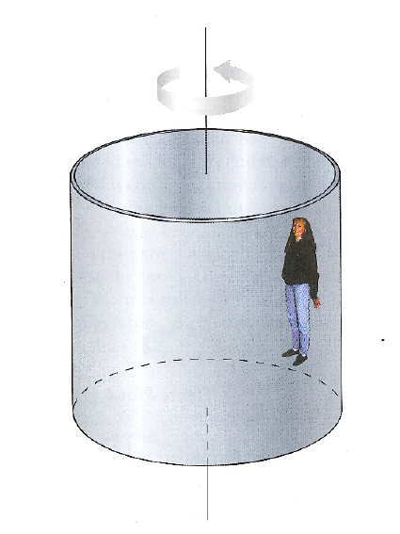

(*Continued on the back*)

1. Find the direction and calculate the magnitude of the magnetic force on the charged particles moving in the various situations shown below. Assume that the speed is 2 × 104 m/s and the magnitude of the magnetic field is 2.1 T.

