Example 8.

The switch has been opened for a long time and it closes at t=0. Determine the capacitor voltage and current.
Key steps to calculate the step response of the RC circuit.

- Find the initial voltage $V_{0}=v_{c}(0^{+})$ at $t=0^{+}$
and the final voltage $V_{f}=v_{c}(∞)$ as $t→∞$
- Find the time constant $τ=\text{RC}$
- $v_{c}(t)=V_{f}+(V_{0}−V_{f})e^{−\frac{t}{τ}}$

The initial voltage of the circuit
$v_{c}(0^{+})=v_{c}(0^{−})=0V$, $V_{0}=0V$
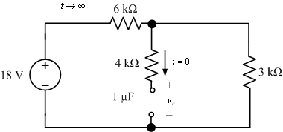
$$v_{c}(∞)=\text{18}×\frac{3}{6+3}=6V$$

$$τ=\text{RC}=\text{6000}×{\text{10}}^{−6}=0\text{.}\text{006}s$$
$v_{c}(t)=V_{f}+(V_{0}−V_{f})e^{−\frac{t}{τ}}=6+(0−6)e^{{−t}/0\text{.}\text{006}}=6−6e^{−\text{166}\text{.}7t}$V, t>0
$$i_{c}(t)=C\frac{{\text{dv}}_{c}}{\text{dt}}={\text{10}}^{−6}×(−6)×(−\text{166}\text{.}7)×e^{−\text{166}\text{.}7t}A=1e^{−\text{166}\text{.}7t}\text{mA}$$

