CSSE463 Image Recognition Lab 7 alternative: Hough Circle Finder

Deliverables:
All scripts/functions:
/60 correct and complete
Word doc with images all together, nicely formatted:
/30 pts: Demonstrated effort on finding circles: result images, discussion of results (positive and negative), image of parameter space (if you created one)
/10 pts: Professionalism

Overall Directions:
Your goal is to find circular objects in an image using a Hough transform. The input is a grayscale image, and the output is an image with the center and outline of all circular objects marked, e.g.:
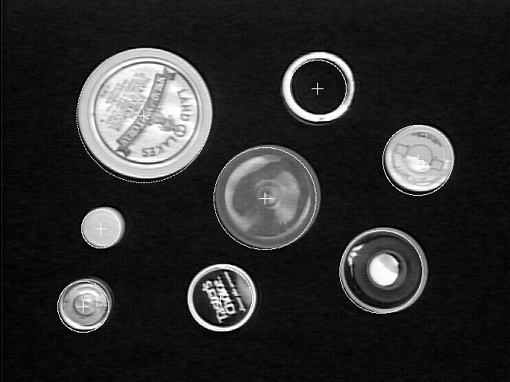
There are 3 test images. Since we aren’t using a machine-learned classifier, per se, you may tweak your system to work on this test set.
You may opt to implement your system to find fixed or arbitrary-radius circles.
You may want to make some preliminary test images that contain graphically generated perfect circles for debugging your program. You are permitted to use pre-existing software for low-level operations (e.g. image i/o, graphics, edgel finding etc.).
Hints:
- You will probably need to use gradient direction information to make your system run efficiently. It is up to you to determine how precise this is. Recall when doing these calculations that (x,y) corresponds to (col, -row) in images.
- You may resize your images down to make your alg. run more quickly. I resized down a factor of 2 using: img = imresize(img, 0.5, 'bilinear');
- A potentially tricky issue is figuring out how to partition the parameter space and detect the clusters. If your boxes are too small, none will ever accumulate enough votes to jump out (and you might run out of memory). If they are too big, the different circles will be confused.
- You want to output only one result per object, hence if you have circles that are concentric and of similar size (i.e., peaks that are near each other in the voting space), you will probably want to output only a single circle for the group.
- Large circles are expected to receive more votes (since they have more edge points). You might want to try to exploit this by using a threshold that’s a function of the size of the circle you are trying to find.
Acknowledgement: this lab was borrowed in large part from my computer vision professor at Rochester, Dr. Randal Nelson. http://www.cs.rochester.edu/~nelson/courses/vision/

