ES205 Analysis and Design of Engineering Systems:

Modeling-- We modeled systems using ideal elements and then applied basic principles to obtain governing differential equations.

Analysis-- We solved the governing equations to gain insight that can be used in designing systems.
-- Exact solutions
-- Numerical solutions (Simulink and Matlab)
-- Design Space
-- Other domains
-- s-domain
-- frequency domain

Design:
-- Worked in teams
-- Oral presentations
-- Peer evaluations
-- Report writing

Lecture Topics:
Modeling:
1) Mechanical Systems
2) Electrical Systems
3) Electromechanical Systems
4) Thermal Systems
5) Fluid Systems
6) Hydraulic Systems
7) Model Forms and Notation

Analysis:
1) Numerical Solutions
2) First Order Systems
3) Second Order Systems
4) Frequency Response Plots (Bode Diagrams)

1) Mechanical Systems
a) system elements such as mass, spring, and dampers
b) springs in series/parallel
c) gears
d) translational and rotational systems
k_{eq}
x₂
x₁
F
F
v₂(t)
v₁(t)
c
F
F
Spring: Damper:

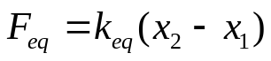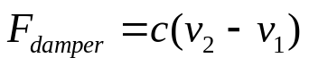

Spring in Series: Springs in Parallel:
k₁
k₂
k₃
k₁
k₂
k₃

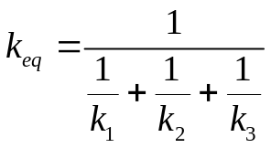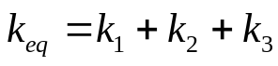
Gears:
N₂
N₁
θ₂
s₁ s₂
θ₁
R₂
R₁
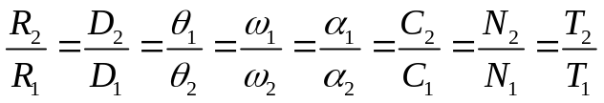

J
k_{θ}
θ

T
B
f(t)
x(t)
m
k
c
Translational System: Rotational System:

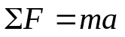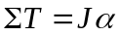

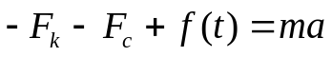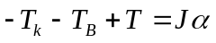
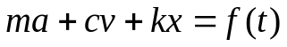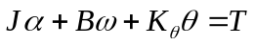
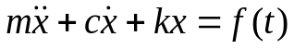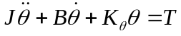
k_{θ}θ
T
Bω
J
α
a
m
f(t)
kx
cv

2) Electrical Systems
a) Resistance, Capacitance, Inductance
b) Complex Impedance
c) Complex Impedance in series and parallel
d) RLC circuits
e) Op Amps (two rules)
R
v_{B}
v_{A}
i
Resistor: time domain s domain Impedance:

v_{a} - v_{b} = i R V_{a} -V_{b} = I R Z_{R} = R

Capacitor:
v_{B}
i
C
v_{A}
i = C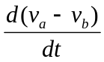 I = 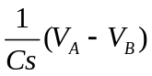 Z_{C} = 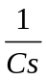

v_{A}
L
v_{B}
i
Coil:
v_{a} - v_{b} = L 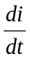 V_{a} - V_{b} = Ls I Z_{L} = L s

Impedance in Series: Impedance in Parallel:
Z₂
Z₃
Z₁
Z₁
Z₂
Z₃
Z_{eq} = 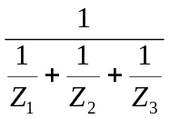
Z_{eq} = Z₁ + Z₂ + Z₃

Example RCL circuit: Op Amp Rules: if feedback
v_{i}(t)
i₁

R
L
C
i₂

i₃

v_{o}
I_{p}
V_{n}
+
I_{n}
-
V_{p}
Rule 1:
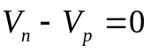

Rule 2:
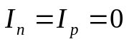
I₁ - I₂ - I₃ = 0 (Eq 1)

V_{i} -V_{o} = I₁ R (Eq 2) Common Op Amp Circuit:

I₂ = 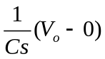 (Eq 3) 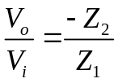
V_{o}
-
+
Z₂
Z₁
V_{i}

V_{o} - 0 = Ls I₃ (Eq 4)

3) ElectricalMechanical systems
a) DC Motors--armature controlled
b) DC Motors-- field controlled
b) Combination systems

Armature Controlled DC Motor Field Controlled DC Motor:
R_{A}

L_{A}
+
θ_{M}, ω_{M}
v_{b}
K_{E},K_{T}
i_{A}
-
i_{f}
J, c
T_{d}
v_{in}
+
θ_{M}, ω_{M}
v_{b}
K_{E},K_{T}
-
i_{A}
J, c
T_{d}
L_{f}
R_{f}

v_{in}
i_{f}
R_{A}

L_{A}

Mathematical Models:
Armature Control Motor Model: Field Control Motor Model:
Electrical Model Electrical Model
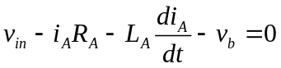 (Eq 1) 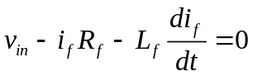 (Eq 1)

and 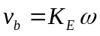 (Eq 2) 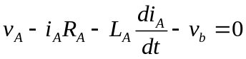 (Eq 2)

and 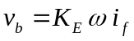 (Eq 3)

Mechanical Model Mechanical Model
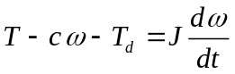 (Eq 3) (Eq 4)

and 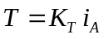 (Eq 4) and 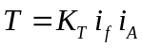 (Eq 5)

v_{in} = control voltage v_{b} = motor back emf
i_{A} = armature current i_{f} = field current
T = motor torque T_{d} = disturbance torque on shaft
J = motor inertia c = motor damping constant
ω= speed of motor
R_{A} = Armature Resistance R_{f} = field resistance
L_{A} = Armature inductance L_{f} = field inductance
K_{E} = motor back EMF constant K_{T} = motor torque constant

4) Thermal Systems
a) Conduction, Convection, Radiation
b) Lumped Capacitance
c) Biot Number

Conduction: Lumped Thermal Storage System:
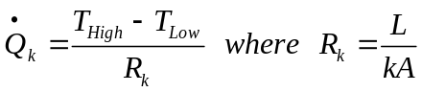
.
W_{in}
U_{sys}
.
Q_{out}
.
Q_{in}
where k is the thermal conductivity

Convection:
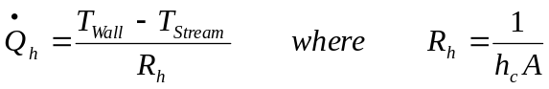
where h_{c} is the convection coefficient from Conservation of Energy:

Radiation: 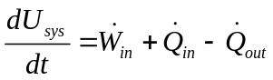
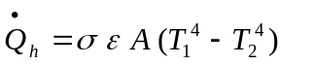 or
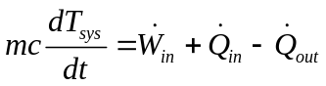
where σ is the Stefan-Boltzman constant
and ε is the emissivity

Test for Valid Lumped Thermal System:

If Bi < 0.1 , then the system may be treated as a lumped thermal system.
where 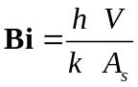
.
Q
h_{c}
T_{fluid}
T
m
Typical Lumped Thermal System Problem:
R_{conv}
T
C_{th} = m c

.
Q
T_{fluid}

Model:
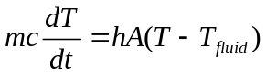

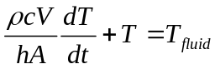

5) Fluid Systems
a) Tank draining problems

Continuity Equation: Bernoulli's Equation with External Work Term:
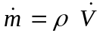 = ρ v A 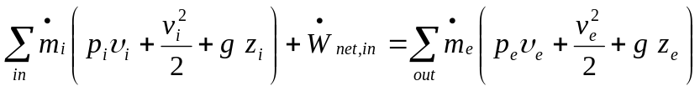
Conservation of mass:
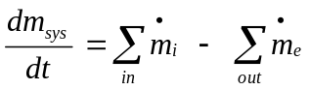 or 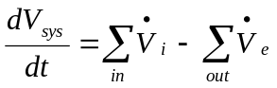

Static fluid pressure: Discharge coefficient relationship:
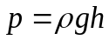 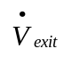 = A_{e} 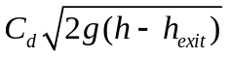
h
A_{i}
A_{exit}
V_{e}
V_{i}
h_{exit}
.
.

Tank Draining:
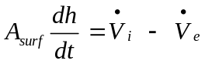
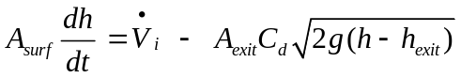

6) Hydraulics:
Spool Valve: Piston:
x
.
V
.
V
K_{v}
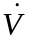 = K_{v} x 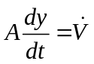
y
.
V
System

x
z
L₂
L₁
y

Lever:

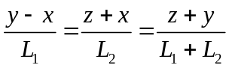

7) Model forms and notation: Simulation Diagram:
a) Block and simulation diagrams

m
+
-
-
f
x

K_{B}
K_{C}
.
x
..
x
1
K_{A}
b) ODEs
c) Transfer functions
d) State space
e) Input-Output

DE Model (2nd order equation):
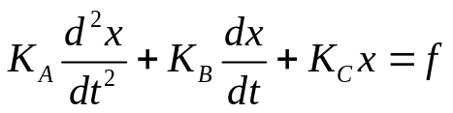 or 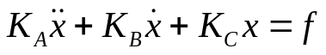

DE Model (Set of 1st order equation):
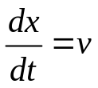 or 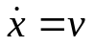
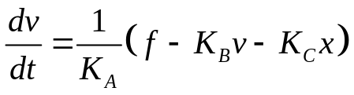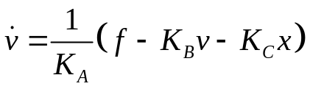

State Space Form:
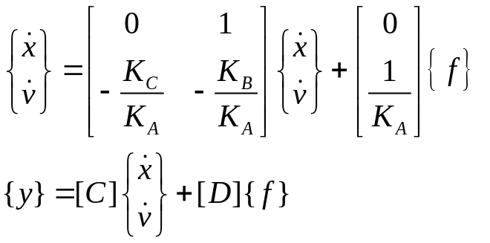

Transfer Function: Input/Output:
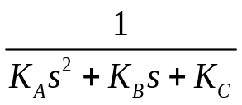
F(s)
X(s)
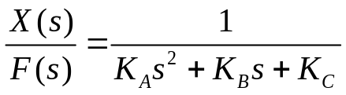

Analysis:
1) Numerical solutions (Simulink, Matlab, and Maple)

2) First Order Systems 1st Order Standard Form:
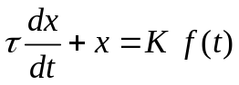
a) Standard form
b) Free response
c) Step response
d) Harmonic response where τ = time constant
e) System identification K = static gain
and parameter estimation
t
X_{o}
63%
of X_{o}
86%
of X_{o}
95%
of X_{o}
t = τ
t = 3τ

t = 2τ
0
Free Response: f (t) = 0

Settling Time:
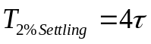
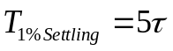

Step Response: f (t) = A u(t)
t
KA u_{o}
63%
86%

95%
98%
initial slope =
t-t_{o}=0τ
Response
t-t_{o} = 1τ

t-t_{o}= 2τ

t-t_{o}= 3τ

t-t_{o} =4τ

Settling Time:
Static Gain:
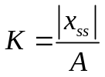

Harmonic Response: where f (t) = A cos(ω_{f} t) or A sin(ω_{f} t)
Magnification factor:
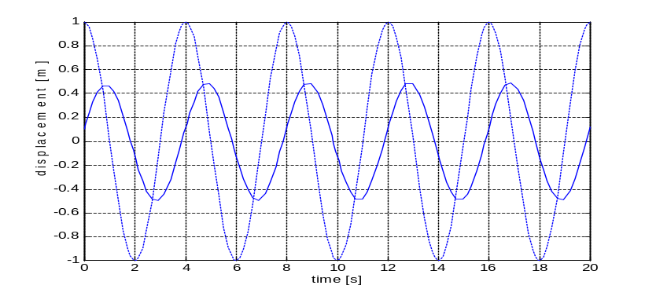

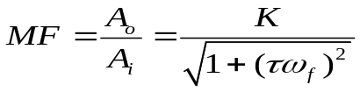
A_{i}
A_{o}
Phase angle:
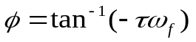

Steady State Response:
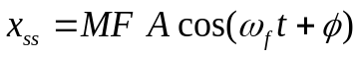

Measured from Plot
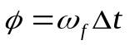 (lag)

3) Second order systems
a) standard form
b) free response
c) step response
d) harmonic excitation
e) system identification and parameter estimation

Free Response: f(t) = 0:
Overdamped solution:
t
Underdamped solution:
t
Critically damped solution:
t

Logarithmic decrement: Damped natural frequency
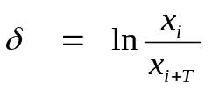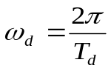

Damping ratio Undamped natural frequency
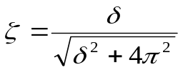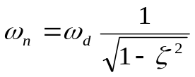

2% Settling Time: 1% Settling Time:
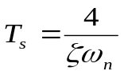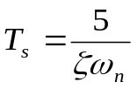

Second order systems...continued

Step Response: f(t) = A u(t)

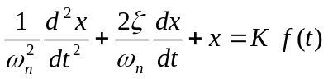
t
Overdamped:
and
Critically Damped:

t
Underdamped:

Logarithmic decrement: Damped natural frequency
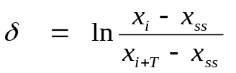

Damping ratio Undamped natural frequency

Steady State Response, x_{ss} or x∞ = K (static gain)

Rise Time, T_{rise}:
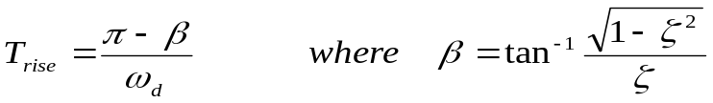

% Overshoot (%OS):
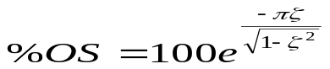

2% Settling Time: 1% Settling Time:

t

Second order systems...continued

Harmonic response: f(t) = A cos(ω_{f} t + λ) or A sin(ω_{f} t +λ)
A_{i}
A_{o}

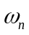= undamped natural freq.
ζ = damping ratio
K = static gain

Steady-State response:

Magnification factor: Output Phase angle:
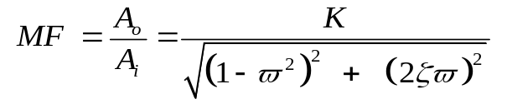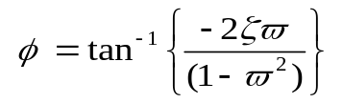

Normalized frequency Measured from Plot
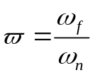

Phasor Notation:

C = a + i b = C e^{iθ} = C 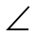 θ
where C = 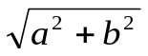
and θ = tan⁻¹(b/a)

Mulitple Harmonic Input Response: 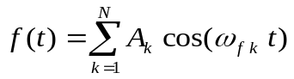

or
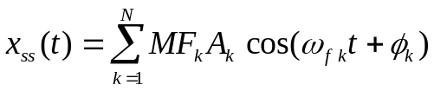
where and
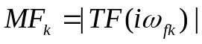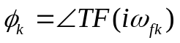

4) Frequency response plots (Bode Plots)
a) Read magnitude and phase to find steady state response
c) Interpreting Bode plots to find transfer function
d) Straight line asymptotic approximations system identification
e) Exact frequency analysis with Matlab and/or Maple
Term Type: TF: Log Magnitude Phase Angle
--------------------------------------------------------------------------------------------------------------------.
0 db
20 log₁₀(K)
0º
-180º
for K<0
0º
for K>0

Constant K
Gain

-------------------------------------------------------------------------------------------------------------------.
20 db/dec log₁₀(K)
0º
0 db
180º
n=2
n=1
n= -1
n= -2
90º
-90º
-180º
n= -2
n= -1
n=1
n=2
-20 db/dec log₁₀(K)
-40 db/dec log₁₀(K)
40 db/dec log₁₀(K)
ω =1
Pole/zero s^{n}
at
origin

----------------------------------------------------------------------------------------------------------------.
0º
-45 º/dec log₁₀(K)
10*ω_{break}
0.1*ω_{break}
-90º
1st order Pole
0 db
ω_{break}
-20 db/dec log₁₀(K)
not at origin
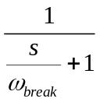
1st order Zero
0 db
ω_{break}
+20 db/dec log₁₀(K)
0º
+45 º/dec log₁₀(K)
10*ω_{break}
0.1*ω_{break}
90º
not at origin
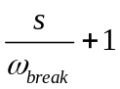

-----------------------------------------------------------------------------------------------------------------.
0º
-90 º/dec log₁₀(K)
10*ω_{break}
0.1*ω_{break}
-180º
0 db
ω_{break}
-40 db/dec log₁₀(K)
0 db
ω_{break}
+40 db/dec log₁₀(K)
2nd order Pole
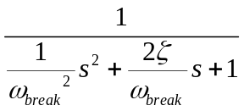

+90 º/dec log₁₀(K)
0º
10*ω_{break}
0.1*ω_{break}
180º
2nd order Zero


