IRPA Integrated Dynamical Systems Modeling (Summer 2003)
Report

Prepared for:

Robert Throne, Bradley T. Burchett, Frederick Berry, and David Purdy
Electrical and Computer Engineering Department

Prepared by:

Gwen Lee-Thomas, Director of Assessment
Office of Institutional Research, Planning and Assessment
Rose-Hulman Institute of Technology


Rose-Hulman Institute of Technology
Office of Institutional Research, Planning and Assessment
5500 WABASH AVENUE-CM11 TERRE HAUTE, INDIANA 47803-3999
TELEPHONE: (812) 877-8816 FAX: (812) 877-8931 EMAIL: irpa@rose-hulman.edu

Office of Institutional Research, Planning and Assessment

MEMORANDUM

DATE: July 22, 2003
TO: Throne, Burchett, Berry, and Purdy
Electrical and Computer Engineering Department
FROM: Gwen Lee-Thomas
SUBJECT: Formative Report Summary on Integrated Dynamical Systems Modeling Baseline Survey

The Office of Assessment has completed the preliminary analysis of the baseline data surveys administered during the spring quarter of 2003. Two surveys (with identical content) were administered to student in the ECE department. One survey was entitled “Analysis and Design of Engineering Systems Course Survey” administered to students in ES-205 and the second survey was entitled “Linear Control Systems Course Survey” administered to students in ECE-320. There were 157 students who completed the surveys, 130 were enrolled in ES-205, 27 were enrolled in ECE-320, 24 were female, 122 were male and 11 students’ gender identification was not available in the Banner system. In terms of majors, 6 were computer engineering, 54 were electrical engineering, 84 were mechanical engineering, and 11 students did not have major-identification data in the Banner system.

The survey consisted of eight items relevant to integrated dynamical systems modeling concepts. Students indicated their level of knowledge and their level of confidence in each of the concepts before and after taking the course. There were also four attitudinal survey items as well as an opportunity for students to offer suggestions on ways of improving the course.

The findings indicated that overall students’ level of knowledge of and confidence in apply the concepts resulted in a statistically significant increase after taking the course. There were also findings that revealed statistical differences in student responses based on gender, major, and course. Gender differences occurred with item #15 with regard to knowledge after taking the course (“Trade-offs between the state variable model and a transfer function model.”)—in that female students had a higher mean score (Mean = 3.29) than male students (Mean = 2.919).

Students provided 139 comments that covered classroom assignments and workload, laboratory assignments and workload, homework and overall perceptions of the course. Generally, students enjoyed the course and agreed that the course helped them better understand the use of models, the limitations of models, and how modeling can be applied in engineering courses.

IRPA Integrated Dynamical Systems Modeling (Summer 2003)
Table of Contents

 | PAGE
INTRODUCTION |  | 2
METHODOLOGY
Participants.................................................................................................................. |  | 4
Statistical Analysis……................................................................................................ |  | 4
FINDINGS
Overview...................................................................................................................... |  | 5
ES-205 and EC-320 Comparisons.............................................................................. |  | 6
Comparisons by Major ……………………………………………………………………. |  | 8
Comments ………………………………………………………………………………… |  | 9
SUMMARY |  | 11
ATTACHMENTS
Attachment I--ES-205 Analysis and Design of Engineering Systems Course Survey
Attachment 2--ECE-320 Linear Control Systems Course Survey
Attachment 3-- ES-205 Analysis and Design of Engineering Systems Course Survey Results by Percent
Attachment 4--ECE-320 Linear Control Systems Course Survey Results by Percent

IRPA Intergrated Dynamical Systems Modeling (Summer 2003)
Introduction

During the spring quarter of 2003, the Office of Assessment in the Office of Institutional Research, Planning and Assessment worked with the Electrical and Computer Engineering faculty project leaders in the design of the Integrated Dynamical Systems Modeling Survey for students enrolled in ES-205 and ECE-320. The purpose of the survey was to gather baseline information regarding students’ ability to apply various concepts related to Integrated Dynamical Systems Modeling (IDSM) prior to implementing a laboratory specifically designed to help students make clear distinctions between mathematical systems and real systems by comparing the behavior of the model with that of the real system.

The survey contained four sections. The first section allowed students to identify their level of knowledge and confidence in applying various concepts with regard to systems modeling before taking the course. The second section of the survey allowed students to identify their level of knowledge and confidence in apply the same concepts after taking the course. Students selected responses using a 4-point Likert scale indicating their level of knowledge and also confidence as “High,” “Moderate,” “Low,” of “No Clue.” The rubrics for each of these scaled responses are shown in Table 1.

Table 1
Rubrics for Response Scale on Survey
Summer 2003
BEFORE
Level of Knowledge | Rubric
High | I knew the concept and had applied it.
Moderate | I knew the concept but had not applied it.
Low | I had only heard about the concept.
No Clue | This concept was new to me.
Level of Confidence | Rubric
High | I was confident that I understood and could apply the concept in this area.
Moderate | I was somewhat confident that I understood the concept and was fairly sure I could apply it to a new problem.
Low | I had heard of the concept but had little confidence that I could apply it.
No Clue | I was not confident I could apply the concept.

AFTER
Level of Knowledge | Rubric
High | I know the concept and I have applied it.
Moderate | I know the concept but I still have not applied it.
Low | I have only heard about the concept.
No Clue | This concept is new to me.
Level of Confidence | Rubric
High | I am confident that I understand and can apply the concept to problems.
Moderate | I am somewhat confident that I understand the concept and am fairly sure I can apply it to a new problem.
Low | I have heard of the concept by have little confidence that I can apply it.
No Clue | I am not confident that I can apply the concept.

The third section of the survey included statements regarding students’ attitude toward systems modeling. Student responses were indicated on a 5-point Likert scale which included “Strongly Agree,” “Agree,” “Disagree,” “Strongly Disagree,” “I Don’t Know” with a rating value of 4, 3, 2, 1, and 0, respectively. The third section of the survey included one question that asked students “what three changes would you suggest for this course that would help students better understand the concepts?”

IRPA Integrated Dynamical System Modeling (Summer 2003)
Methodology

Participants
The survey was administered during the last week of class in ES-205 and ECE-320. Of the 157 students who responded, 130 were in ES-205 and 27 were in ECE-320. In terms of gender, respondents included 24 female, 122 male and 11 students whose gender identification was not available in the Banner system. In terms of major, 6 students were computer engineering, 54 were electrical engineering, 84 were mechanical engineering, and 11 students did not have a major identified in the Banner system. Also, one student indicated chemical engineering and one student indicated math.

Statistical Analysis

The student responses from the survey were analyzed and presented in three ways. First, student responses were calculated by percent separated by course (ES-205 and ECE-320). Second, the Independent T-Test statistic was conducted when comparing the mean scores between before and after responses; male and female students; and ES-205 and ECE-320 students. The third statistic included a One-Way ANOVA statistic that compared mean scores among three groups (EE, ME and CPE). Due to having only one respondent majoring in chemical engineering and one respondent majoring in mathematics, their information was not included in the One-Way ANOVA analysis.

Data Collection Process

After the Office of Assessment and one of the project leaders finalized the survey, paper-copies were made then distributed to students in both ES-205 and ECE-320. Students were administered the survey during the last week of class.
IRPA Integrated Systems Dynamical Modeling (Summer 2003)
Findings

Overall, students indicated that their level of knowledge and confidence in knowing and applying the various systems modeling concepts improved on all concepts. There was a significant difference between the mean scores of student responses when comparing their before and after responses. See Figure 1a and 1b. See Attachment I for concepts codes.

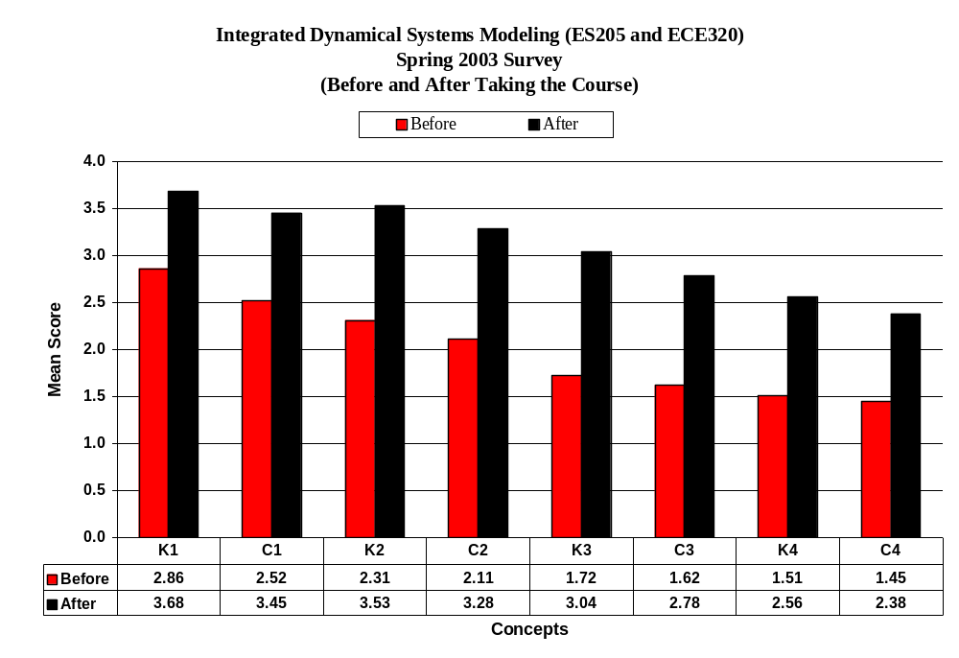
Figure 1a: K1-C4
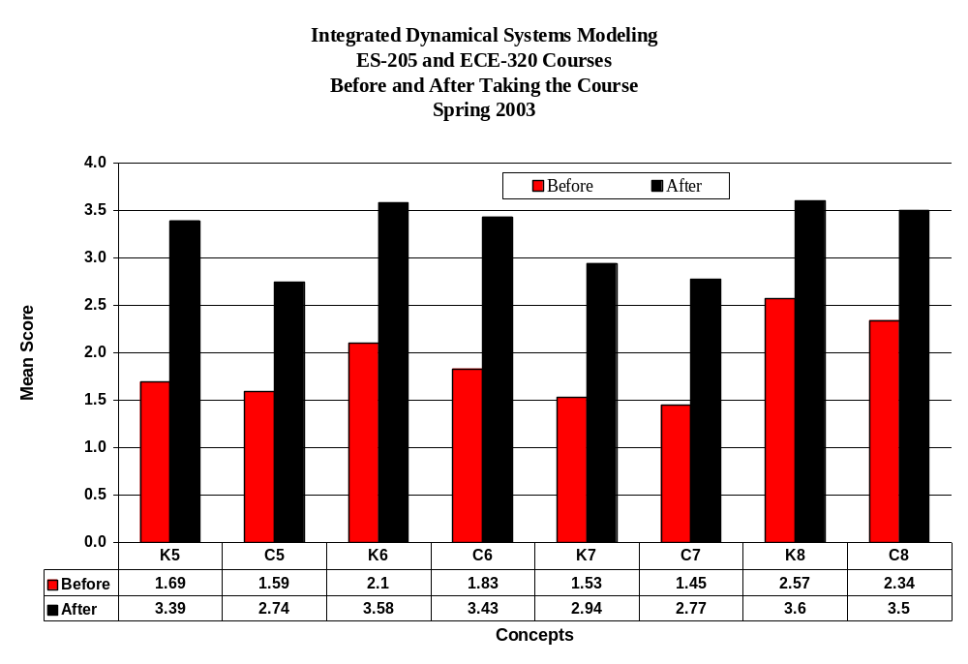
Figure 1b: K5 through C8

The results indicate that the greatest increase with regard to knowledge occurred with K5 “Benefits of a state variable model,” K7 “Trade-offs between the state variable model and a transfer function model,” and K3 “Benefits of feedback control systems.” In terms of increases in mean score with regard to confidence, the greatest increase occurred with C-6 “Benefits to transfer function model,” C7 “Trade-offs between the state variable model and a transfer function model,” and C-2 “Various approaches to modeling dynamical systems.” Of the increases in mean scores from before to after, the smallest increases occurred with K1, C1, and C4.

ES205 and ECE320 Comparisons:

When responses were separated by course, there were several differences that were significant when comparing ES-205 and ECE-320 student responses. Before the course was taken ECE-320 students indicated a statistically significant higher mean score than ES-205 in K3, C3, K4, C4, K5, C5, C6, K7 and C7. After taking the course ECE-320 had a significantly higher mean score than ES-205 in K11 and C11. However, ES-205 had significantly higher mean scores than ECE-320 after taking the course with concepts K9, K10, K16, and C16. See Table 2. Overall student responses by percent rate are shown in Attachment III and IV.

Table 2
Integrated Dynamical Systems Modeling Project
ES-205 and ECE-320 Course Survey Mean Scores
Spring 2003

BEFORE
CONCEPTS | ES-205 |  | ECE-320
CONCEPTS | Knowledge | Confidence | Knowledge | Confidence
- Distinctions between a model and a real dynamical system. | 2.85 | 2.52 | 2.93 | 2.52
- Various approaches to modeling dynamical systems. | 2.28 | 2.08 | 2.41 | 2.22
- Benefits to feedback control systems. | 1.64 | 1.53 | 2.11 | 2.07
- Size limitations on control signals of real systems. | 1.45 | 1.40 | 1.81 | 1.69
- Benefits of a state variable model. | 1.59 | 1.52 | 2.15 | 1.93
- Benefits of a transfer function model. | 1.97 | 1.65 | 2.70 | 2.67
- Trade-offs between the state variable model and a transfer function model. | 1.44 | 1.35 | 1.96 | 1.93
- Comparisons between predicted response of a mathematical model and the response of a physical system. | 2.55 | 2.32 | 2.67 | 2.44

AFTER
CONCEPTS | ES-205 |  | ECE-320
CONCEPTS | Knowledge | Confidence | Knowledge | Confidence
- Distinctions between a model and a real dynamical system. | 3.73 | 3.51 | 3.38 | 3.19
- Various approaches to modeling dynamical systems. | 3.57 | 3.32 | 3.31 | 3.08
- Benefits to feedback control systems. | 2.95 | 2.70 | 3.46 | 3.19
- Size limitations on control signals of real systems. | 2.60 | 2.42 | 2.35 | 2.15
- Benefits of a state variable model. | 3.49 | 2.74 | 2.88 | 2.69
- Benefits of a transfer function model. | 3.61 | 3.47 | 3.42 | 3.27
- Trade-offs between the state variable model and a transfer function model. | 2.97 | 2.78 | 2.77 | 2.69
- Comparisons between predicted response of a mathematical model and the response of a physical system. | 3.66 | 3.58 | 3.31 | 3.08

With regard to students’ attitude toward systems modeling, there was a statistical difference between ES-205 and ECE-320 in that students enrolled in ES-205 had a stronger agreement that “This class helped me better understand how modeling systems can be applied in engineering situations,” and “This class has helped me to better understand the frequency response of a system.” With regard to ability to develop various models, again ES-205 had significantly higher agreement than ECE-320 on all models except electrical systems. See Table 3.

Table 3
Integrated Dynamical Systems Modeling
ES-205 and ECE-320 Course Surveys Mean Scores
Attitude Toward Systems Modeling (Q17-Q21e)
Spring 2003

Concepts | ES-205 | ECE-320
- As a result of this class, I understand the uses of models in ways that will help me in future classes. | 3.36 | 3.22
- As a result of this class, I understand the limitations of models in ways that will help me in future classes. | 3.52 | 2.85
- This class has helped me to better understand how modeling systems can be applied in engineering situations. | 3.40 | 2.79
- This class has helped me to better understand the frequency response of a system. | 3.29 | 3.00
- I can develop a model for . . .
- Electrical Systems | 3.31 | 3.48
- Mechanical Systems | 3.55 | 2.79
- Thermal Systems | 3.08 | 2.17
- Fluid Systems | 3.19 | 2.08
- Multidisciplinary Systems | 2.98 | 2.58

Comparisons by Major:

Student responses were also separated by major. These findings revealed statistically significant differences between electrical engineering (EE) students and mechanical engineering (ME) students on several items. Specifically, EE students had higher mean scores on K3, K6 and C6 than ME students before taking the class and ME students had a significantly higher mean score on K9, C9, K10, C14 and C16 than EE students after taking the class. It appeared that prior to taking the class EE students have higher knowledge of “Benefits of feedback control systems” and “Benefits of transfer function model” than ME students. EE students also appeared to have greater confidence in their ability to apply “Benefits of a transfer function model” than ME students. However, after taking the course, ME students indicated a higher knowledge of “Distinctions between a model and a real dynamical system,” and “Various approaches to modeling dynamical systems.” In addition ME students indicated a higher confidence in applying “Distinctions between a model and a real dynamical system,” “Benefits of a transfer function model” and “Comparisons between predicted response of a mathematical model and the response of a physical system.”

With regard to attitude toward dynamical systems modeling, more ME students indicated a stronger agreement than EE students that they better “. . . understand the uses of models in ways that will help them in future classes,” “[The class had helped them] better understand how modeling systems can be applied in engineering situations” and “The class had helped [them] to better understand the frequency response of a system.”

In terms of being able to develop various models, EE students indicated a higher agreement with developing electrical systems models and mechanical systems models than ME or Computer Engineering (CPE) students. However, ME students indicated a higher agreement than EE students that they could develop thermal systems models, and CPE indicated a higher agreement that they could develop fluid systems models and multidisciplinary systems models than ME or EE. See Figure 3.

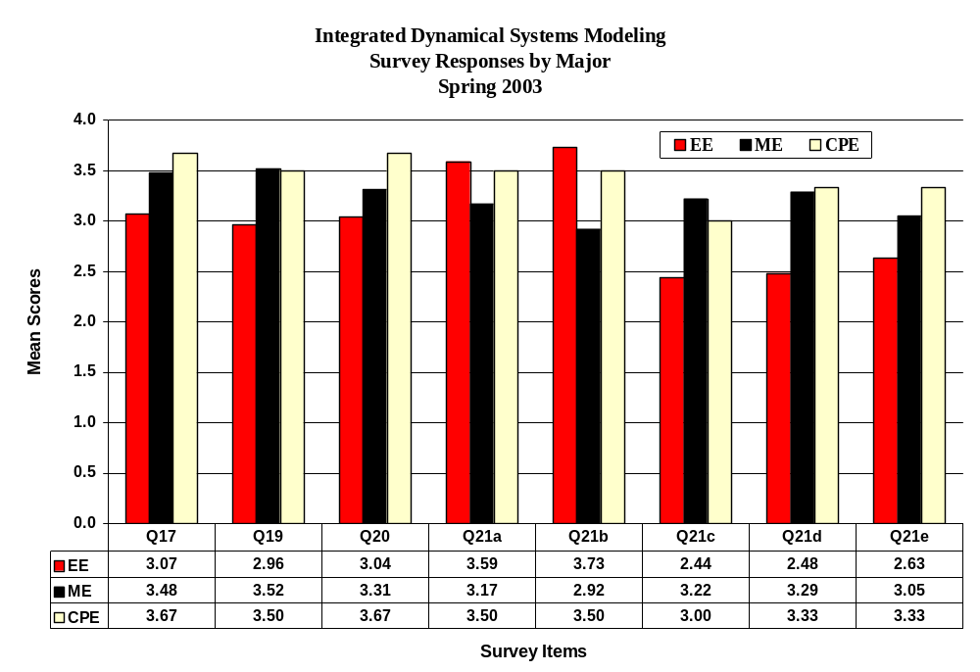

Comments:

The final section on the survey included the following question “What three changes would you suggest for this course that would help students better understand the concepts?”

Student comments covered basically four areas which included the classroom assignments and workload, laboratory work, homework, and overall perception of the course. Within each of these areas 139 students in both the ES-205 and the ECE-320 courses provided similar comments.

Classroom Assignments:

The students indicated that the subject matter was sometimes covered too fast. Twenty-three students (17%) indicated that they would prefer either more time on certain topics or fewer topics. For example, the students would have preferred spending more time on multidisciplinary systems which was viewed as a culminating understanding of the more specific systems. In addition to this, students would have preferred three tests instead of two given the amount of information that was covered on each test. Other comments on classroom assignments included students’ preference for more visual aides, movies and interactive hands-on activities (8%); more real-world examples (16%); and a preference for faculty developing a uniform way of teaching DE across the curriculum. Students also commented that they would prefer more quizzes (even daily) to help them keep abreast of the various concepts that were taught in the course.

Laboratory Work:

There were 33 comments regarding laboratory work and assignments, representing 24% of the 139 comments. Students indicated that the laboratory work needed to have a stronger and clearer connection to the coursework and homework. Other comments alluded to the work being too demanding, in some cases busy-work, a need for more explanations in the lab, an opportunity to compare the data collected during lab-time to models that were made, and a clearly defined checklist of steps.

Homework:

Of the 18 students who commented on the homework (13%), most students indicated that the homework problems should either be fewer in number or given less frequently. The homework problems were given twice a week and extended for 30 or 40 pages. Students also would like to have the homework problems returned sooner, preferred more review sessions, and fewer “plug-n-chug” problems.

Overall Perceptions:

There were three sub-areas with regard to students overall perceptions of the course which included, using a textbook or more organized notes for the course (24%); pre-requisites for the course and what groups should be included (7%); and the overall grading process used with the lab-work and homework (4%). Students indicated that the course needed to have a textbook or a set of organized notes, because there were too many notes that were taken during class. Students also indicated that the class appeared to be heavy toward electrical engineering students and should include more examples and information with a mechanical engineering focus. Students also indicated that the teaching should be sensitive to those students who do not have MATLAB experience. In some cases, students indicated that there needed to be more tutorial with MATLAB while others indicated that there was too much coverage of MATLAB.

A concern students expressed was the objectivity of the grading process. Several students indicated that the grading should include the work completed instead of their use of English. This concern was expressed for laboratory work as well as homework. Finally, students indicated that they would like to have certain directions since they did not prefer guessing at the answer and checking it with the system. See Attachments III and IV.

Figure 1: Chart Description
IRPA Integrated Dynamical Systems Modeling (Summer 2003)
Summary

Summary

Overall, students indicated that their level of knowledge and level of confidence in applying the concepts improved, and statistically, their responses improved significantly. More specifically, EE indicated a higher knowledge and confidence level than ME and CPEs before the course, however, ME students and CPE student responses increased statistically higher than EEs. Also, there were several concepts that were statistically different when comparing the responses of students enrolled in ES-205 and ECE-320 with concepts before taking the course. Students enrolled in ECE-320 indicated a higher mean score in several concepts with regard to knowledge and confidence than those students enrolled in ES-205 before taking the course. However, after taking the course ES-205 students indicated a higher knowledge and confidence level with all concepts except “Benefits of feedback control systems.”

When survey responses were separated by gender, there was only one concept that was statistically different. Female students indicated at a higher level their knowledge about “Trade-offs between the state variable model and a transfer function model” than male students—3.29 and 2.91, respectively.

In summary, students’ indication of their level of knowledge and confidence in applying various integrated dynamical systems modeling improved from the beginning of the course to the end of the course with suggestions to include a textbook or more organized notes, make the laboratory, homework and class lectures more congruent, and using more interactive materials in the classes.

IRPA Integrated Dynamical Systems Modeling (Summer 2003)
Attachments

Attachments
- ES-205 Analysis and Design of Engineering Systems Course Survey
- ECE-320 Linear Control Systems Course Survey
- ES-205 Analysis and Design of Engineering Systems Course Survey Results by Percent
- ECE-320 Linear Control Systems Course Survey Results by Percent

Rose-Hulman Institute of Technology
ES-205 Analysis and Design of Engineering Systems Course Survey
Spring 2003

Please use the following scale to indicate the level of knowledge and confidence you have in your ability in each of the following areas BEFORE taking this course:
Knowledge: What you knew regarding this concept area.
4 = High, I knew the concept and had applied it. 2 = Low, I had only heard about the concept.
3 = Moderate, I knew the concept but had not applied it. 1 = No Clue, this concept was new to me.

Confidence: Level of confidence you had in your ability to solve problems in this area.
4 = High, I was confident that I understood and could apply the concept to problems.
3 = Moderate, I was somewhat confident that I understood the concept and was fairly sure I could apply it to a
new problem.
2 = Low, I had heard of the concept but had little confidence that I could apply it.
1 = No Clue, I have no idea if I can apply the concept.

Course Concepts | Level of Knowledge | Level of Confidence
- Distinctions between a model and a real dynamical system.
- Various approaches to modeling dynamical systems
- Benefits of feedback control systems.
- Size limitations on control signals of real systems.
- Benefits of a state variable model.
- Benefits of a transfer function model.
- Trade-offs between the state variable model and a transfer function model.
- Comparisons between predicted response of a mathematical model and the response of a physical system.

Please use the following scale to indicate the level of knowledge and confidence you have in your ability in each of the following areas AFTER taking this course.
Knowledge: What you know regarding this concept area.
4 = High, I know the concept and I have applied it in this course.
3 = Moderate, I know the concept but I still have not applied it.
2 = Low, I have only heard about the concept, but do not know it well enough to apply it.
1 = No Clue, I do not know the concept.

Confidence: Level of confidence you have in your ability to solve problems in this area.
4 = High, I am confident that I understand and can apply the concept to problems.
3 = Moderate, I am somewhat confident that I understand the concept and I can apply it to a new
problem.
2 = Low, I have heard of the concept but I am not sure that I can apply it.
1 = No Clue, I am not confident that I can apply the concept.

Course Concepts | Level of Knowledge | Level of Confidence
- Distinctions between a model and a real dynamical system.
- Various approaches to modeling dynamical systems
- Benefits of feedback control systems.
- Size limitations on control signals of real systems.
- Benefits of a state variable model.
- Benefits of a transfer function model.
- Trade-offs between the state variable model and a transfer function model.
- Comparisons between predicted response of a mathematical model and the response of a physical system.

Please use the following scale to respond to questions 17 – 21.

Strongly Agree | Agree | Disagree | Strongly Disagree | I Don’t Know
4 | 3 | 2 | 1 | 0

- _____ As a result of this class, I understand the uses of models in ways that will help me in future
classes.
- _____ As a result of this class, I understand the limitations of models in ways that will help me in
future classes.
- _____ This class has helped me better understand how modeling systems can be applied in
engineering situations.
- _____ This class has helped me to better understand the frequency response of a system.
- I can develop a model for . . . (Please use the scale above)
(a) _____ Electrical Systems (b) _____ Mechanical Systems (e) ____ Multidisciplinary Models
(c) _____ Thermal Systems (d) _____ Fluid Systems

- What three changes would you suggest for this course that would help students better understand the concepts.

Rose-Hulman Institute of Technology
ECE-320 Linear Control Systems Course Survey
Spring 2003

Please use the following scale to indicate the level of knowledge and confidence you have in your ability in each of the following areas BEFORE taking this course:
Knowledge: What you knew regarding this concept area.
4 = High, I knew the concept and had applied it. 2 = Low, I had only heard about the concept.
3 = Moderate, I knew the concept but had not applied it. 1 = No Clue, this concept was new to me.

Confidence: Level of confidence you had in your ability to solve problems in this area.
4 = High, I was confident that I understood and could apply the concept to problems.
3 = Moderate, I was somewhat confident that I understood the concept and was fairly sure I could apply it to a
new problem.
2 = Low, I had heard of the concept but had little confidence that I could apply it.
1 = No Clue, I have no idea if I can apply the concept.

Course Concepts | Level of Knowledge | Level of Confidence
- Distinctions between a model and a real dynamical system.
- Various approaches to modeling dynamical systems
- Benefits of feedback control systems.
- Size limitations on control signals of real systems.
- Benefits of a state variable model.
- Benefits of a transfer function model.
- Trade-offs between the state variable model and a transfer function model.
- Comparisons between predicted response of a mathematical model and the response of a physical system.

Please use the following scale to indicate the level of knowledge and confidence you have in your ability in each of the following areas AFTER taking this course.
Knowledge: What you know regarding this concept area.
4 = High, I know the concept and I have applied it in this course.
3 = Moderate, I know the concept but I still have not applied it.
2 = Low, I have only heard about the concept, but do not know it well enough to apply it.
1 = No Clue, I do not know the concept.

Confidence: Level of confidence you have in your ability to solve problems in this area.
4 = High, I am confident that I understand and can apply the concept to problems.
3 = Moderate, I am somewhat confident that I understand the concept and I can apply it to a new
problem.
2 = Low, I have heard of the concept but I am not sure that I can apply it.
1 = No Clue, I am not confident that I can apply the concept.

Course Concepts | Level of Knowledge | Level of Confidence
- Distinctions between a model and a real dynamical system.
- Various approaches to modeling dynamical systems
- Benefits of feedback control systems.
- Size limitations on control signals of real systems.
- Benefits of a state variable model.
- Benefits of a transfer function model.
- Trade-offs between the state variable model and a transfer function model.
- Comparisons between predicted response of a mathematical model and the response of a physical system.

Please use the following scale to respond to questions 17 – 21.

Strongly Agree | Agree | Disagree | Strongly Disagree | I Don’t Know
4 | 3 | 2 | 1 | 0

- _____ As a result of this class, I understand the uses of models in ways that will help me in future
classes.
- _____ As a result of this class, I understand the limitations of models in ways that will help me in
future classes.
- _____ This class has helped me better understand how modeling systems can be applied in
engineering situations.
- _____ This class has helped me to better understand the frequency response of a system.

- I can develop a model for . . . (Please use the scale above)
(a) _____ Electrical Systems (b) _____ Mechanical Systems (e) ____ Multidisciplinary
Models
(c) _____ Thermal Systems (d) ______ Fluid Systems

- What three changes would you suggest for this course that would help students better understand the concepts.

c.

Each of the statistical processes was conducted using a p-value of .05 to determine statistical significance. In other words, when survey responses were compared between and among the different groups, we are 95% confident that the differences did not occur by chance.

